How to Set Up a Resume Assignment in Big interview
- Request a faculty account for Big Interview, if you have not already. You may email your request to Carrie Hachadurian, Associate Director of Career-Integrated Learning, cphachadurian@wcu.edu
- Log in to Big Interview (wcu.biginterview.com) by clicking on the Log In link located in the upper right corner.
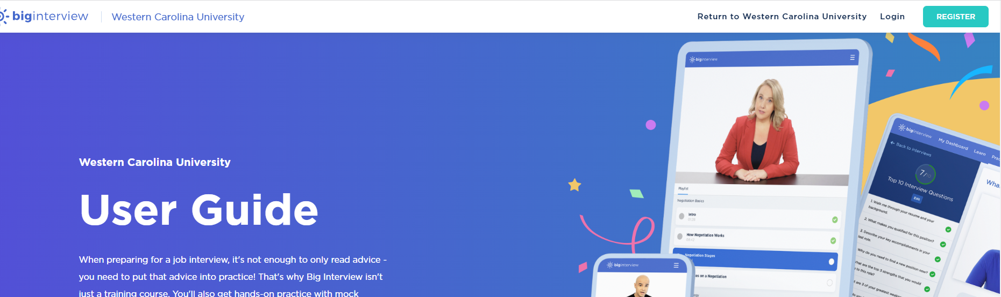

- Once logged in, you should see your faculty/ admin dashboard. Click on Resumes Scoring Guides
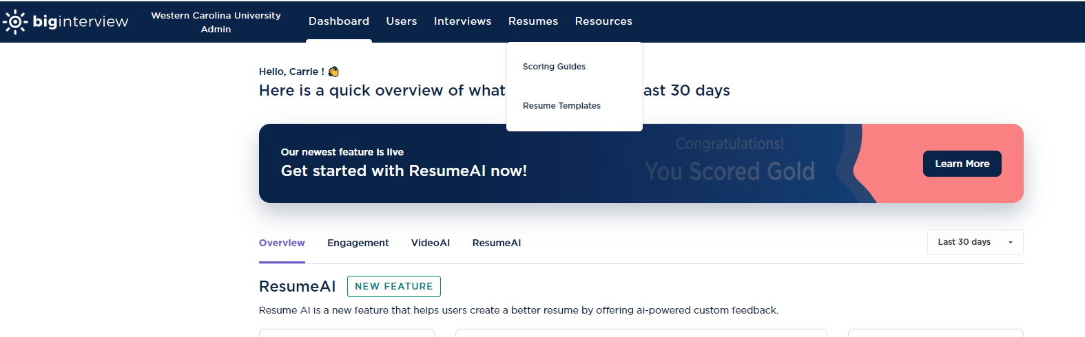

- On the next screen, click the purple New Scoring Guide button
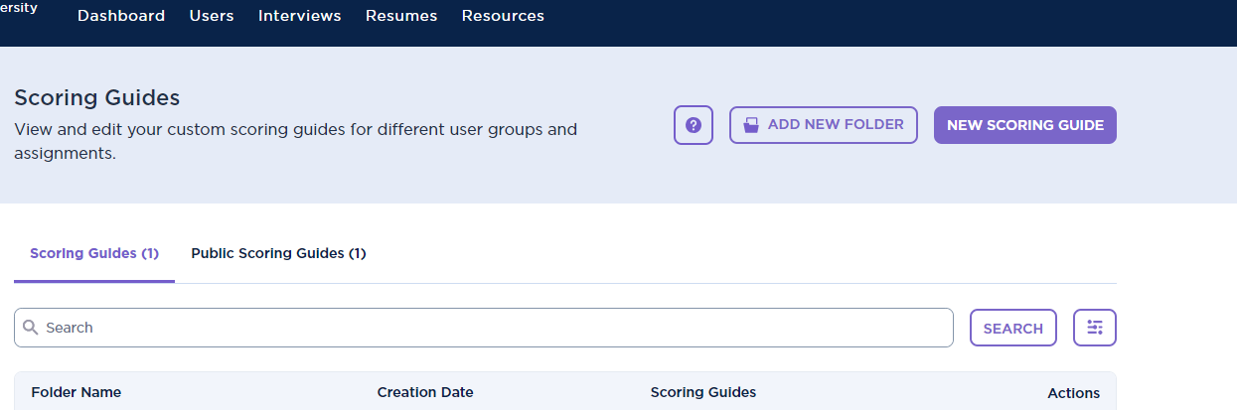
- Type in the name of your scoring guide. We recommend you type in your course abbreviation and course number: Resume Assignment (e.g. USI 130-02 Resume Assignment).
- Choose the due date and type in the assignment description (optional)
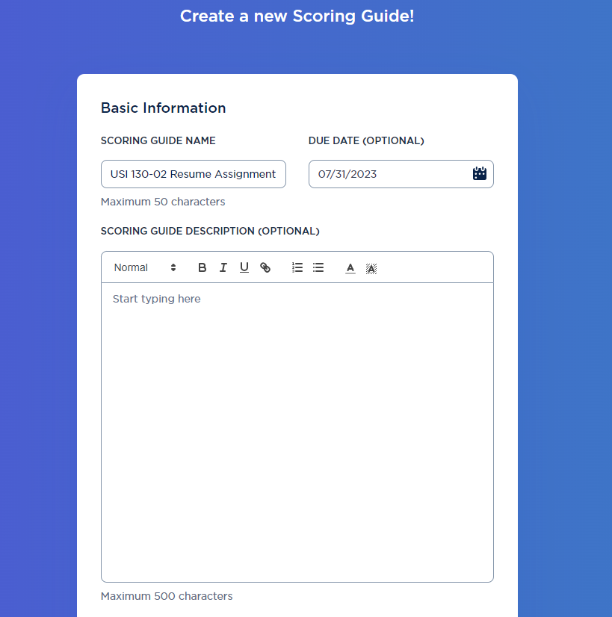

- Scroll down and finish setting up the assignment basic guidelines screen. A new notes: You may opt to upload a resume template(s) you want your students to use (such as the CCPD resume samples). Shared Scoring Guide is turned off. We recommend you keep it off, otherwise any admin can see your students’ results. You may also opt to turn on email notifications so that Big Interview will email you each time a student submits their assignment.
- For Scoring Settings, you can choose to have Big Interview grade the resume based on experience, on education, or either. An Experience-based resume is one that focuses on work experience (more common for those applying to jobs). An education-based resume is one that focuses on academics and research, similar to a CV.
- Target score is set to Gold. Big interview has 3 scores: Gold, Silver, and Bronze. It doesn’t not give a numerical grade to students. You’ll need to decide how you want to input the grade into Canvas. (e.g. they get full points if they do the assignment vs. specific numerical grades for gold, silver, and bronze)
- For Job Description, you can require your students search for a job they’d like to apply for and copy/ paste that job description into Big Interview; you can pre-load the assignment with a specific job description you want your students to use; or you can make copying/ pasting a job description optional.
- Click Next Step.
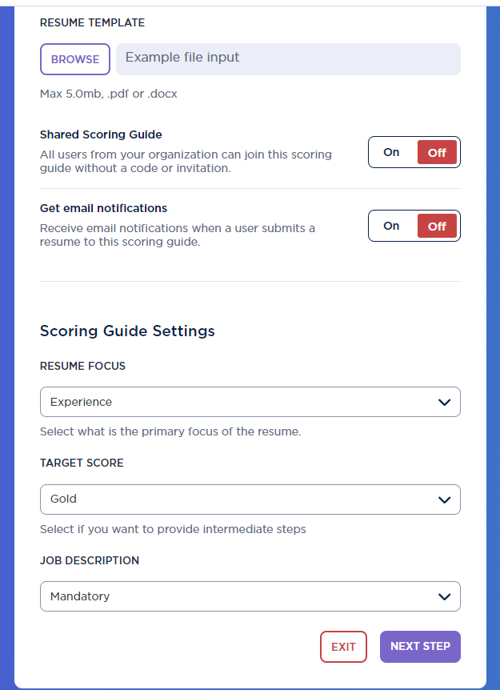

- Now we come to the customization part of the scoring guide where you get to decide on Big Interview scores your students’ resumes based on your preferences and industry standards for your field. On the lefthand side of your screen are the criteria. Click on each to set your own or to review Big Interview’s pre-set standards.

For example, in the Summary Statement section, you can choose to turn that requirement off. If you decide to leave it on, you can choose how important the summary statement is in the scoring of the students’ resumes.

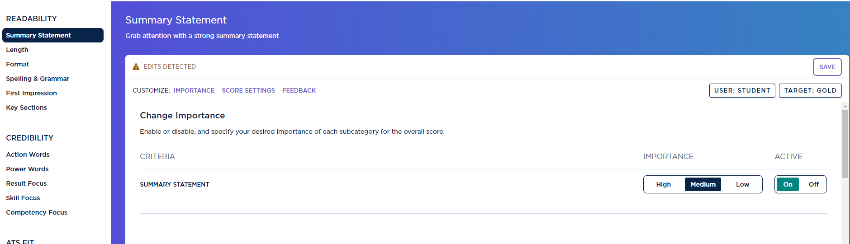

You can then change the number of words that would meet Gold, Silver, or Bronze status:
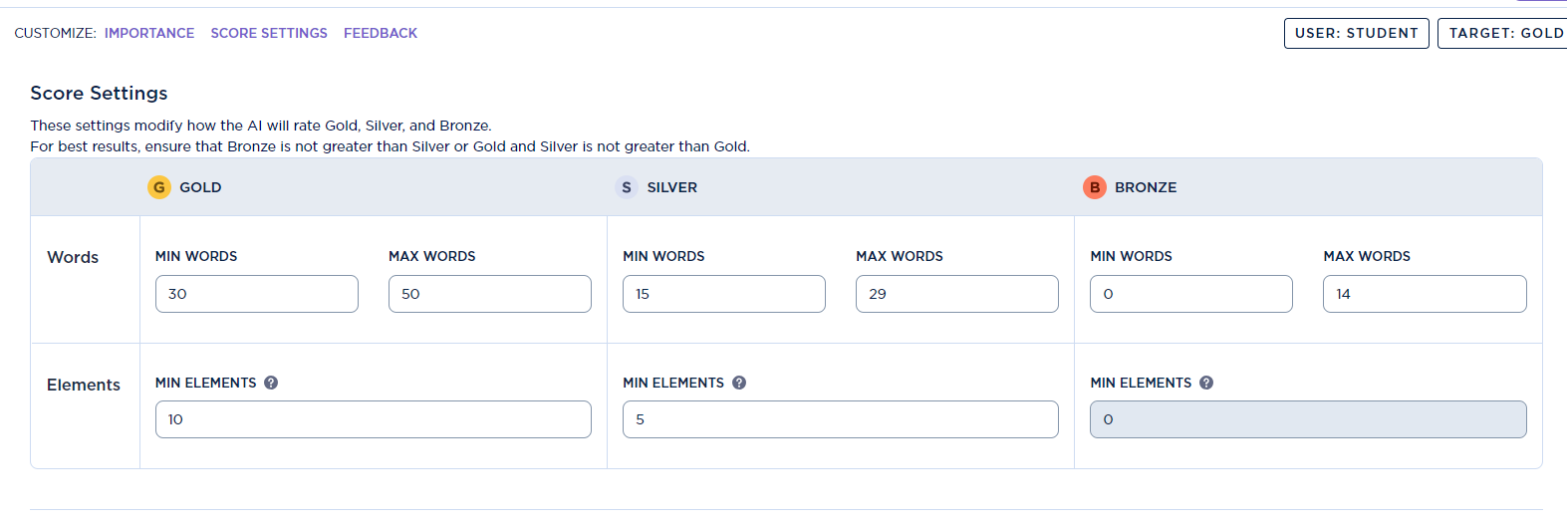
Finally, you can edit the feedback Big Interview gives the student based on their scored level

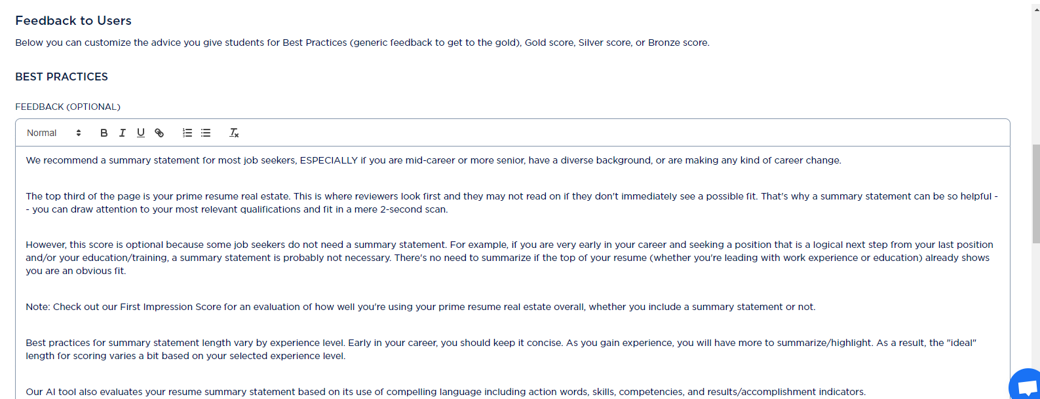

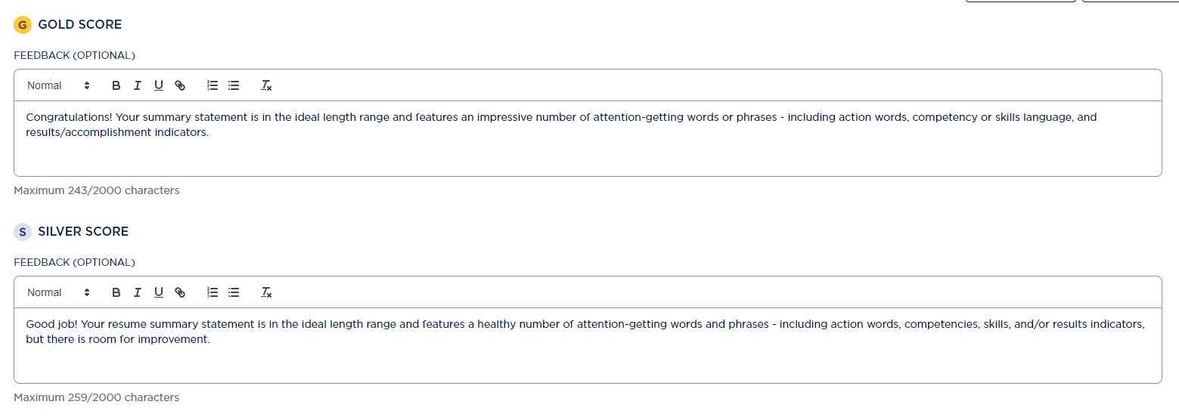

- Once you have finished editing or reviewing the criteria on the left, click Next Step, located at the top of your screen.
- You can email your students with the resume assignment instructions using Big Interview, but this step is completely optional. If you’d like Big Interview to notify your students, you can upload a CSV file with your students’ names and email addresses. You can also manually add students by clicking on the Add button towards the top.
- If you do NOT want Big Interview to email your students, scroll down and copy the assignment access code. NOTE: This is VERY important. Without the code, your students will not be able to access your assignment. Many faculty will choose to copy/ paste the code into the Canvas assignment instructions.
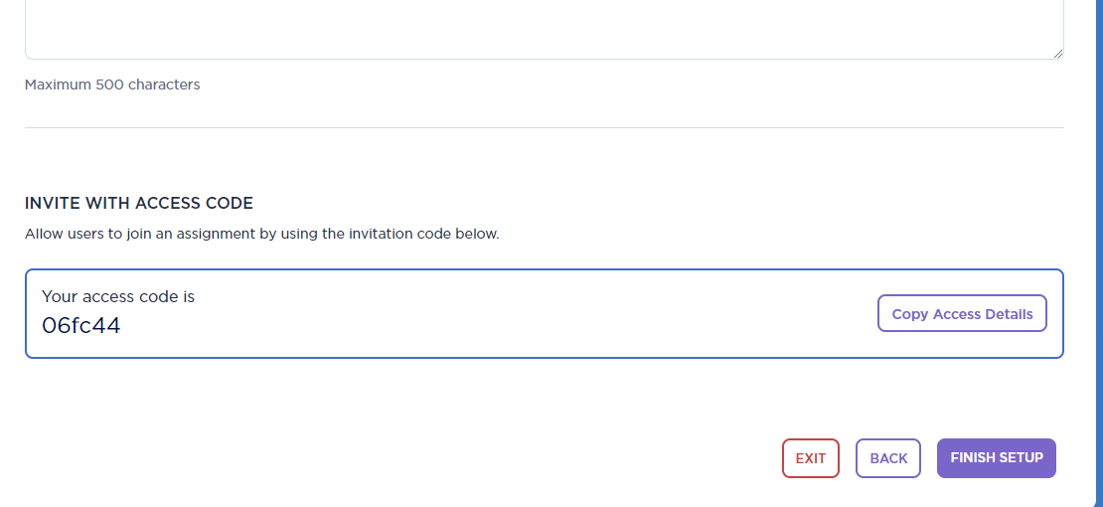
- Then click Finish Setup. You should see the assignment in the Scoring Guides list (You’ll need to click on the link that says Uncategorized)
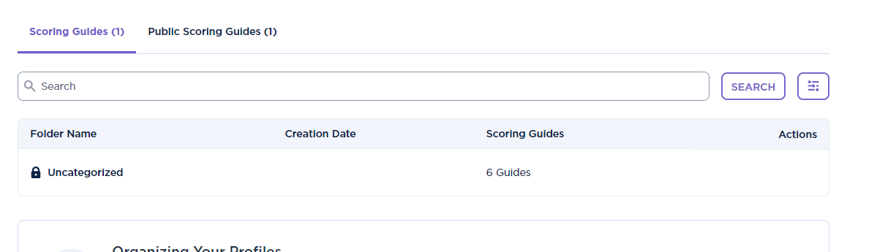

- And then you’ll see the scoring guides that you have set up, where you can view your students’ results. You can also opt to have students screenshot their results and upload into Canvas.
