HELPFUL APPS
The Office of Accessibility Resources 137 Killian Annex
SPEECH-TO-TEXT

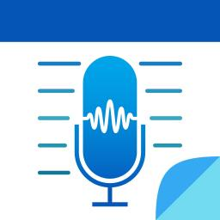
NOTETAKING

AudioNote 2
Track audio recordings that
are linked to your notes.
Nebo
Take smarter notes by using I interactive ink.

Supernotes
Create notes with photos
and recordings.
TIME MANAGEMENT
Evernote iThe ultimate digital notebook.
Remember the Milk
TEXT-TO-SPEECH
OTHER
And hundreds more available!
Add assignments & prioritize when coursework is due.

Do! – Simple To Do List
Create tasks you can prioritize. Includes ability to create widgets on your device’s home screen.
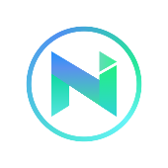
Natural Readers
Reads any text pasted in its window
or uploaded to webpage. Can convert
text to a spoken sound file.
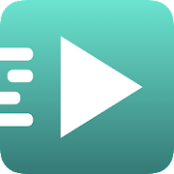
Simple Text Reader (TTS Reader)
Reads plain text out loud. Can paste copied text, upload text files, or link web pages

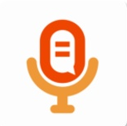
SpeechNotes
Online notepad that can enables your to type as you speak. Includes ability to export files.
FOCUS
Just Press Record
Transcription tool that allows editing and searching. Cloud and punctuation technology included.
Flora
Grow a virtual tree that dies if you wake up your phone. Includes to-do list and habit tracker.
Tide
Focus timer with nature sounds.

