PRM 260-01: Professional Planning in PRM

Parks & Recreation Management Department of Human Services
Fall 2019

Course # & Title: PRM 260-01: Professional Planning in PRM (1 credit hour)
Class Times: Wednesdays: 10:10-11:00am
Location: Killian 304 and Online
Instructor: Debby Singleton
Preferred Pronouns: she/her/hers
Office: 122J Reid Gym
Office Hours: By appointment
Phone #: 227-3971 E-mail: singleton@wcu.edu

COURSE DESCRIPTION: This course is designed to assist and guide PRM majors in the creation of their experiential transcript. This includes; guiding them through the curriculum requirements of the major, assisting them with the development of professional skills and artifacts, providing opportunities to explore potential internships and career paths, and developing relationships with their peers and the PRM community.

PURPOSE: This course is intended to be taken in a student’s first year in the program. The course will assist students in developing their “experiential transcript” which is the focus of WCU’s Quality Enhancement Plan, DegreePlus. The work completed in this course sets the foundation for projects and assignments in future PRM courses including PRM 370: Capstone Internship Orientation and PRM 495: Senior Seminar. In addition, students become active, engaged participants in their academic success and career.

PRM Major Requirements 2017-2018 University Catalog: http://catalog.wcu.edu/preview_program.php?catoid=41&poid=5666&hl=parks+and+recreation+management&returnto=search

DegreePlus Information for Students: http://www.wcu.edu/learn/academic-enrichment/ccpd/degree-plus/students-info.aspx

Learning Outcomes:
Students will be able to…
1. Design effective professional materials necessary to pursue a career in Parks & Recreation Management (7.04)
2. Interpret their academic progress to ensure successful graduation from the PRM program (7.01 b, c)
3. Explain the components of the PRM Student Handbook and their relevance to their degree completion (7.01 b, c)
4. Design a professional digital portfolio (7.04)

REQUIRED RESOURCES:
• PRM Student Handbook. Copies are located in our Bb shell.
Please save the pdf of the handbook to your computer and bring to class when requested.
• Center for Career & Professional Development website: http://www.wcu.edu/learn/academic-enrichment/ccpd/
• Linked In website: https://www.linkedin.com/
• Degree Plus website: https://www.wcu.edu/learn/academic-enrichment/ccpd/degree-plus/

COURSE ASSIGNMENTS:
Assignment | COAPRT Learning Outcome | Points
PRM Handbook Quiz | 7.01 b, c | 100
Career Choices Worksheet |  | 100
PRM Essay |  | 100
Resume | 7.04 | 100
Cover Letter/Professional Email | 7.04 | 100
Career & Networking Event Reflection |  | 100
Synthesis Discussion |  | 100
Synthesis Paper | 7.01 b, c | 100
Digital Portfolio: Linked In | 7.04 | 125
Participation/Attendance |  | 100
Total Points |  | 1000
*Class assignments and points may be updated, deleted, or changed during the semester. Students will be consulted.

GRADING SCALE:
A+ | >101%
A | 93-100% | C | 73-76.9%
A- | 90-92% | C- | 70-72.9%
B+ | 87-89.9% | D+ | 67-69.9%
B | 83-86.9% | D | 63-66.9%
B- | 80-82.9% | D- | 60-62.9%
C+ | 77-79.9% | F | Below 60%

Seriously, this happens.

Brief Description of COURSE REQUIREMENTS/ASSIGNMENTS:
• For each assignment, a link in Bb will provide instructions, detailed assignment description, grading rubric, due date and submission requirements. The instructor will go over each assignment but it is your responsibility to read the assignment and ask questions if you do not understand something.

• PRM Handbook Quiz: Study the PRM Student Handbook. The quiz may be given online or in class.

• Career Choices Worksheet: This worksheet is a self-reflection on your academic and career choices.

• PRM Essay: Students will complete the PRM Essay to be officially declared a PRM major.

• Resume: Students will create a professional resume. *Please visit the Center for Career & Professional Development to have them review your resume PRIOR to submitting it for a grade. You can make an appointment by visiting their website: http://www.wcu.edu/learn/academic-enrichment/ccpd/visit-ccpd.aspx

**Students planning to focus on Outdoor Leadership & Instruction or Recreation Resource Management are also required to complete an Outdoor Resume.

• Cover Letter/Professional Email: Students will develop a template for a personal cover letter and professional email that can be used for future mini-internships, the capstone internship, and career opportunities.

• Career & Networking Fair: Students are required to attend the event and write a reflection.

• Synthesis Discussion: Students will participate in a class wide discussion of the synthesis paper on the last day of class.

• Synthesis Paper: This assignment will require you to reflect upon where you are in your current academic career at WCU, steps you need to take to graduate and an exploration of your future goals. Requirements for the paper include at least 3 pages, double-spaced, 1” margins, APA format, references page. You will submit the paper online.

• Digital Portfolio: Materials will be uploaded to the digital platform, Linked In. Details can be found in Bb. You will expand upon this portfolio in PRM 370 and then again in PRM 495.

• Participation and Attendance: This is a quantitative and a subjective grade. Since this is a face to face, hybrid style course, students are expected to keep up with weekly assignments, schedule, and online requirements. **Attendance is taken during face to face classes, but will not be recorded during hybrid classes.

Meeting Attendance | Participation Points
50 points= no absences | Fully engaged, active participation, entire semester= 50 points
40 points= 1-2 absences | Above Average participation, engaged at least 75% of the time= 40 points
30 points= 3-4 absences | Average participation, engaged at least 50% of the time= 30 points
0 points= 5 or more absences | Below Average participation, engaged at least 25% of the time= 20 points
 | Poor participation, not engaged= 0 points

• Extra Credit Opportunities: Throughout the semester, I will provide opportunities for extra credit that relate to professional planning in PRM. Each extra credit opportunity will be worth 5-10 points. To receive the points, students must submit in class or delivered to the instructor a written, one paragraph (1/2 page) summary which includes the following criteria within one week of the completed activity:
  - Date of activity, time served/participated
  - Name of sponsoring organization and contact person
  - Why did you want to do this, what did you do, what did you take away from the experience?
  - Please include your name and email address (WCU please) as a right-indented header
  - Formatting is 12-point, Times New Roman font with 1” margins.
  - **Maximum amount of extra credit allowed is 30 points total for the semester.

Extra Credit may also be obtained through attending WCU’s Career and Professional Development Center variety of workshops and events throughout the semester. The PRM Program offers a wide array of programs and events to help you expand your network and community. The instructor will provide information on these events, the number you are required to attend for this class, and the requirements for assessment points. PRM will also offer panel discussions and industry leader discussions to help you find internships and summer jobs.

Written Assignment Policies

All written assignments are required to meet the following criteria:

- Have a font no smaller or bigger than 12-point with standard margins.
- Be completed on a computer
- Be double-spaced and in the appropriate format for the assignment.
- Have numbered pages, including the cover sheet
- Have a cover sheet listing the following:
  - Name and number of course (PRM 270: Leadership & Group Dynamics)
  - Student’s name
  - Date assignment is due
  - Named title
- Meet APA Publication Manuscript style, i.e., references, citing (direct and paraphrased quotes, headings, etc.). See Purdue Owl for help: http://owl.english.purdue.edu/owl/section/2/10/
- Use your spell-check, grammar, and thesaurus tools, which are provided in all word document software. I deduct points for errors, PROOF YOUR WORK!

Don’t be this kid.

Late Assignment Policy
All of the class assignments have a specified due date, so pay attention to the syllabus (read it and refer to it often). Assignments must be handed in on time. Each assignment is due the class period assigned or designated on the course schedule. Late assignments will be penalized (1 day late = minus 10% of total grade; 2 days late = minus 20%; etc.) If you are having a problem completing an assignment on time, please ask the instructor for assistance. This policy includes weekend days.

Test Make-up and Missed Class
If you are sick or unable to complete a test during the class period or time period allotted, you must notify the instructor one week prior to the time the test is scheduled or if sick, prior to the beginning of the test. If you do not contact the instructor at all, you will receive a grade of zero on the exam and no make-up. There are no make-up opportunities for quizzes or other class presentations/projects. If you are absent on the day the instructor describes an assignment, it is your responsibility to get the information from a classmate or check Blackboard.

Course Schedule: Please refer to the course schedule posted in Blackboard for the most current information. *The Schedule is “Fluid”, meaning that the topics for discussion may change depending upon student participation and interest; assignment dates may change due to student input or university scheduling; or unique opportunities may present themselves and be added. Students will be notified in a timely manner of schedule changes.

Course Evaluation Schedule: Students will be asked to participate in an online evaluation of this course. An email will be sent to students reminding them to complete the online course evaluations. The evaluations are scheduled to be available during the last month of the semester.

Netiquette Guide for a Hybrid-Online Course:
It is important to recognize that the online classroom is in fact a classroom, and certain behaviors are expected when you communicate with both your peers and your instructors. These guidelines for online behavior and interaction are known as netiquette.
GENERAL GUIDELINES When communicating online, you should always:
• Treat instructor with respect, even in email or in any other online communication
• Always use your professors’ proper title: Dr. or Prof., or if you in doubt use Mr. or Ms.
• Unless specifically invited, don’t refer to them by first name.
• Use clear and concise language • Remember that all college level communication should have correct spelling and grammar
• Avoid slang terms such as “wassup?” and texting abbreviations such as “u” instead of “you”
• Use standard fonts such as Times New Roman and use a size 12 or 14 pt. font
• Avoid using the caps lock feature AS IT CAN BE INTERPRETTED AS YELLING
• Limit and possibly avoid the use of emoticons like :) or ϑ
• Be cautious when using humor or sarcasm as tone is sometimes lost in an email or discussion post and your message might be taken seriously or offensive
• Be careful with personal information (both yours and other’s)
• Do not send confidential information via e-mail

MESSAGE BOARD NETIQUETTE AND GUIDELINES When posting on the Discussion Board in your online class, you should:
• Make posts that are on topic and within the scope of the course material
• Take your posts seriously and review and edit your posts before sending
• Be as brief as possible while still making a thorough comment
• Always give proper credit when referencing or quoting another source
• Be sure to read all messages in a thread before replying
• Don’t repeat someone else’s post without adding something of your own to it
• Avoid short, generic replies such as, “I agree.” You should include why you agree or add to the previous point
• Always be respectful of others’ opinions even when they differ from your own
• When you disagree with someone, you should express your differing opinion in a respectful, non-critical way
Resource: http://teach.ufl.edu/wp-content/uploads/2012/08/NetiquetteGuideforOnlineCourses.pdf

Classroom Expectations:
The shared learning space of the college classroom is built on respect for each other and each other’s learning. Learning together means our actions can intentionally and unintentionally distract others from their learning goals. As responsible learners who respect the rights of others and vow to minimize avoidable distractions such as: non-academic technology use, coming in late, sleeping, off-topic discussions, doing other homework, eating, etc.

E-mail Etiquette: Electronic mail to and from your “@catamount.wcu.edu” address is the preferred method of communication. Please follow common e-mail rules:
1. Use your @catamount.wcu.edu email address
2. Use a short and accurate subject header
3. Use a proper salutation (Hello, Good Morning, Greetings, etc.)
4. Introduce yourself in the first paragraph (if needed)
5. The message body should be written in a concise and clear manner. Please do not BS or ramble. Get to the point.
6. Leave-taking (departing farewell) should be appropriate. (Respectfully, Yours sincerely, Take care, etc.)
7. Sign your email with your full (First and Last) name
8. Proofread for content, spelling and grammar.

For the visual learners…
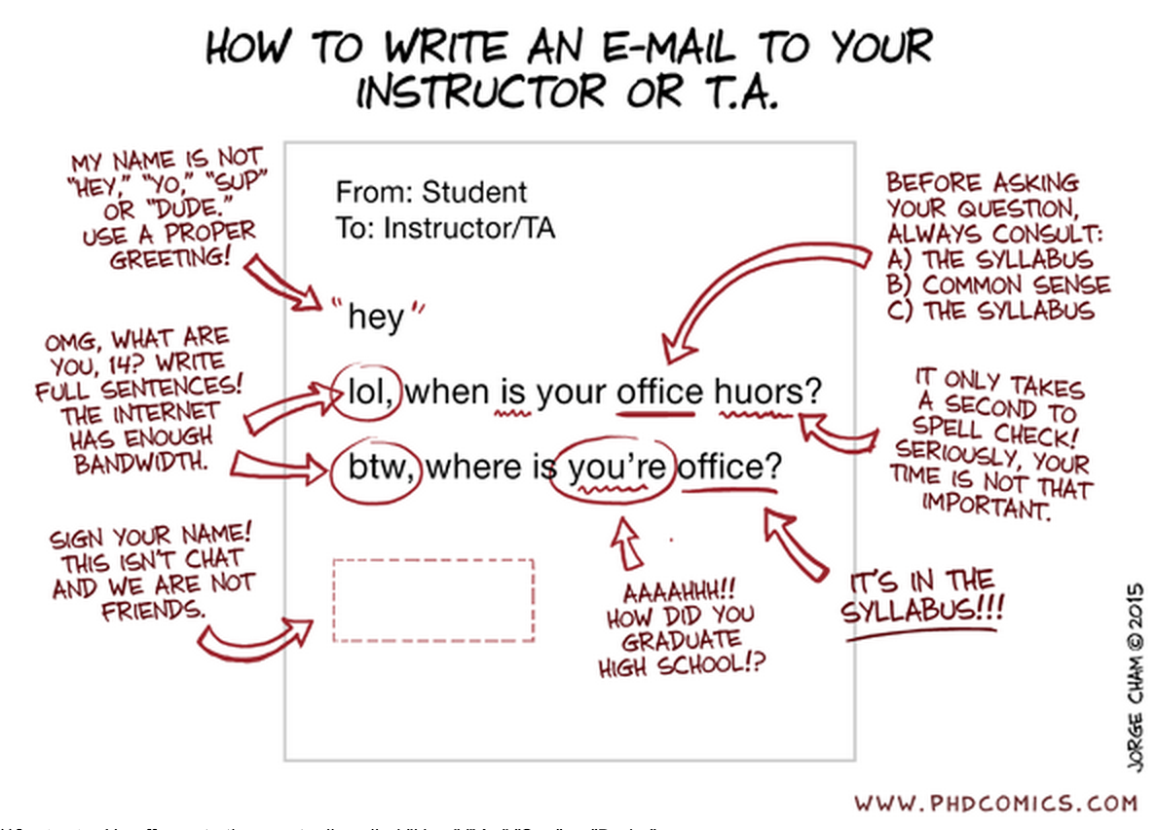

Appendix A: Boilerplate
“The university requires me to pass along to you a whole litany of contractual information, some of which you may find important, some of which you may not. I have placed this information at the end of this syllabus; I suggest you refer to it as necessary.”

University Expectations and Support Services

Writing and Learning Commons (WaLC)

The Writing and Learning Commons (WaLC) is a free student service, located in BELK 207, providing course tutoring, writing tutoring, academic skills consultations, international student consultations, graduate and professional exam preparation resources, and online writing and learning resources for all students. To schedule tutoring appointments, visit the WaLC homepage (http://walc.wcu.edu) or call 828-227-2274.

Blackboard Support

The learning management system for this class is blackboard and can be found at: http://wcu.blackboard.com Additional help with blackboard can be found at: http://tc.wcu.edu, (828) 227-7487 or by visiting the Technology Commons located on the ground floor of the Hunter Library.

Accommodations for Students with Disabilities

Western Carolina University is committed to providing equal educational opportunities for students with documented disabilities and/or medical conditions. Students who require reasonable accommodations must identify themselves as having a disability and/or medical condition and provide current diagnostic documentation to the Office of Disability Services. All information is confidential. Please contact the Office of Disability Services at (828) 227-3886 or come by Suite 135 Killian Annex for an appointment.

Student Support Services
Student Support Services provides support to students who are either first-generation, low-income or those who have disclosed a disability with: academic advising, mentoring, one-on-one tutorial support, and workshops focused on career, financial aid and graduate school preparation. You may contact SSS at (828) 227-7127 or email sssprogram@wcu.edu for more information. SSS is located in the Killian Annex, room 138.

Civility and Ground Rules
The Western Carolina University Community Creed states: “I will respect the rights and well-being of others.” Each student may possess different ideas, as well as different ways of communicating those ideas. Because of these differences, respect and civility are integral to maintaining the quality of the academic environment and free inquiry.
(http://www.wcu.edu/student-life/policies-affecting-students/statement-of-student-rights-and-responsibilities.asp)

SafeAssign Tool
All written work submitted for this class is eligible for submission to the SafeAssign tool at the instructor’s discretion.
_____________________________________________________________________________________________________________________________________

WCU Policies

Sexual Harassment Policy
The University deems sexual harassment to include conduct constituting sexual harassment under Title VII of the Civil Rights Act of 1964 and Title IX of the Education Amendments of 1972.

Academic Integrity Policy
"I will practice personal and academic integrity" – WCU Community Creed

Academic Integrity Policy and Reporting Process
This policy addresses academic integrity violations of undergraduate and graduate students.
Students, faculty, staff, and administrators of Western Carolina University (WCU) strive to achieve the highest standards of scholarship and integrity. Any violation of the Academic Integrity Policy is a serious offense because it threatens the quality of scholarship and undermines the integrity of the community. While academic in scope, any violation of this policy is by nature, a violation of the Code of Student Conduct and will follow the same conduct process (see ArticleVII.B.1.a.). If the charge occurs close to the end of an academic semester or term or in the event of the reasonable need of either party for additional time to gather information timelines may be extended at the discretion of the Department of Student Community Ethics (DSCE).

General:
This policy addresses academic integrity violations of undergraduate and graduate students. Students, faculty, staff, and administrators of Western Carolina University (WCU) strive to achieve the highest standards of scholarship and integrity. Any violation of this policy is a serious offense because it threatens the quality of scholarship and undermines the integrity of the community.
Instructors have the right to determine the appropriate academic sanctions for violations of the Academic Integrity Policy within their courses, up to an including a final grade of “F” in the course in which the violation occurs.

Definitions:
1. Cheating – Using, or attempting to use, unauthorized materials, information, or study aids in any academic exercise.
2. Fabrication – Creating and/or falsifying information or citation in any academic exercise.
3. Plagiarism – Representing the words or ideas of someone else as one’s own in any academic exercise.
4. Facilitation – Helping or attempting to help someone to commit a violation of the Academic Integrity Policy in any academic exercise (e.g. allowing another person to copy information during an examination).

Undergraduate and Graduate Academic Integrity Process:
Additional information is available on the Student Success website under Student Community Ethics: http://www.wcu.edu/experience/dean-of-students/AcademicIntegrity/academicintegrity.asp

**Students who are caught cheating, fabricating, plagiarizing or facilitating academic dishonesty, will receive a grade of F in this course.
__________________________________________________________________________________________________________________________________

General Academic Info:
Academic Calendar includes dates for all breaks, university closures, final exams, etc. The academic calendar can be found at: http://www.wcu.edu/learn/academic-calendar.aspx
Final Exam
The university final exam schedule can be found here: https://www.wcu.edu/registrar/calendars/fall_final_exam.pdf

Important Dates
Students must be familiar with the class attendance, withdrawal, and drop-add policies and procedures. Please double check these dates online, as they sometimes change. Here is the link to these dates on WCU’s website: https://www.wcu.edu/WebFiles/registrar/REG_2018-2019_Academic_Calendar_FINAL.pdf
________________________________________________________________________________________________________________________________________

Syllabus Updates:

This syllabus, with its course schedule, is based on the most recent information about the course content and schedule planned for this course. Its content is subject to revision as needed to adapt to new knowledge or unanticipated events. Updates will remain focused on achieving the course objectives and students will receive notification of such changes. Students will be notified of changes and are responsible for attending to such changes or modifications as distributed by the instructor or posted to Blackboard

