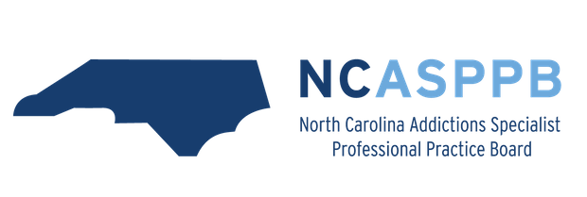

Instructions for Applying to the Addiction Studies Program:

- Answer all questions thoroughly.
- In boxes that need to be checked, double click on the box to select check.
- Include an updated resume.
- Only complete applications will be accepted and acknowledged.
- Fill in the application, print, sign, and scan the application and resume as one document.
- Title the email ASP Application Spring 2024

- Name (last, first, middle):

- Permanent Address:

Mailing or Local Address (if different):

- County of Permanent Residence:

- Mobile Phone Number: Other Phone Number:
- 92 #:
- Date of Birth:
- Gender: Female Male Other Prefer not to say
- Ethnicity: Hispanic/Latino Non-Hispanic/Non-Latino
- Race: American Indian or Alaska Native Asian Black or African American
Native Hawaiian or Other Pacific Islander White Other

- Catamount Email Address:

Personal Email Address:

- Select your program:
Advanced Standing Program: | yes | no Full Time Part Time
Tradition Program: | yes | no Full Time Part Time

- Will you be pursuing any of the following in addition to the Addiction Studies Program:
Integrated healthcare? | yes | no
Child Welfare Education Collaborative? | yes | no
School Social Work Certification? | yes | no
Culturally Based Native Health Certificate? | yes | no
Clinical Mental Health Counseling? | yes | no
School Counseling? | yes | no

- Do you reside in a rural area (per census designation; use the HRSA Rural Health Analyzer again- https://data.hrsa.gov/tools/rural-health)? yes no
- Are you a first-generation college student (both parents did not graduate from college)? yes no
- Are you a member of a federally recognized tribe? yes no
- Are you a veteran? yes no
If yes: Active Duty Military Reservist Veteran, Prior Service Veteran, Retired Other

- Specialization Year Field Placement Name:

- Full Address of Placement Site (include the four-digit zip code extension):

- Field Instructor (at placement site) Name:
- WCU Faculty Liaison Name (this in not your field instructor):
- Field Instructor Phone Number:
- Field Instructor Email:
- Who will provide your CCS Supervision:
- Reasons for interest in this placement:

- Explain how this placement meets the requirements of the Addiction Studies Program:

- Professional Social Work or Counseling areas of interest:
- Professional and employment goals:

__________________________________________________________________________________________

I understand and will abide by the requirements of the Addiction Studies Program.

Signature: _________________________________________________ Date:

Print Full Name:

If you have questions, please contact:

Aaron Plantenberg, MSW, LCSW, LCAS, CCS
Addiction Studies Program Coordinator/Instructor
Western Carolina University
College of Health and Human Sciences - Department of Social Work
3971 Little Savannah Rd, Room 316
Cullowhee, NC 28723
Phone: 828.227.2703
Fax: 828.227.7708
Email: aplantenberg@wcu.edu

