[](http://www.google.com/imgres?q=clipart+hand+with+tissue&hl=en&tbo=d&qscrl=1&rlz=1T4GGHP_enUS447US447&biw=1440&bih=783&tbm=isch&tbnid=5iUbuK756hy4eM:&imgrefurl=http://www.canstockphoto.com/illustration/tissue.html&docid=PVO6026wVYa9tM&imgurl=http://ec.l.thumbs.canstockphoto.com/canstock11635916.jpg&w=132&h=150&ei=YzjvUIi0Homy8ASClIH4DA&zoom=1&iact=rc&dur=371&sig=102853343428852213992&page=1&tbnh=120&tbnw=105&start=0&ndsp=37&ved=1t:429,r:36,s:0,i:194&tx=66&ty=72)C:\Users\pmbuchanan\AppData\Local\Microsoft\Windows\Temporary Internet Files\Content.IE5\GM0OKOSO\MC900098035[1].wmf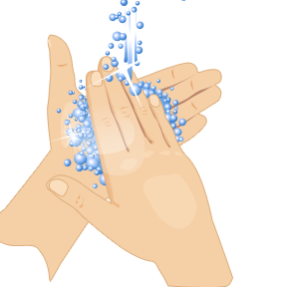

**Contain germs by steering clear of others who are sick.**

**If you do get sick, stay at home until you’re well again, so you don’t spread more** **germs.**

**3 Contain**

**Cover your cough.**

**Use a tissue to cover your mouth and nose when you cough or sneeze. Don’t have a tissue?** **The crook of your elbow will do.**

**Wash your hands often.**

**Scrub your hands for at least 20 seconds with soap and water or use an alcohol-based hand cleaner.**

**2 Cover**

**1 Clean**

**Know the 3 C’s**