Faculty Senate Minutes
2/24/2021 Regular Business Meeting 3:00-5:00 pm via ZOOM
ADMINISTRATIVE PROCEDURES
ROLL CALL and APPROVAL OF MINUTES
Approval of Regular Business Meeting Minutes from January 20, 2021
Vote was taken with roll call. Minutes Approved.
Michael Boatright | approve
Indi Bose | arrived 3:11; did not vote on minutes
Chancellor Kelli Brown | here
Kristin Calvert | approve
Todd Collins | approve
David de Jong | approve
Heidi Dent | approve
Heather Mae Erickson | approve
Garrett Fisher | approve
Mariana Fisher | approve
Enrique Gómez | approve
Yancey Gulley | approve
Jeremy Jones | approve
Sudhir | approve
Marco Lam | approve via proxy Heidi Dent
Will Lehman | approve
Niall Michelsen | approve
Sean Mulholland | approve
Leigh Odom | approve
Kadence Otto | here
Matthew Rave | approve
Carrie Rogers | approve
Roya Scales | approve
Provost Richard Starnes | here
Vicki Szabo | approve
Elizabeth Tait | arrived 3:55; did not vote on minutes
Martin Tanaka | approve
Drew Virtue | approve
Elizabeth Wark | approve
Ashlee Wasmund | absent
Laura Wright | approve
Jessica Zellers | approve

New WCU Faculty Senate SharePoint Information: Suzanne Melton
The remaining AY2020-21 business meeting shared documents will now be located on the following online SharePoint site: https://catamountwcu.sharepoint.com/sites/WCUFacultySenate
This new online site is a public site accessible to all using network credentials, with senators having editing/contributing ability. This move is to accommodate folks with a more user-friendly and accessible means of reviewing materials. Many of our MAC users have reported accessibility issues with the internal intranet site.
Within the online site, there is a 2020-21 Meeting library that houses the remaining senate meeting folders, and the review/meeting documents within.
Suzanne Melton also made a suggestion that the Faculty Senate Planning Team discuss the current internal site and a possible migration to the online site or other venues of online storage and collaboration. The “old” internal site was inherited many years ago and it would be beneficial to do a review and re-organization of those materials and move to a format that is efficient for all users.
Kadence Otto reminded external folks to submit reports one week prior to the business meeting. This is to allow senators more time in the meetings to ask critical questions and conduct senate business.

EXTERNAL REPORTS
Chancellor’s Update: Chancellor Kelli Brown
COVID Activity on Campus
COVID activity on campus continues to remain relatively low. In the past week, we had 13 total confirmed cases of COVID-19. On-campus, we had 7 positive cases out of 552 administered tests. This is a positivity rate of 1.3%. We currently have 7 students in isolation on-campus and 52 in self-isolation off-campus. We are expecting these numbers will increase some with the resumption of face-to-face and hybrid classes, but we will continue testing and monitoring throughout the spring.
WCU Regional Clinic Update and Vaccination Prioritization
Although we had planned to open our regional vaccination clinic this past week, shipment delays from the severe winter weather across the country caused us not to receive our vaccine allocation for the week. Pending vaccine shipments, we will begin to offer vaccinations to those in Phase 1 and Phase 2 of the prioritization groups by the end of the week.
Gov. Roy Cooper and NCDHHS Secretary Mandy Cohen recently announced that the State’s transition into COVID vaccination Group 3 will be multi-phased, with those working in child care or PreK-12 education being eligible starting this week on Feb. 24. More information can be found here.
According to the Governor’s announced timeline, the state plans to expand vaccine eligibility to additional Group 3 workers, including most frontline workers on university campuses, March 10. The following UNC System employees do qualify in the PreK-12 school category:
- Student Teachers – For those who have student teachers actively teaching in PreK-12 schools, student teachers are listed under “PreK-12 Roles” in the Deeper Dive guidance linked above, and thus are eligible for the vaccine starting Feb 24.
A “frontline essential worker” is defined by NCDHHS as a worker in one of eight designated essential industries (including education) who must be in-person at his or her place of work. Guidance outlining this definition can be found here.
Board of Governors Meeting
At their meeting on February 18, I was so pleased that the Board of Governors announced WCU Professor Dr. Billy Ogletree as winner of the 2021 Governor James E. Holshouser, Jr. Award for Excellence in Public Service. The award honors faculty who exemplify the University’s commitment to service and community engagement. Dr. Ogletree will receive a $7,500 stipend and a bronze medallion in honor of his work. The full announcement can be seen at https://www.wcu.edu/stories/posts/News/2021/02/holshouser-award-2021.aspx.
In other business, the Board of Governors approved our request to increase the Health Services Fee by $36. The Board also increased the Campus Security Fee at all UNC campuses. WCU’s fee was increased by $30 and we will begin charging this campus security fee in Fall 2021.
Finally, the Board announced that Darrell Allison, a longtime education advocate and champion of North Carolina’s historically minority-serving institutions, was named the 12th chancellor of Fayetteville State University on Thursday. He was elected by the University of North Carolina Board of Governors, following his nomination by University of North Carolina System President Peter Hans.
February 2021 Consensus General Fund Revenue Forecast
On Thursday, February 11, the February 2021 Consensus General Fund Revenue Forecast was officially released. OSBM’s one-pager is found here and Fiscal Research Division’s full report is found here. The revenue forecast was better than expected, which was welcome news.
University Accolades
- Ben Francis-Fallon, an associate professor of history, was named the winner of The Huntington Library’s inaugural Shapiro Book Prize for his “The Rise of the Latino Vote: A History,” published by Harvard University Press. Francis-Fallon was formally presented the prize, given for an outstanding first book on American history and culture, on Wednesday, Feb. 3, during a webinar. The Huntington is one of the largest repositories of American historical materials in the nation and includes expansive and diverse holdings in history, literature and high and popular culture.
- Sarah Carpenter, a graduate student in WCU’s nurse practitioner program, recently learned she was the recipient of the Fullerton Medical Scholarship Award. The Fullerton Medical Scholarship Program was established by The Fullerton Foundation in 1985 to support the development of primary care providers in the Carolinas. The program seeks to improve the availability of primary care providers in upstate South Carolina and Western North Carolina by providing substantial tuition assistance to medical students and student nurse practitioners who intend to practice some form of primary care. Carpenter is the second WCU family nurse practitioner student to receive the $20,000 award in the last three years.
- Western Carolina University has been ranked among the top providers of online programs by U.S. News & World Report in numerous categories for 2021.
- In its evaluation of undergraduate and graduate online programs offered by higher education institutions across the country, the magazine placed WCU at 27th for online bachelor’s degree business programs and 32nd for veterans seeking online graduate degrees in business.
- Other rankings included 164th for online bachelor’s degree programs overall, 76th for online graduate business programs.
Question from Michael Boatright: Colleagues in other departments are asking if there are any plans to have a Covid impact statement available for annual reviews and reports? Is this necessary or in the works currently?
Response from Provost Starnes: The CRC is working with Associate Provost Brandon Schwab on this.
Question from Carrie Rogers: With regards to the “student-teacher” vaccine availability, is this for faculty who work with student teachers or ...?
Response from Chancellor Brown: This is referring to Group 3 - (pre-k - 12 environment), and those teachers are in 3(a) (teachers, staff, custodial, transportation and student teachers, etc…) Melissa Wargo shared that it is for workers in a K-12 school. Email communication should go out today with further details.
Question from Vicki Szabo: Do we have any updates on the state budget and the exercise we completed last semester?
Response from Chancellor Brown: We are continuing budget hearings and will continue to have the university-wide budget hearing. For the state budget, they will be doing this a bit later this year, likely as late as May or June.

Provost’s Report: Provost Richard Starnes
Tenure, Promotion and Reappointment Process
We are coming toward the end of this year’s TPR cycle. As you know, we had to make some changes on the fly to accommodate virtual meetings of review committees, electronic voting, and the use of electronic documentation of faculty dossiers. I want to thank everyone involved in the review process for their patience and flexibility, especially to those faculty undergoing review this year. As can be expected for a change as big as this one, there were some glitches, but by and large I think the process worked well. I want to express my sincere appreciation to Suzanne Melton, Carrie Hockman, and Brandon in my office for making it all happen. We are gathering feedback from those involved and will take the lessons learned to determine what we should continue to do and what we can do better. I also know that the Senate’s Collegial Review Council has been working on this and will be sharing their recommendation for next steps later this semester.
Standing Committee on Faculty Salaries
The Standing Committee on Faculty Salaries continues to meet monthly. The goal of the committee is to propose specific strategic directions addressing faculty salaries to the Chancellor by the end of spring semester 2021.
Administrative Searches Update
The search committees for a new Dean of Library Services and a new dean of the College of Arts and Sciences continue their work with plans to bring candidates to campus during the month of March. Details will be forthcoming.
Spring 2021 Census Report* (addendum)
Enrollment for the current semester is a mixed bag; we have declined 1.3% in overall enrollment (spring 2020 to spring 2021) although there are gains in graduate (2.23%) and distance student enrollment (6.38%). Enrollment at Biltmore Park has increased by 14.5% (up from 563 to 645, duplicated). The fall 2020 first-time full-time freshman cohort retention rate slipped 4.85% (from 91.3% the past two years to 86.5% this spring). There are encouraging signs on our race/ethnicity enrollment: Black/African American student population increased by 3.1% from 634 to 654 this spring over last spring; the Hispanic student population increased by 2.56% from 821 to 842 over the same time; and our Asian student population increased by 16% from 131 to 152. Our Native American student enrollment remains flat.
Fall 2021 Enrollment
Fall enrollment projection is mixed. While there are fewer applications from first-time full-time freshmen, we have admitted more than 2,600 students compared to this time last year; the number of students who have committed to attend is within 100 of there we were a year ago. New transfer students are up in applications, admitted, and commitments, as are new distance learning program students. Honors student admission is up significantly while commitment is slightly behind point-in-time last year. Graduate student enrollment is trending up.
Relief Fund and Summer Enrollment at WCU
The Governor’s Emergency Education Relief (GEER) fund is a method in which WCU can increase student enrollment due to the impact of COVID-19. The emergency grant will be available to WCU undergraduate students (residential and distance) who have separated from WCU over the past four years. The GEER fund will be available to non-Pell eligible students or those who are not eligible to receive Financial Aid for summer enrollment. The GEER fund originated at the state level and will be available to only in-state students. To recover separated students over the previous eight semesters, WCU will initiate multiphase marketing to promote the return and the application of these funds for summer enrollment.
WCU can increase summer enrollment with the application of the Higher Education Emergency Relief Fund (HEERF). If approved, the Office of Summer Sessions would like to apply the HEERF to further the impact on WCU’s enrollment and reduce financial barriers for returning students. The HEERF grant is a federal assistance program and can apply to any US resident, in-state or out-of-state.
Furthermore, the continuation of the $100,000 institutional contribution will allow First-Time, Full-Time Freshmen (FTFTF) cohorts who do not meet the 30, 60, 90, or 120 benchmarks or are within six hours of graduation will assist in degree completion. The application of these funds will continue to contribute to the increase of WCU’s 6-year graduation rate, as seen over the past three years.
FTFTF will be the primary target group of the summer enrollment efforts; FTFTF who have broken enrollment will be contacted and updated on the financial assistance available for summer enrollment. Students within stop-out and in good academic standing will be assisted with registration via professional advisors in the Advising Center. Students outside of their stop-out window will be directed to the Office of Undergraduate Admissions to complete an application for re-admission for the summer term. Students who were in poor academic standing when last enrolled will be directed to the Office of Undergraduate Admissions to complete a re-admission application and complete a Statement of Academic Intent (SAI). Students who are identified and return for summer enrollment will be tagged in WCU’s Navigate system for tracking. Students who receive this opportunity to return to WCU will be offered financial assistance up to $1,000 to cover costs associated with enrolling in summer classes.
In collaboration with WCU’s Advising Center, the Office of Student Retention and the Office of Summer Sessions will generate communication for target groups. A multipronged enrollment campaign will consist of direct mailings, email campaigns (Catamount and non-catamount email accounts on file), and phone calls; social media will aid in outward-facing marketing.
Marketing outreach
Phase 1: March 1, 2021: FTFTF within the stop-out timeframe and are in good academic standing can register for the upcoming semester without reapplying. These students did not complete 30 hours at the end of their first academic year or 60 hours at the end of their second academic year. Targeting these two completion bands falls in line with WCU’s Finish in Four campaign. Summer enrollment will assist these students with timely graduation.
Phase 2: March 1, 2021: FTFTF outside of the stop-out timeframe and in good academic standing who did not achieve 90 hours at the end of their third academic year or 120 hours at the end of their fourth academic year, or are within 6 hours of graduating, will receive marketing. Targeting these completion bands falls in line with WCU’s Finish in Four campaign and can help students to be on track for timely graduation. Students who are eligible to participate in the Finish Line program (90 completed hours and 2.0+ GPA) will have their application fee waived.
Phase 3: March 15, 2021: FTFTF students who were enrolled in the previous four years and were in poor academic standing when last registered still have time to reapply and complete the SAI process to return in summer. This outreach comes after the previous groups because this population may be less likely to return as they could have enrolled at a local community college or began full-time employment since last enrolled at WCU.
Phase 4: April 1, 2021: Outreach to all undergraduate students with unmet liberal studies requirements will receive marketing. These students could be part of previous outreach to FTFTF cohorts but could be outside of those target groups due to the number of completed hours or the number of transfer hours prior to enrolling at WCU.
Question from Enrique Gómez: Can we talk about the growth we have had in underrepresented student groups?
Response from Provost Starnes: Two areas of growth are due to national demographic growth. Provost Starnes has asked the enrollment planning committee, chaired by Vice Provost Carol Burton, to look at ways to develop overt strategies. We won’t see an impact yet, but the current growth is largely driven by growing demographics.
Comment from Sudhir Kaul: Our college had a recent accreditation visit on four of our E&T programs. We were dinged on faculty workload, student to faculty ratio, and institutional support. Are there any strategies we can do to mitigate the ABET concerns?
Response from Provost Starnes: We can address some of this through the budget process where there is opportunity to articulate needs. We do have some institutional issues in the way in which NC Promise is funded. It came in last time as one-time funding and we cannot use the money to allocate positions. Part of the legislative agenda is to solidify recurring commitments around NC funding. We will be paying attention to those issues coming in. We will have to let the budget process play out and see what the legislature does.
Question from Rebecca Hart (SGA rep): When looking at students of color increase, are we also looking at the retention rate? We don’t really offer resources to keep them here.
Response from Provost Starnes: We continue to look at retention rates and we created a retention office last spring to identify barriers to success. We are paying close attention and are able to look at sub-populations better and develop strategies going forward.
Vicki Szabo shared that she posted the UNC report on racial equity that addresses that very question.

Staff Senate: Chair Ben Pendry
What a year it has been. On behalf of the WCU Staff Senate, thank you to the Board of Trustees for their ongoing support of WCU Staff Members. The below report is a snapshot of work since the December BOT meeting.
January Mid-Year Retreat
Staff Senate was pleased to be joined by Dr. Kim Gorman and Dr. Kathleen Brennan who shared some initial results of data from their survey on stigma among WCU employees related to mental health. Additionally, Dr. Cory Causby provided a detailed review of the UNC System Engagement Survey with WCU specific data. These two presentations helped to inform members of the Senate as we prepare for the last half of the fiscal year and begin thinking about FY22.
WCU Staff Senate Website
Led by Senator Deborah Millican, an awesome team of Senators recently published the newly redesigned staff senate website. The new website can be found here -https://affiliate.wcu.edu/staffsenate/
Virtual Forum
Staff Senate organized and hosted a campus forum on January 19, 2021 for faculty and staff to discuss items related to return to in-person instruction, state budgets, campus budget reduction exercise, and other items of interest. Staff and Faculty Senates collected questions from employees before the form and moderated Q&A during the forum. There were over 250 attendees who participated in the virtual forum, Training Survey & Forward Action. As previously reported, WCU Staff Senate conducted a campus-wide survey seeking input from staff members on systems (such as Banner and Talent Management) and skill areas (such as pivot tables and Excel, and engaging with students in crisis), which they believed they needed additional information or training.
Members of Staff Senate met with Mike Byers and Craig Fowler and many of the identified training areas were already in queue for next steps.
Former Senate Chair, Alison Joseph is leading an effort from the Division of Administration and Finance to build a repository for forms and training documents for those items directly related to A&F. Senate is exploring options for a recurring survey to be completed in the off years from the System Engagement Survey.
Employee Wellness
The Senate continues to focus on items related to overall wellness. A sub group of Senators have partnered with representatives from WCU Human Resources and the Staff Wellness committee to advocate for and promote existing resources and brainstorm about future needs.
Scholarship Support
The scholarship and professional development committee is, once again, working with the U-Club. This year will feature a virtual silent auction to raise funds to support the Staff Senate Scholarship Fund.
WCU Police Take ‘No Shave’ Challenge –Staff Scholarship Fundraiser
The Western Carolina University Police Department held its second “no shave” campaign during the university’s winter break as a fundraiser for the Staff Senate Scholarship Fund. Participating officers raised $300 and Mike Byers, WCU’s vice chancellor of administration and finance, matched that amount for a total of $600. As a year-round law enforcement agency, the WCU Police Department has uniform and appearance codes for members of the force, with limitations on male facial hair.
Chief Steve Lillard shared, “One goal of the police department is to build relationships within our community so that we can have positive interactions with groups on campus that are outside of our traditional law enforcement role. This event allows us to work with the Staff Senate on a very important topic that can directly impact our students and help them achieve their educational goals.”
The Staff Senate Scholarship Fund was created in 2007 to promote higher education and help relatives of staff members attend WCU. Chair of Staff Senate Ben Pendry expressed his gratitude: “Thanks to Chief Lillard and Dr. Byers for continuing this event. This is a commitment on the part of the WCU’s Police Department, and the Senate is so, so appreciative.” For more information, contact Staff Senate at staffsenate@wcu.edu.
Professional Development
At the request of Staff Senate, WCU administration once again allocated $10,000 in support for professional development for staff members. Staff who are participating in conferences, workshops, or taking steps to grow their own professional development can apply for support through the Staff Senate Professional development fund. This has been an extremely popular program and Staff Senate will be submitting the necessary materials to make support of the professional development fund recurring.
Spring Culture in Conversation Series
The Office of Equal Opportunity and Diversity Programs, the Faculty Senate, the Staff Senate, and the Student Government Association announce the Spring Culture in Conversation Series. Following a special campus forum on Equity, Diversity, and Inclusiveness the Series in July 2020, the Culture in Conversation Series was created to bring related topics and speakers to the campus community to keep these conversations active. A key component of the series has been highlighting the expertise and talent of our WCU faculty, staff, and students. We believe the Spring offerings address three very important topics and we hope you will join us for all three.
Session 4: Body Discrimination
12:00pm – Tuesday, February 16, 2021
Panelists:
Betsy Aspinwall, Associate Director / Clinical Director, WCU Counseling and Psychological Services
Alex Fields, Associate Director, WCU Residence Life
Dean Paulk, Assistant Director, WCU Department of Intercultural Affairs
Callie Shultz, Program Director & Assistant Professor, Parks and Recreation Management
Session 5: LGBTQUI+ at WCU
12:00pm – Tuesday, March 16, 2021
Session 6: Allyship & Bystander Behavior
12:00pm – Tuesday, April 20, 2021
Panelists:
Shantoneeka Zorn (they/them), Counselor in Residence, WCU Counseling and Psychological Services
C. Shane Lindsey (all pronouns with respect), Mercer University – Cecil B. Day Graduate and Professional Campus

Student Government Association Report: Rebecca Hart
Judicial Branch
- Meeting Thursdays at 5:30 pm started 02/04/2021
Legislative Branch
- Meeting Mondays at 6:00 pm started 02/01/2021
- Applications for Student Body President and Vice President have ended, and we will begin the process of debate and campaigning. Once my successor is official, I will invite that person to the Faculty Senate meeting so I can introduce them and allow them to see what they need to expect.
Executive Branch
- Meeting Mondays at 4:30 biweekly and 1:1 SBP and director biweekly meetings
- Scheduling/New Office hours
- We will not be holding office hours until foot traffic through the University Center increases.
- Campus Safety Walk [TBD-month one]
- The campus safety walk met yesterday, and we will start getting a timeline for this semester.
- MLK Jr. Week Events
- We are working closely with the ICA Council programming during MLK week and will start hosting our own event on the 25th of “How Black is Black Enough?”
- Legislative Database
- We have finished our archive section of the database and will begin to establish if the resolutions were enacted or just passed.
- Website Revamp
- We have gotten our domain as an affiliate website and started to figure out how we want it to be set up
- Athletic Ticketing and SGA’s Role
- SGA will be in charge of distributing student tickets to athletic games
- Blood Drive
- We will be hosting a blood drive this month and in April
- Clubs and Organizations
- Our Director of CORE will be looking into training for RSO advisors
External Activities
- COVID-19 Updates
- Entrance Testing
- We worked over the break to help students know where they could get entrance tests without having symptoms
- PPE for Students
- We have marketed to residence and commuters where they can get PPE bags this semester
- HERF Money
- We are waiting for a timeline from the office before we get started marketing and advocating to students where they have resources
- Culture in Conversation
- Being marketed to students for we can have more engagement
UNCASG Activities

- We were nominated for the Delegation of the Year and we nominated Karen Walker for the Sander Service Award and we nominated Daniel Lourd Tizon for the Service Leadership Award
- We voted on and passed six resolutions that was passed unanimously
- GB 04- Social Justice Accessibility Department Act
- GB 05- Graduate and Professional Student Solidarity Act
- AR 23 Black Lives Matter Act
- AR 22 Title IX Act
- GB -06 Equity Statement
- GB 07- Campus Liaisons Minimum Duties Act
- AR 21 COVID-19 Act [sent back to author]
- We discussed the upcoming February meeting of the BOG
- Security Fee
- The BOG passed a 100% raise in the security fee for the upcoming year
- Health Fee
- Student Activity Fee
- The BOG wanted to move the activity fee to become an opt-in fee rather than a mandatory fee
Platform
- Raising Awareness of Students Rights and Resources
- Pragmatic and Consistent Organizational Structure
- Promoting Transparency to the Student Body, A 20/20 view in 2020
- Fostering connectivity through community engagement and RSOs
- Leading the Charge of Campus Safety
- UPD Advisory Board
- The Board has been formed and will start meeting this semester, YAYYYYY
- Mobilizing the Student Body for 2020 Elections
- Supporting Underrepresented Students
- The Three Zeros of Sustainability
Initiatives
- Academic Integrity
- WCU Yearbook
- ROTC Program
- ASG Engagement
- Easter Monday
- Student Honor Memorial at Graduation
- Grade Distribution
- Please visit my website if you would like quality leisure reading https://dawson4sbp.weebly.com
Comment from Kadence Otto: In reference to the three zeros of sustainability, maybe reach out to Jake Greer and Enrique Gómez. It is possible we could work on a joint resolution at some point.
Question from Yancey Gulley: With regard to the system office reports on the task force around racial justice, have either student groups made a plan to review or respond to it?
Response from Rebecca Hart: We have briefly looked over it; she is not sure if SGA is planning to make a statement. Rebecca will suggest a statement to SGA President Dawson Spencer for consideration.

Faculty Assembly Report: Reporting Delegate Vicki Szabo
FA Subcommittee meetings
Norma Houston, Chief of Staff to President Hans
- COVID Vaccine update: University personnel are prioritized 2 weeks after K-12
- March 10th BOG highlights:
  - Educational Planning –system-wide we are meeting/exceeding most of our metrics, and close on the remainder
  - Budget –capital planning in process
Kimberly van Noort –Sr. VP for Academic Affairs:
- System-wide Retention –overall good, but lost more Freshmen that prior year
- Common-Course Numbering –committee working this system-wide for course equivalencies between institutions
- New Program Proposals –will add new section to address demand in workforce and projected student debt
BOG Governor Reginald Holley –presented PowerPoint for UNC System Racial Equity Task Force with 6 recommendations
Mesia Steed (WSSU) –presented report from Historically Minority-Serving Institutions (HMSI) Committee
Full Faculty Assembly Minutes from the January 15, 2021 Meeting

CFC Canvas Update: Eli Collins-Brown
Spring and Summer 2020 courses have been migrated into Canvas and are available for instructors to get started! Spring and Summer 2020 instructors should have received an email from Dr. Eli Collins-Brown with information on getting started.
Fall 2020 courses and active student centers and organizations are currently being worked on by the LMS Implementation team and we hope to have a migration date soon; we are targeting March.

Spring 2021 courses will be available August 2021. Faculty that want to use these courses for Fall 2021 should import these courses themselves. Here are the instructions for exporting from Blackboard and importing to Canvas – Migrating a Course – Exporting a Blackboard Course/Importing to Canvas. Once a course has been migrated, it can be found on your Canvas dashboard which you can access by visiting canvas.wcu.edu and clicking the “Login to Canvas” button.

Canvas training workshops will begin February 18th. We will have workshops available every Thursday and Friday at 11am during the Spring semester; we have included the overview below. Prior to attending the workshop, faculty are encouraged to have started the self-paced training course and required to have completed the migrated course checklist. We are asking that all instructors register for the workshop ahead of time so that we can prepare session information and staffing. To register for Canvas workshops, visit canvas.wcu.edu and click “Register for Canvas Course Workshop”.

Canvas Workshops:
In this workshop, CFC staff will answer questions related to Blackboard course migrations (faculty who seek this kind of assistance should have a completed migration checklist document, to expedite support).
- Staff will also assist faculty who choose to go an alternate route and build a course from scratch.
- For departments interested in requesting a workshop or training for the department or program, a request form is also available on canvas.wcu.edu.

Migration Tips:
- canvas.wcu.edu is the landing page for everything Canvas at WCU. This page has a link to login to Canvas that you can bookmark and valuable information about migration from Blackboard to Canvas.
- All courses will be in Canvas beginning May 17th with the Minimester.
- We have compiled information from our recent Departmental meetings and created an FAQ page. We will continue to add questions and answers as they come up. Visit the Canvas Migration FAQ page to explore our FAQ.
- Canvas is also here to help during the migration. We encourage all instructors to use the help support link within Canvas if you have questions as you are building your courses in Canvas.
- This is the overlap period between Blackboard and Canvas. All faculty have access to Canvas right now.
- A self-paced training course(s) is available in your Canvas dashboard which is the best place to start. All instructors have also been given a development shell to create and copy content into as you are getting familiar with Canvas.
- Canvas Commons is a public resource available from Canvas which offers support, training, ideas from other schools, etc. You can visit Canvas Commons available in Canvas on the global left menu by selecting “Commons.”
- If you want a course prior to 2020 in Canvas follow the steps in from IT Help to export the Blackboard course and import into Canvas.
Canvas Migration Timeline
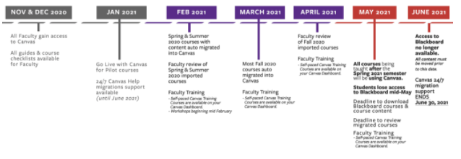
Question from Rebecca Hart (SGA rep): Would anyone do a town hall for the student body to be able to ask questions?
Response from Eli Collins-Brown: Yes, please contact Annette Parris to help schedule this.

S/U Data Analysis Report: Larry Hammer
S/U Grading
Spring 2020 & Fall 2020

Total Submissions:

Spring 2020 | 1914
Fall 2020 | 1566

Total Number of Grades Converted:

Spring 2020 | 3249
Fall 2020 | 2853

Total Number of Students Who Submitted Requests:

Spring 2020 | 1709
Fall 2020 | 1381

Percentage of Students Who Requested All Grades vs. Some Grades Converted:

 | All | Some
Spring 2020 | 7.4% (126) | 92.6% (1583)
Fall 2020 | 7.9% (109) | 92.1% (1272)

Total Number of Students Who Requested S/U in Spring 2020 and again in Fall 2020:

468

Percentage of Students Who Improved Academic Standing with S/U Conversions:

Spring 2020 | 21.2% (362)
Fall 2020 | 16.7% (231)

*Registrar’s Office is continuing to accept requests for both semesters
Larry Hammer shared that in his mind, if there is a need for the students, the registrar's office is prepared to offer that assistance in any way. His personal opinion is that these are different times and just like some other actions we have taken, we are ready and not concerned by this potential action. At the end of the day, we record the grade, and this is just a different view of the mark to reflect the students’ performance. We can revert back if necessary. A big factor for consideration is really student peace of mind. We want them in the classroom, focused on learning. You are not your grades; it is what you learn that is important.
Comment from Mariana Fisher: We need to also take into account some unintended consequences of this action. In nursing, how do we differentiate the GPA? How do we calculate the S/U to evaluate for admissions, especially for graduate programs? While we are supportive of protecting the students, we need to make sure students are aware of consequences that could come from this action. How do we from admissions take the S/U into account when we are trying to determine the point value of the grade? This could potentially be damaging to the students ability to be accepted into a specific graduate program.
Question from Enrique Gómez: Can students revert back to a letter grade from S/U?
Response from Larry Hammer: We are not sure that all institutions do their data that way, but WCU students are able to revert back to the letter grade if they ask to do that.
Question from Carrie Fisher: Is there a time restriction?
Response from Larry Hammer: We have not established a time restriction. The preference is not to bound it with a time policy.

COUNCIL and COMMITTEE REPORTS
Academic Policy and Review Council: Chair Roya Scales
APRC continues to work on curriculum items. There are 32 for review on our March 3rd agenda.
We are working on the non-curricular taskforce report from April 2019 and are making progress. Enactment should begin in Fall 2021.
We are working on UCC membership. We will contact CONEC to get the positions on election ballots for spring.
On March 3rd, we will be discussing a revision to ENG proficiency requirements.

Collegial Review Council: Chair Carrie Rogers
We have been meeting twice a month. We conducted and closed a survey regarding the TPR site, with a 60% response rate, and are going through the findings with Associate Provost Brandon Schwab’s office.
We are looking at handbook language and there will be a resolution coming forward soon.
There will be a COVID impact statement coming forward as well that we are working on with Associate Provost Brandon Schwab. We would like to see an impact statement where the responsibility in the creation of it is shared across constituents. There is a concern that we do not want to burden faculty with more work.
Question from Enrique Gómez: What is the impact on DCRD language on non-tenure track pathways?
Response from Carrie Rogers: We will need to revise the DCRD again in the future. Drew Virtue is working on a subcommittee with the English department to draft the language.
Kadence Otto shared that the pathways are meant to help faculty and not harm them. We should pass this along to our faculty that are concerned and let them know that they are not going to have negative repercussions.

Faculty Affairs Council: Chair Sean Mulholland
Our wonderful 6-year graduation rate is a result of decades of investment in people. Over the last 20 years, the real investment in people has been falling at the system level. The result is a real decline in salaries/compensation at WCU for faculty and for staff.
Sean Mulholland presented a PowerPoint titled Investment in Our People to show the data.
Comment from Laura Wright: Thinking about the impact this has on the state of North Carolina, this is a problem impacting faculty across the system and the entire state.
Comment from Kadence Otto: She has spent much time thinking about what else we could be doing with our time outside of doing all this research and compiling this data to make an argument. This is concerning.
Comment from Sean Mulholland: This is not a unique issue to WCU, it is across the board. Other institutions are doing a little here and there and compounding it really adds up. We are falling behind and continue to fall behind.
Comment from Vicki Szabo: There are WCU problems. Other institutions have found ways to give adjustments...
Comment from Sean Mulholland: Cost of living is a big issue as well here in the area; there will be more information coming on this soon. NC Promise money is being treated as a one-time thing, and this ties the hands of the Chancellor and Provost.
Comment from Kadence Otto: What would happen if all faculty decided they were just going to do 3:3 load, scholarship, and service? This would really expose an issue. We have been covering up with bandaids. We have to make a decision as a unified front and say we are not doing all this extra stuff for free.
Comment from Sean Mulholland: The standing committee that Provost Starnes is on for faculty compensation is going through a number of ways to address these issues of compensation, and faculty is not alone in this.
Question from David de Jong: What would happen if a group of employees strike?
Response from Kadence Otto: We can do a sit-in. What is the faculty comfortable with? At minimum, we need to say we cannot be taken advantage of anymore...all these extra duties have to go. It is personal and we have to think about this.
Comment from Rebecca Hart (SGA rep): Seeing the data is disheartening. At ASG, we have talked about this as a problem across the state. Please share the data with us. ASG is in favor of standing behind you and pushing it to the Board of Governors.

Rules Committee: Chair-Elect Laura Wright
There will be a resolution coming for the next meeting. We have looked at aspirational peers and there is a vast expanse of committee structures. Enrique Gómez has done some research and we are trying to determine how many committees is the right number. Here is what we have found:
Aspirational Peer Institutions FS Committees:
Central Washington University: 15K students (8)
- Executive
- Academic Affairs
- Budget and Planning
- Bylaws and Faculty Code
- Curriculum
- General Education
- FS evaluation and assessment
- Faculty Legislative Rep.
Eastern Washington University: 13,500 students (3)
- Academic Senate
- Executive
- Rules
Ferris State University: 14,200 students (16 – but it’s hard to tell if these are all senate committees)
- Academic Policy and Standards
- APRC
- Academic Senate Executive
- Arts and Lectures
- Athletic Advisory
- Distinguished Teacher Award
- Faculty Research
- International Education
- Library/Historical/Archival
- Professional Development
- Senate Diversity
- Student Life
- Health Promotion and Substance Abuse Prevention
- University Assessment
- University Curriculum
- University Graduate and Professional Council
Indiana State University: 13,600 students (8)
- Administrative Affairs
- Arts Endowment
- Curriculum and Academic Affairs
- FAC
- Faculty Economic and Benefits
- Graduate Council
- Student Affairs
- University Research
St. Cloud University: 15,500 students (7)
- Academic Calendar
- Assessment
- Center for Excellence in Teaching and Learning
- University International Advisory Council
- Alnwick Castle Advisory Group (study abroad in England)
- Student Success Steering
- University Curriculum
University of Central Arkansas: 12,000 students (5)
- Executive
- Committee on Committees
- Academic Affairs
- FAC
- Diversity, Equity, and Inclusion
Western Illinois University: 9400 students (4)
- Executive
- Budget Transparency
- Senate Nominating
- Committee on Provost and Presidential Performance
Also has 8 councils:
  - Admission, Graduation, Academic Standards
  - Campus Planning and Usage
  - Curricular Programs and Instruction
  - General Education
  - IT
  - Intercollegiate Athletics
  - International Education
  - Writing Instruction in the Disciplines
Western Kentucky University: 20K students (7)
- Academic Quality
- Budget and Finance
- Faculty Welfare
- Colonnade General Education
- Graduate Council
- Senate Executive
- Undergraduate Curriculum
Also has two non-standing:
  - Athletics
  - Benefits
University of Tennessee at Chattanooga: 11K students (20)
- Athletics
- Budget and Economic Status
- Course Learning Evaluations
- Faculty Administrative Relations
- Faculty Grants
- Faculty Handbook
- Faculty Rating of Administration
- Faculty Senate Executive
- General Education
- Grade Appeals
- Honor Court
- Learning Environment
- NonTenure Track Faculty
- Student Media Board
- Undergraduate Academic Standards
- Undergraduate Admissions
- Undergraduate Curriculum
- Undergraduate Petitions
- 9-Month Faculty Leave
- Fall 2020 Attendance Policy
Central Oklahoma: 17K students (6)
- Faculty Handbook/Academic Affairs
- Personnel Policies/Adjunct Affairs
- Faculty Welfare
- Student Relations, Alumni & Community Service
- Research, Information Resources, and Technology
- Faculty Senate Officers/Exec. Committee/Budget Committee
Colorado Springs: 12,400 students (12)
- Educational Policy and University Standards
- Personnel & Benefits
- Budget
- Non-Tenure Track Faculty
- Misconduct in Research
- Minority Affairs
- Women's Committee
- Teaching with Technology Committee
- Intercollegiate Athletics
- Sustainability
- PRIDE (advocate for LGTBQIA+)
- Committee on Research
North Florida University: 16K students (12)
- Executive Committee (EC), chaired by the FA Vice President and responsible for setting FA meeting agendas.
- Academic Programs Committee (APC), responsible for all curricular proposals and changes.
- Academic Standards Committee (ASC), responsible for recommending academic policy.
- Adjunct Affairs Committee (AAC)
- Budget Advisory Committee (BAC)
- Campus Technology Committee (CTC)
- Faculty Affairs Committee (FAC)
- Faculty Enhancement Committee (FEC)
- Nominations and Elections Committee (NEC)
- Research Council (RC)
- Strategic Planning Advisory Committee (SPAC)
- Support Services Committee (SSC)

Senate Report: Chair Kadie Otto
Provost Starnes and Kadence Otto reviewed data from across the system, and specifically, the role of the Faculty Senate Chair. The chair is currently provided a 2:2 course reduction. We will be adding a $4,000 stipend to the chair position starting Fall 2021. Kadence Otto urged folks to think about the new addition if they are considering this role. We are hoping for a competitive election. We are working with Associate Provost Brandon Schwab and his office to make the change in the handbook.
The Faculty Assembly has said they are willing to put Sean Mulholland and Heidi Dent on the agenda for their April meeting. This means, we will reach the whole system on the issue of compensation.

Three to four weeks ago, we issued a call for comments from the general faculty on their pay. We compiled the data to look for trends. At the Board of Trustees meeting, Sean Mulholland will present quantitative work, and Kadence Otto will present the qualitative work.

Kadence Otto’s report is shared below.

The Investment
Kadie Otto, Chair of the Faculty Senate
Report to the WCU Board of Trustees
Friday, March 5, 2021
I’m glad we’re all on the same team—we agree there is a compensation crisis in N.C. higher education. And, I venture to say, we agree that if investments are not made, faculty, who are experts in their respective fields and who train our students to become leaders in their fields, will go elsewhere. Thus, at minimum, a sustained cost-of-living increase plus 1% is not a cost—it’s a smart, necessary investment.
Working 9-to-5
Most people work a traditional 9-to-5 job. Faculty do not. Faculty have invested their time, money, energy, effort, and intellectual ability to earn the highest degree known to humankind. They are the world’s ‘thought leaders.’ They spend their careers thinking, teaching, mentoring, writing, serving, publishing, analyzing, refining, debating, studying, discussing, questioning, and problem-solving toward the goal of making this world a better place. Some faculty write in the middle of the night; others write on weekends. When their teaching duties end in May, faculty spend the summer researching, writing papers, and revamping their courses. When faculty are not doing, they are thinking. This, a blessing and a curse—a thinking mind, an aware mind, a curious mind, a problem-solving mind never turns off. Faculty work 24/7.
Our Reality
Given the above, the fact that first-year college students were just 5-years-old the last time faculty had a COL adjustment is confounding. Why isn’t N.C. investing in its future? To uncover the hardships this 13-year COL absence has had on WCU faculty, I asked them to share their stories. I received 113 emails spanning 55 single-spaced pages of text. I anonymized the data into Excel. Below are the results of the Descriptive Analysis.
Descriptive Analysis (n = 113)
Gender Male 49% Female 51%
Race Caucasian 91% Minority 9%
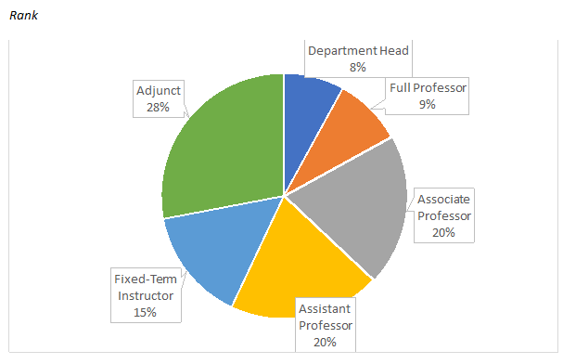
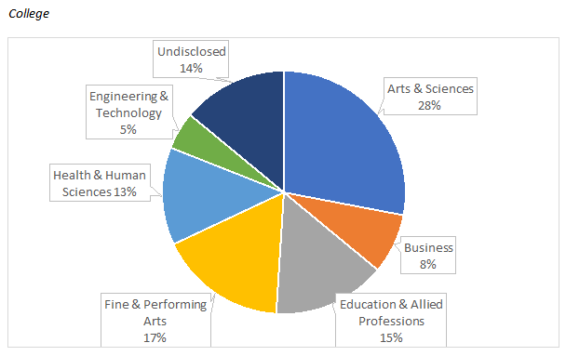
Next, I asked Dr. Heidi Dent, Faculty Senator and Assistant Professor of Marketing, to run a Thematic Analysis which revealed the overarching sentiments of the faculty.
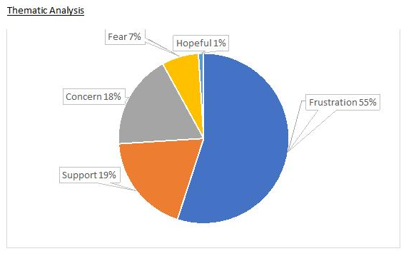
The Word Cloud Analysis below reflects the themes (underlined) that emerged; sentiment and verbiage which appeared frequently throughout the commentary surrounds each theme.
Word Cloud Analysis
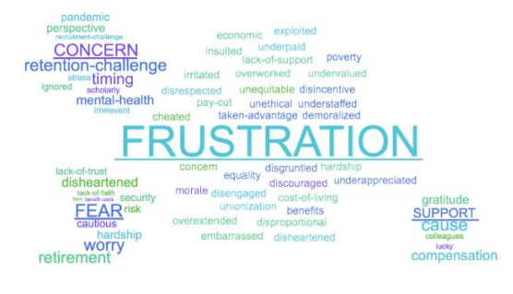
Last, based on my reading of the 113 faculty comments, I identified Key Word(s) & Key Feedback by Rank, respectively.
Key Word(s) & Key Feedback by Rank
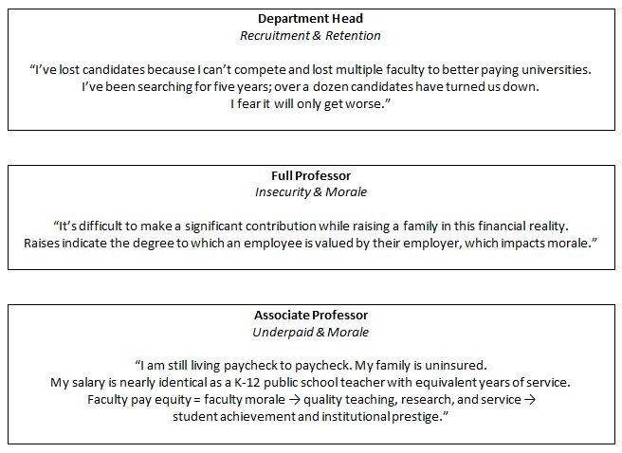
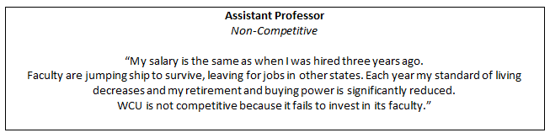
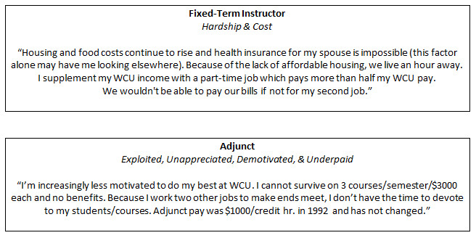
In closing, when I reflect on the time, energy, and effort faculty have put into surviving this crisis, what saddens me most is knowing what faculty otherwise would’ve been doing and thinking.

NEW BUSINESS

Resolution Recommending the Continuation of Electronic TPR process for 2021-2022

Resolution regarding Virtual Meeting & Electronic Document Guidelines 2021-2022

WHEREAS the COVID-19 pandemic has required additional flexibility to accommodate employees performing the business of the university remotely; and
WHEREAS the WCU 2020 Plan urges the review of business processes and “the transition to digital alternatives where possible”; and
WHEREAS the Provost’s office, in consultation with Faculty Senate (FS) Collegial Review Council (CRC), presented and employed the Virtual Meeting & Electronic Document Guidelines to manage the 2021-2022 collegial review process; and
WHEREAS the FS CRC must seek feedback from faculty, staff, and administrators as to their experience with as well as the strengths/weaknesses of the 2020-2021 collegial review processes; and
WHEREAS the FS CRC shall undertake a thorough review of available electronic workflow solutions available from commercial and home-grown sources; and
BE IT RESOLVED, the FS CRC recommends the 2020-2021 guidelines for the collegial review process be extended to the 2021-2022 review year and until such time as a sustainable long-term electronic TPR process can be established.

Vote proceeded and passed.

Michael Boatright | approve
Indi Bose | approve
Chancellor Kelli Brown | does not vote
Kristin Calvert | approve
Todd Collins | approve
David de Jong | approve
Heidi Dent | approve
Heather Mae Erickson | approve
Garrett Fisher | approve
Mariana Fisher | approve
Enrique Gómez | approve
Yancey Gulley | approve
Jeremy Jones | approve
Sudhir | approve
Marco Lam | approve via proxy Heidi Dent
Will Lehman | approve
Niall Michelsen | approve
Sean Mulholland | approve
Leigh Odom | approve
Kadence Otto | does not vote
Matthew Rave | approve
Carrie Rogers | approve
Roya Scales | approve
Provost Richard Starnes | does not vote
Vicki Szabo | approve
Elizabeth Tait | approve
Martin Tanaka | approve
Drew Virtue | approve
Elizabeth Wark | approve
Ashlee Wasmund | absent
Laura Wright | approve
Jessica Zellers | approve

SPL Presentation: Martin Tanaka

Martin Tanaka presented the Faculty Affairs Council’s research and direction on Student Perception of Learning (SPL) which is to replace the current SAIs.

See the full presentation.

Open Discussion on Recommendations for S/U and SAI for Spring 2021

We are going to release a survey to the general faculty next week to gain feedback on this issue.

Comment from Sudhir Kaul: Martin Tanaka and Sudhir Kaul did a survey on CET faculty, and the vote was completely split.

Comment from Martin Tanaka: One thing we talked about previously, is that it seems fair to link student assessment with faculty assessment. We should not hold faculty to SAI scores, and then not hold students to grades. We should give grace.

Comment from Sean Mulholland: In his experience, COB faculty were upset about granting S/U grading. If we lumped in SAI’s as well, I can only imagine the upset.

Comment from Indi Bose: Our department is split as well and there are good reasons on both sides.

Comment from Carrie Rogers: Do we have any data on what courses students took S/U in? What department, college, course?
Response from Larry Hammer: The information is available. In courses exempted from S/U grading, we have honored that and not allowed the S/U option.
Question from Kadence Otto: Is it difficult to add more exemptions?
Response from Larry Hammer: It is not terribly difficult. The key thing is that we try to have a consistent message to the student. We need a valid reason for exempted courses.
Comment from Provost Richard Starnes: Licensure or statutory requirements are valid reasons.
Response from Larry Hammer: How do external institutions perceive the S/U for a student when they prefer to see letter grades? This is the real question. Broadly, many institutions are doing S/U grading for a period of time and those external bodies will need to sort through that on their own. We will all be faced with those challenges regardless of whether we allow S/U grading or not.

Comment from Todd Collins: We should encourage everyone to complete the survey and respond. Get your faculty to take it. Part of the confusion last time was that we had bits and pieces, and hopefully we can get a consensus this time to make a recommendation.

Comment from Indi Bose: Part of the split has to do with the kind of classes people are teaching. In big classes, the professors lean towards S/U. Upper level classes are smaller and more personal and they don’t want to give S/U.

Question from Garrett Fisher: Some colleges/departments have chosen not to allow S/U grading. What about a permanent option moving forward? What are the implications? Some students only need to pass a class to move forward.

Enrique Gómez shared that he will have 4 questions on the survey and it should go out in the next day or so.

Rebecca Hart (SGA rep) shared that she will poll the students and look at other UNC system institutions and share the data with Kadence Otto.

MEETING ADJOURNMENT
Jessica Zellers motioned to adjourn. Leigh Odom seconded.

No objections.
Meeting Adjourned.

