5th Annual Old Cullowhee Canoe Slalom

September, 2013
13th^{th} (Practice) 14th (Event)

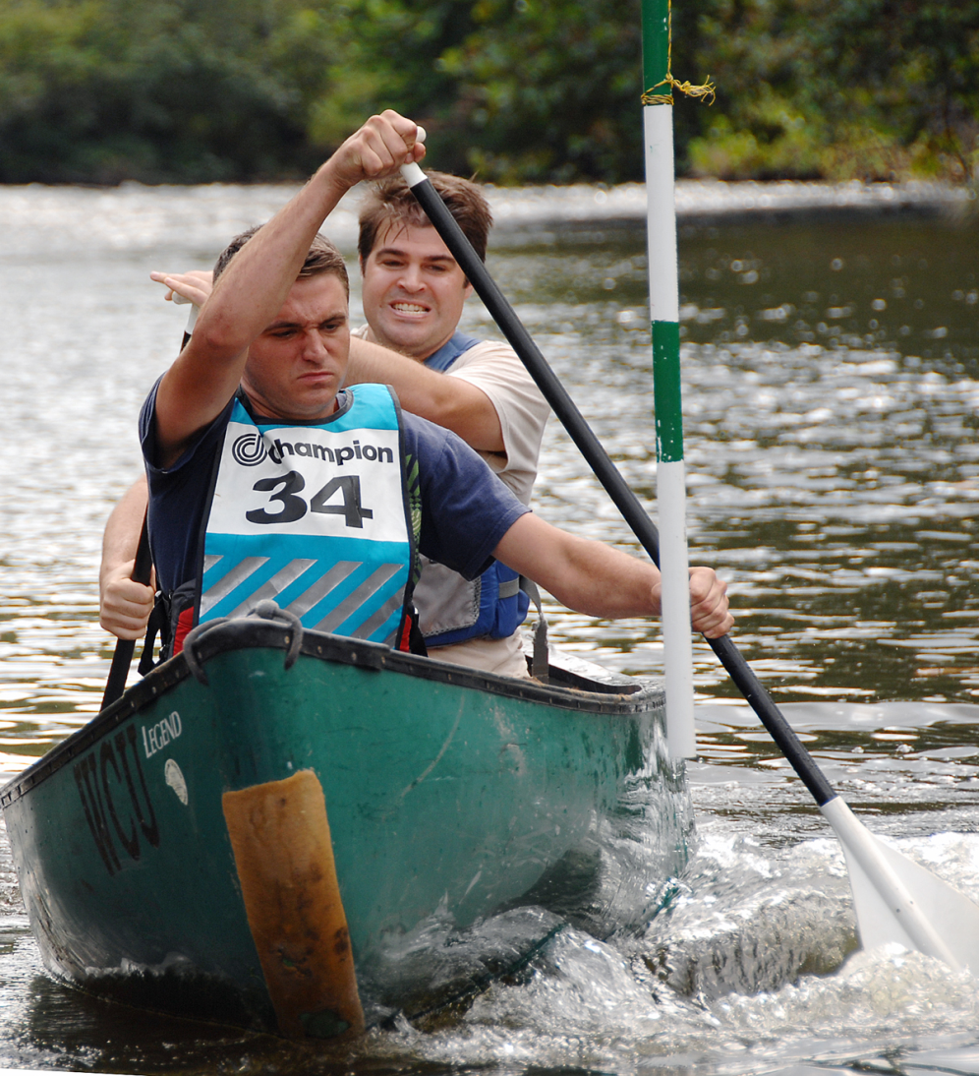

The PRM students are organizing the 5th Annual Old Cullowhee Canoe Slalom, which is a fund-raiser for the Proposed River Park. It is September 13th (practice) and 14th (Event). The event is just upstream of the bridge in old Cullowhee.

Registration ($5 per person per event) is at Base Camp Cullowhee - sign up in advance of the event to ensure a place in the race. Registrations will begin on August 20th. There will be nine “gates” to negotiate on flat but moving water.

It is a “citizens” race and as such is suitable for students, kids, and families. Canoes, paddles and lifejackets are provided. Kayakers, and paddle boarders bring your own boats. The event will begin at 9am on Saturday the 14th. Practice will be on Friday 13th^{th} afternoon and early evening.

