System Access (logging on the Banner® system)
To get to Banner®, open any browser (Internet Explorer not supported, Edge not recommended) and from the WCU Home Page, click on Quick Links then MyWCU (See Figure 1).

Figure 1: WCU Home Page

Click on MYWCU LOG IN (See Figure 2).

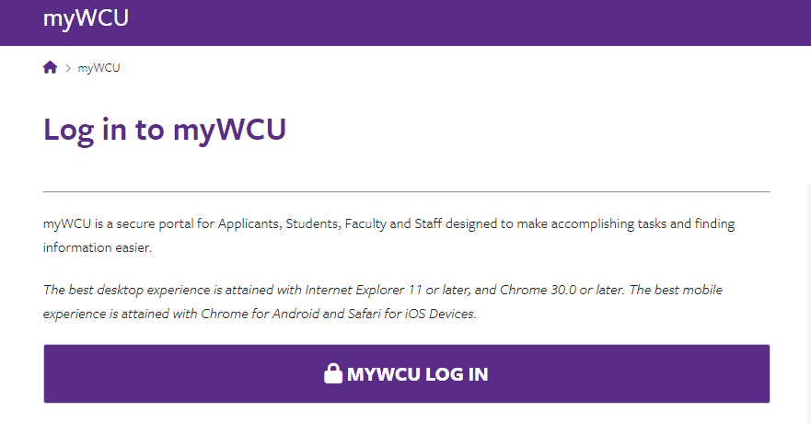
Figure 2: Log in to myWCU

Key in your user credentials (See Figure 3).

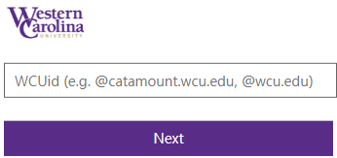
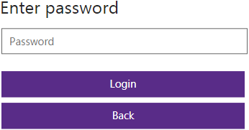
Figure 3: Enter WCUid and Password

Enter your verification code and click Sign in if asked (See Figure 4).

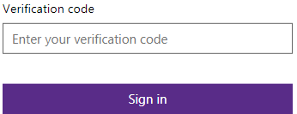
Figure 4: Enter verification code

Or use the Authenticator App approval on your phone.

Click on Internet Banner 9 Admin (See Figure 5).

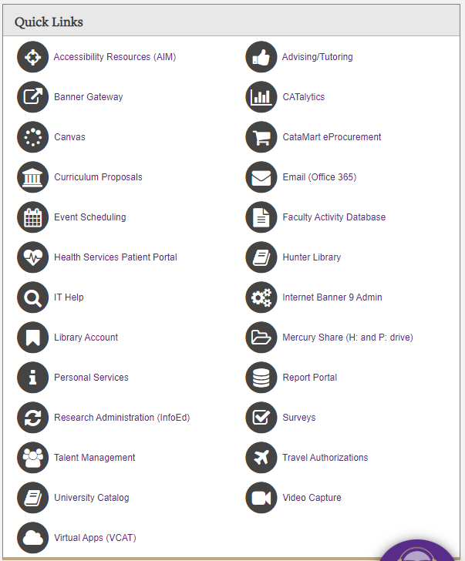
Figure 5: Quick Links

Information about Banner®

When logging into Banner®, the Banner® Application Navigator page is displayed (See Figure 6). What users do next is typically referred to as navigating within Banner®. Navigating to a page is the means for a user to (a) enter data, (b) make inquiries, or (c) run reports/processes.

Menu icon is located on the upper left corner of the page. Click on this icon to see an expanded area with a description of the icons below (See Figure 6).

Dashboard icon is the home button, select to return to the Application Navigator page from any page in Banner® (See Figure 6).

Application icon when selected list the submenus available in the system. See Menu Navigation starting on page 6 (See Figure 6).

Search icon and the Search box allow the user to enter the descriptive name of the page or the Banner® acronym for the page to be accessed (See Figure 6).

Recently Opened icon is located below the Search icon. It is displayed with a count of pages once opened on the first page in an application. Open the list and select a page to access it (See Figure 6).

Help icon gives access to Page Help, Application Navigator Keyboard Shortcuts and Ellucian Privacy Policy (See Figure 6).

Favorite icon gives a list of pages saved as favorites Refer to page 12 (See Figure 6)

Sign Out icon is clicked to log out of Banner® Refer to page 26 (See Figure 6)
Menu Icon
User icon shows profile preferences and settings (See Figure 6).
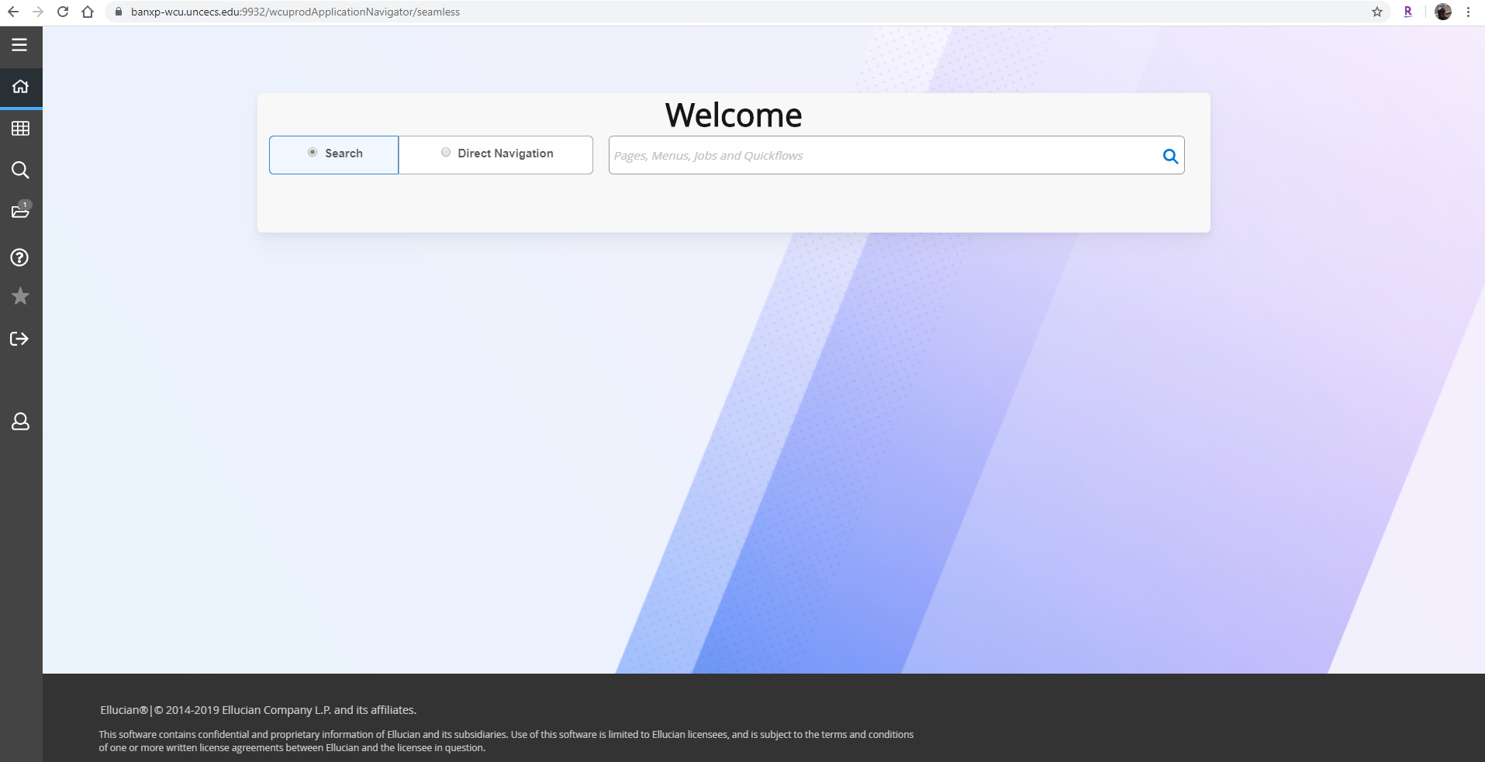
Help, Favorite, Sign Out and User Icons
Search
Icon
Recently Opened pages
(Will display once a page
has been opened)
Applications
Dashboard
Search Box
Figure 6: Banner® 9 Application Navigator

There are multiple methods of navigating within Banner®. They include:

• Menu Navigation
• Direct Access
- Favorites
- My Banner

Menu Navigation

Menu navigation first necessitates choosing a system from the Application Navigator. The Application Navigator is an arrangement of Banner® objects (pages, menus, etc.) in a logical hierarchy, by system and then by module.

To open a system menu, click the menu icon (See the arrow in Figure 7).

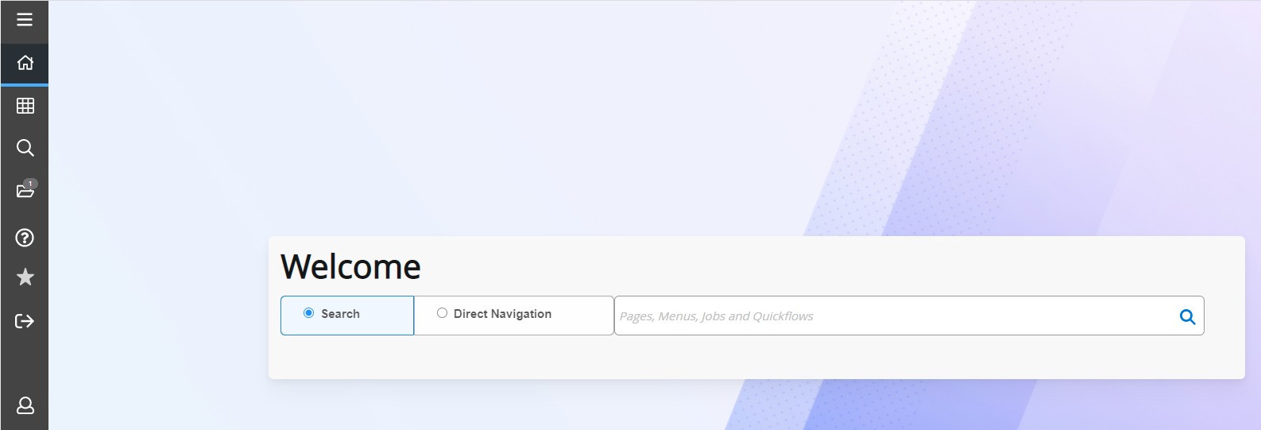
Figure 7: Banner® 9 Menu Icon

Click on Applications (See Figure 8).

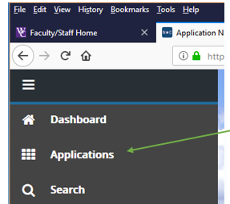
Figure 8: Banner® 9 Applications

Click on the word “Banner” (See Figure 9).

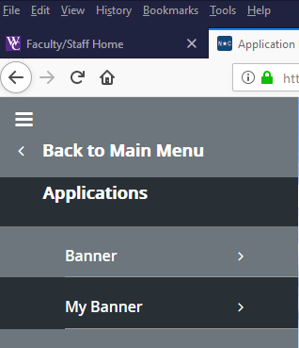
Figure 9: Banner® 9 – Banner Applications

A list of system menus will be shown. There are often multiple layers within a module (by clicking the > at the end of each menu will expand the menu, as shown in Figure 10 by the arrow).

Click the > from the Finance System Menu Screen to display the submenus in the module.
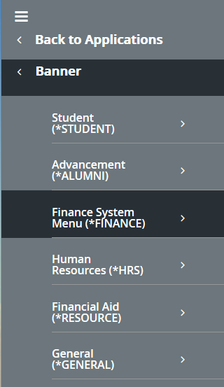
Figure 10: Banner® To get to the Finance System Menu

The submenus in the Finance Menu are displayed (See Figure 11).

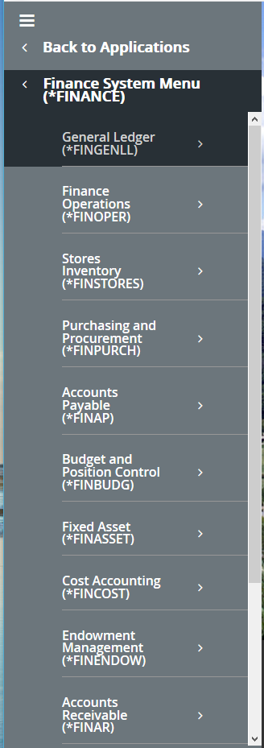
Figure 11: Banner® 9 Finance System Menu.

(See Figure 12 to see pages within Finance Operations submenu).

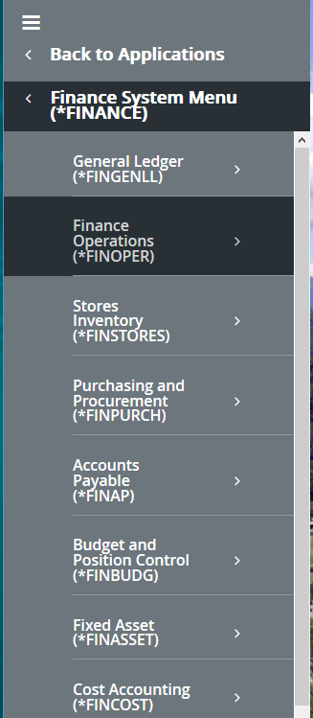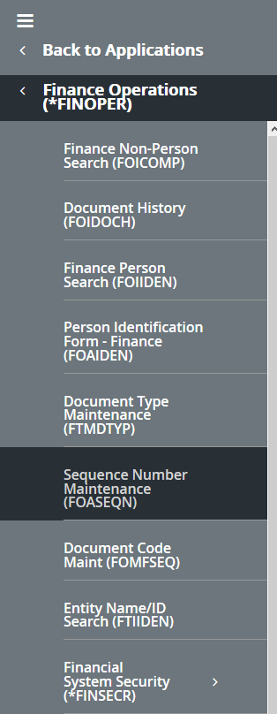
Figure 12: Banner® 9 Finance Operations Pages

Once the page is displayed, click one time on the name of the page needed to open it.

Direct Access

Direct Access is entering the acronym of the page (e.g., FOIDOCH, FAIINVS, FGIBDST, etc.) in the search box and press enter. (See Figure 13).
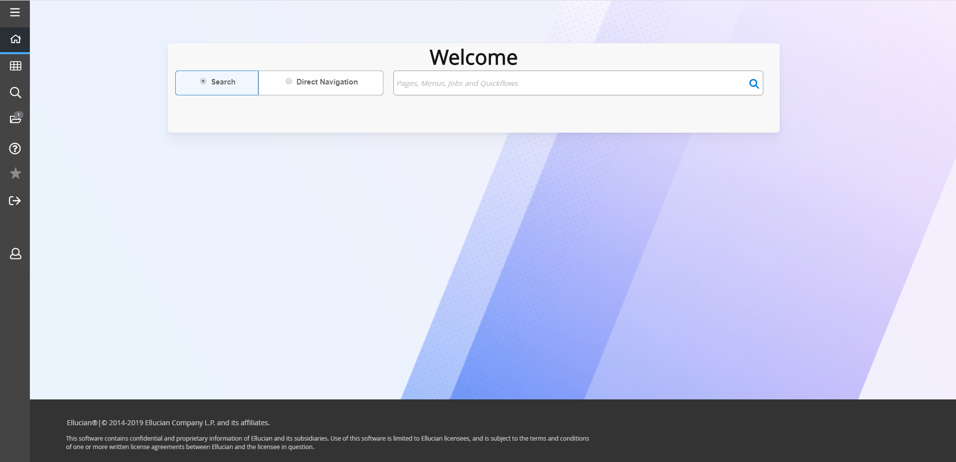
Search Box (on Application Navigator)
To get back to the Main Screen at any point, click on the Home Icon
Figure 13: Banner® 9 Application Navigator

Type the name of the page and press ENTER or select from the pages listed. To see additional pages, use the up and down arrows to the right of the page list (See Figure 14). (To learn more about pages/process names, see the Banner® naming conventions on pages 22 and 23).
To access pages using Direct Access from within a page, click the magnifying glass at the top left-hand side of any screen, enter the page name and press ENTER or by clicking on the displayed page name. Banner® displays the page, if access has been granted.

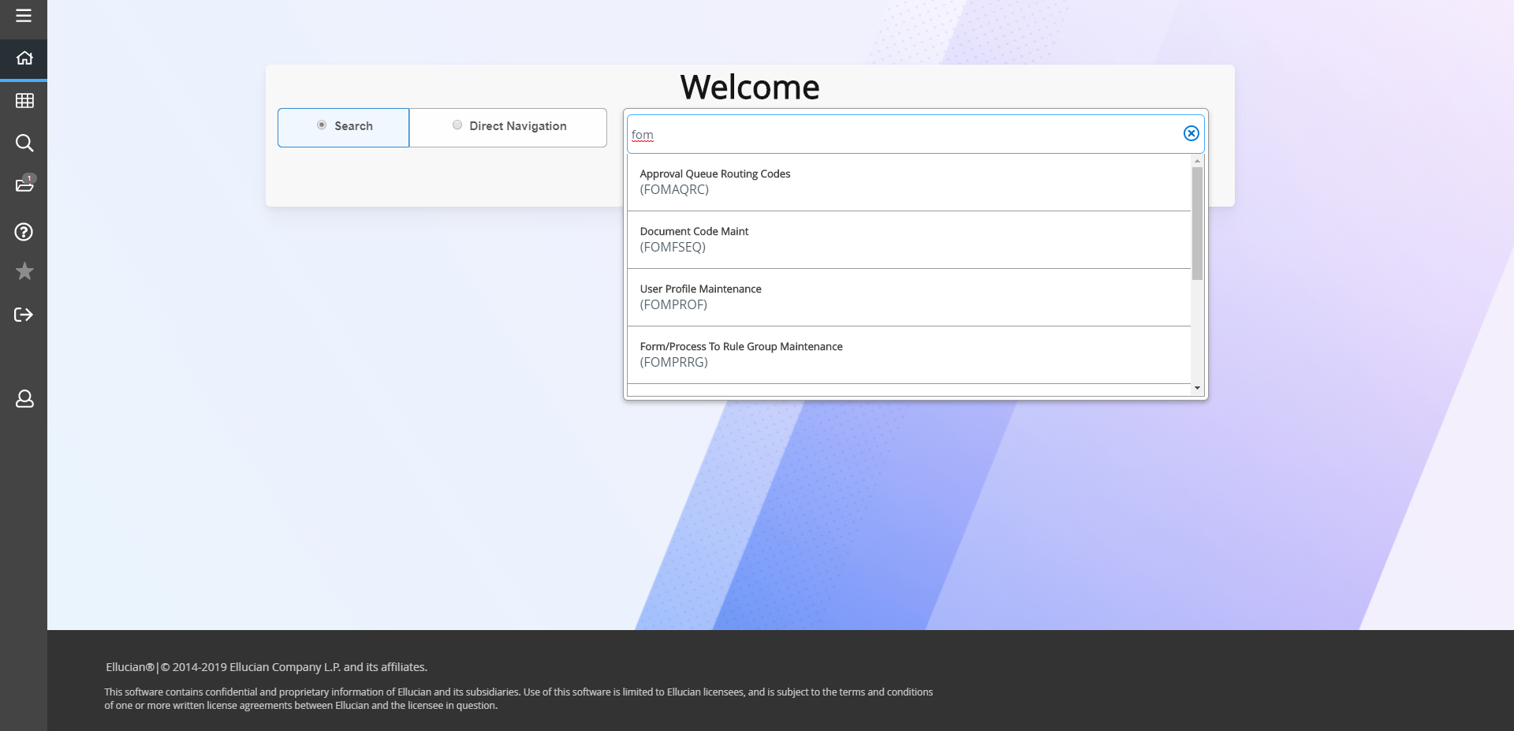
Up and Down Arrows
Magnifying Glass
Figure 14: Banner® 9 Search Box

Favorites Access

Favorites Access is done by selecting the icon beside the page you want to add to the list of pages used frequently (See Figure 15). When the icon is shaded in it adds the page to your favorites (See Figure 16). To access the favorite list, select the icon on the menu ribbon (See Figure 17).

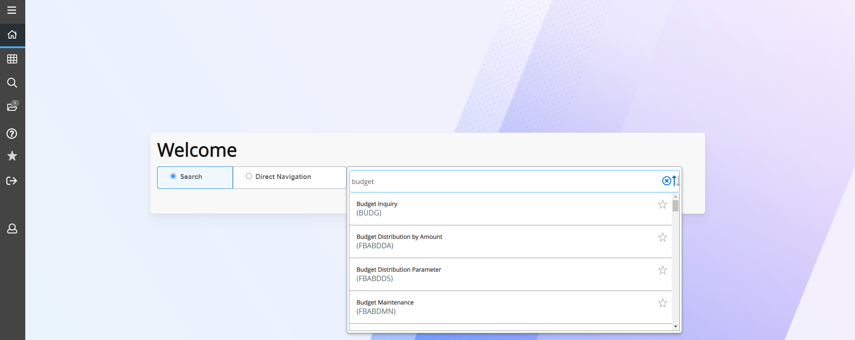
Figure 15: Banner® 9 Favorites

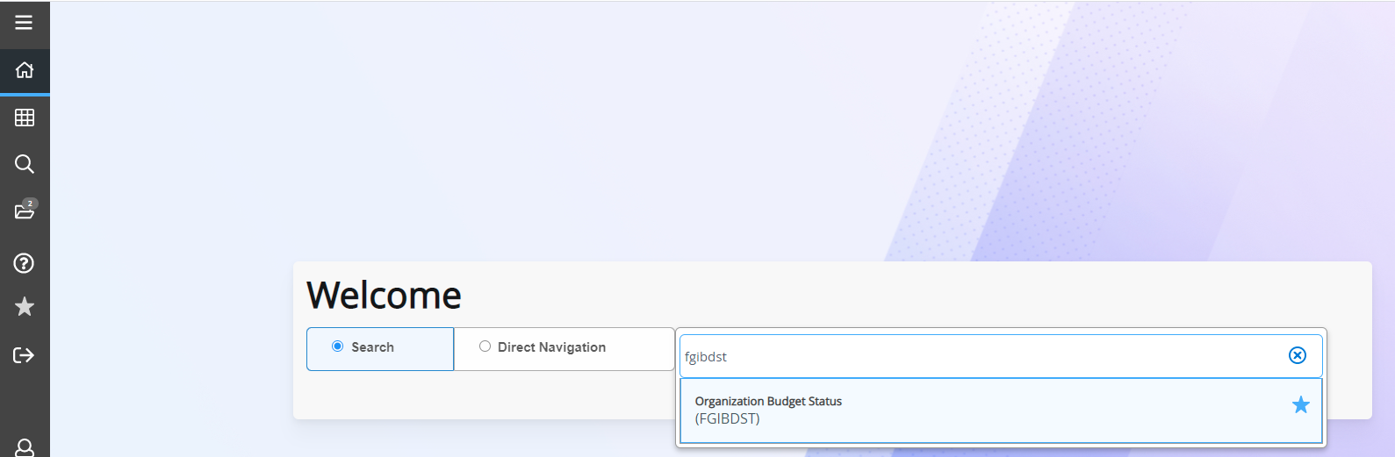
Figure 16: Banner® 9 Favorites

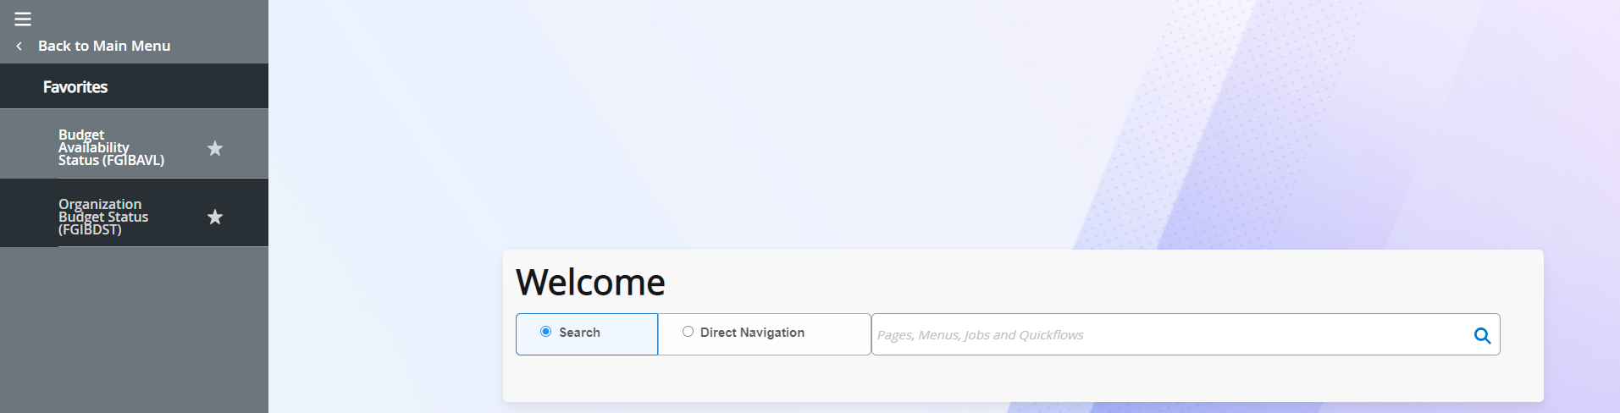
Figure 17: Banner® 9 Favorites

My Banner

To create “My Banner” begin from the Application Navigator and type in the words “My Banner”. Click on “My Banner Maintenance” (See Figure 18).

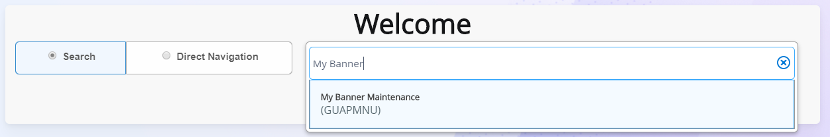
Figure 18: To Access My Banner Maintenance

If Banner® shortcuts has not been set up, the right side of the screen will be empty. (See Figure 19).

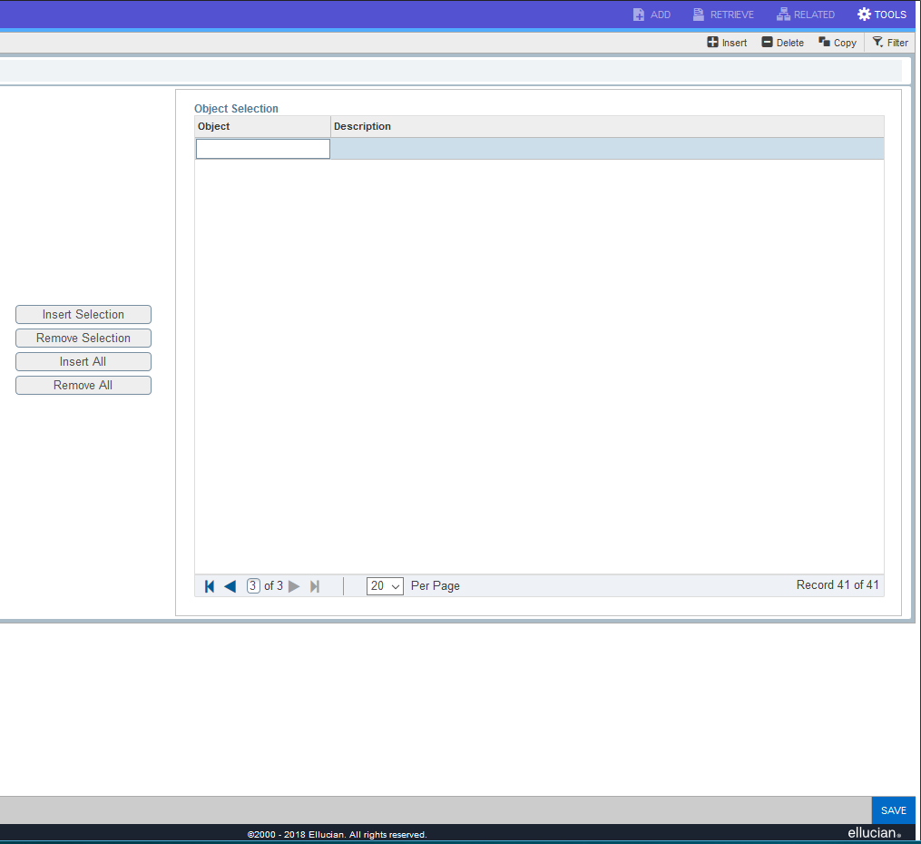
Figure 19: Right Side of My Banner Maintenance Screen

To add items to My Banner, type the page acronym into the object field on the right-hand side of the screen and press the Tab key once. Once entered correctly the page and the description will automatically be displayed (See Figure 20).

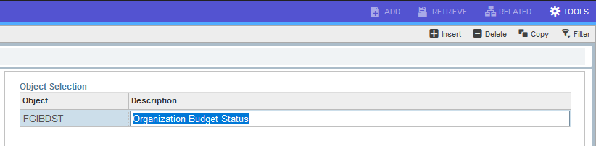Figure 20: Object FGIBDST and Description

To enter another “Object” select “Insert” one time or use the down arrow on the keyboard (See Figure 21).

Figure 21: Insert Button

Key in “Objects” one at a time. If “Insert” is clicked multiple times and click “Save” an error message will be displayed (See Figure 22).

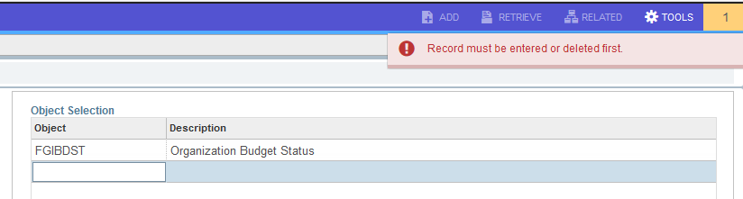
Figure 22: Error Message

After selecting the pages to put in “My Banner”, click “Save” in the bottom right corner of the screen (See Figure 23).
Figure 23: Save Button

Once saved, a message will display “Saved successfully” and how many rows it saved (See Figure 24).

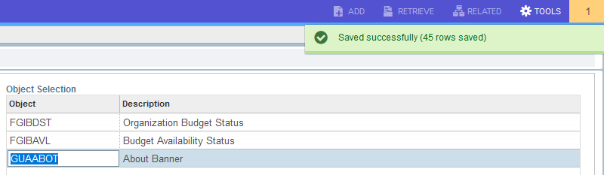
Figure 24: Save successfully message

To see the changes just made, log out of Banner® and log back into the system. Close any pages by clicking on the page close icon in the Page Header (See Figure 25).

Figure 25: Page Header

Refer to page 26 for Log Off instructions

Once logged back into Banner®, the items placed on the right-hand side will be displayed in “My Banner”. Click on the Menu Icon, click Application Navigator, and select “My Banner” to see pages saved. (see Figure 26).

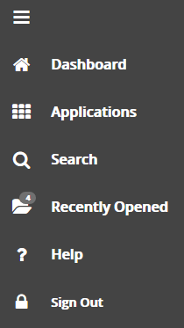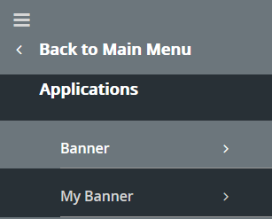
Figure 26: My Banner Maintenance Screen

Once opened the screen will look like Figure 27 below (if same page names were used).

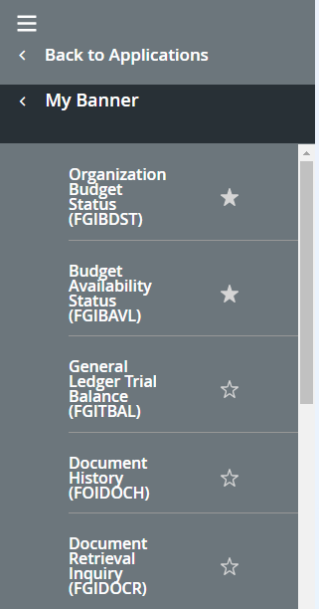
Figure 27: Personalized “My Banner” Links

Click the page name to access the page.

Banner® Page Design

Banner® is composed of pages. Pages are what might also be referred to as screens or windows. Think of Banner® pages as paper forms. Each page represents a specific body of information, such as a name and address page or class schedule page.

Every page has the following parts:

- Page Header
- Key Block
- Sections

Every page has a unique 7-character acronym (e.g., FGIDOCR) and a description of the page (e.g., Document Retrieval Inquiry page) (See Figure 28).
Icons/Menus

Page Name
Key Block
Page Header/Close Icon

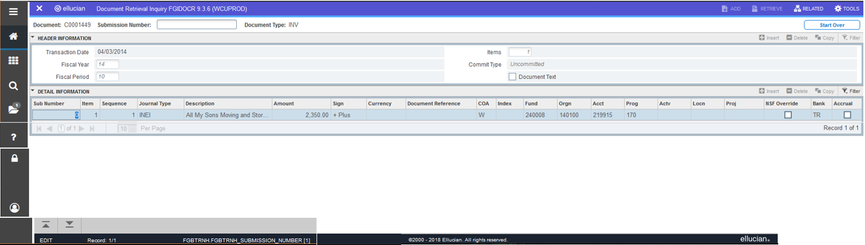
Sections
Previous and Next Section Buttons
Section Icons
Figure 28: Page Navigation

The Page Header contains the following:
- Page close icon will close the current page and return to the last page open.
- Page name
- Add and Retrieve icons, are used with Banner® Document Management – not used by WCU so greyed out.
- Related Menu, which displays a list of pages that can be accessed from the current page
- Tools Menu, which includes refresh, export, print, clear record, clear data, item properties, display ID image, about Banner, and Banner Document Management that includes Retrieve Documents, and add documents.
- Notification Center – is located to the right of the Tools menu and displays information as needed like warning messages, error messages, informational messages, successful save of data. When this feature is available, click in the box with the number in the page header to open or close the Notification Center.

The Key Block is the first block on most pages that contains key information. The key block determines what data is entered or displayed on the rest of the page. All the information on the page is related to the key block. The key block stays on the page as subsequent sections are displayed.

To access the body of the page, populate the key block data and click GO. Return to the key block and possibly make search changes from the body of a page by clicking Start Over.

Sections are pages divided into parts that contain additional details about the key information. A section can represent one record or multiple records depending on the type of information being worked on. Each section contains related information. These sections of data are accessed by scrolling up and down the page. They can be opened or collapsed by clicking on the arrow on the far-left side of the section header. Some sections are accessed by using tabs that group information in a meaningful way.

Banner® 9 transformation includes several buttons. (See Figure 29)

Button | Description
Go | Use the Go button to advance to the body of the page after populating the key block.
Save | Use the Save button to save changes on the page. The Save button is located on the bottom right side of the page.
Section Navigation | Use the Next Section button to navigate to the next section of data. Use the Previous Section button to navigate to the previous section of data. The Next Section and Previous Section buttons are located at the bottom left of each page.
Select and Cancel | Use the Select button to select and retrieve data from a called page to the current page. Use the Cancel button to return to the called page without retrieving any data. When a secondary or called page is needed to retrieve data, Select and Cancel are presented at the bottom of the page.
Start Over | Use the Start Over button to return to the key block of the page.
Figure 29: Button Descriptions

Required fields have an asterisk (*) displayed next to a field name indicating the field requires a value before continuing the page.

The Lookup feature allows user to quickly look up a value for a field. The Lookup button next to a field indicates the field has the Lookup feature (See Figure 30). Click the Lookup button, enter a filter value, and press Enter to display results that match the filter criteria. Select a value and click OK or double-click a value to return the value to the calling page (See Figure 31 on next page).

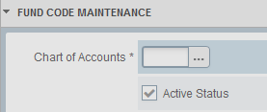
Lookup button
Figure 30: Banner® 9 Lookup Button

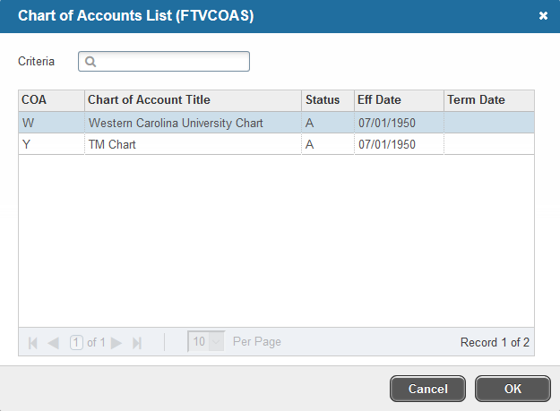
Enter a filter value if needed. In this case, only two records are showing so no filter is needed.
Figure 31: Banner® 9 Lookup Button results

When working within the pages, Banner® gives hints along the way. These hints display what actions can (or are required to) be taken at any given time. In Figure 32, it informs the user by pressing “F8” it will execute this query.

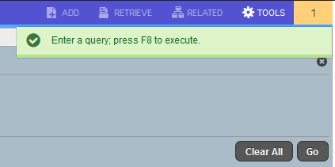
Figure 32: Banner® 9 Hint Box

If an action is pressed that is incorrect, a red box will appear as shown in Figure 33 below.

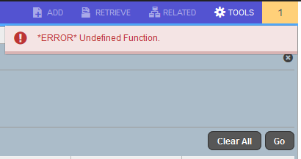
Figure 33: Banner® 9 Hint Box Showing an Undefined Function

Keyboard Functions and Keystrokes

Function | Key Stroke
Next Field/Item | Tab
Previous Field/Item | Shift + Tab
Up | Up arrow
Down | Down arrow
Previous Page Up | Page Up
Next Page Down | Page Down
First Page | Ctrl + Home
Last Page | Ctrl + End
Page Tab 1, Page Tab 2 | Ctrl +Shift+1, Ctrl + Shift +2,..
Edit | Ctrl + E
Choose/Submit/Action | Return/Enter
List of Values | F9
Cancel Page, Exit,  Close Current Page,  Cancel Search or Query | Ctrl + Q
Save | F10
Clear One Record | Shift + F4
Delete Record | Shift + F6
Duplicate Selected Record | F4
Insert/Create Record | F6
Clear All in Section | Shift + F5
Open Menu Directly | Ctrl + M
Next Section | Alt + Page down
Previous Section | Alt + Page up
Duplicate Item | F3
Clear Page/Start Over | F5

Helpful Hint: When clicking on Review Output, press F10 to open output into browser.

Function | Key Stroke
Search/Open Filter Query | F7
Execute Filter Query | F8
Export | Shift + F1
Print | Ctrl + P
Refresh/Rollback | F5
Change MEP Context | Alt + Shift + C
Open Related Menu | Alt + Shift + R
Open Tools Menu | Alt + Shift + T
More Information | Alt + Shift + U
Application Navigator Display Open Items | Ctrl + Y
Application Navigator Search | Ctrl + Shift + Y
Application Navigator Help | Ctrl + Shift + L
Application Navigator Sign Out | Ctrl + Shift + F
Copy | Ctrl + C
Cut | Ctrl + X
Paste | Ctrl + V
Undo | Ctrl + Z
Redo | Ctrl + Shift + Z
Cancel Action | Esc
Select on a Called Page | Alt + S
Retrieve BDM Documents | Alt + R
Add BDM Documents | Alt + A
Submit Workflow | Alt + W
Release Workflow | Alt + Q

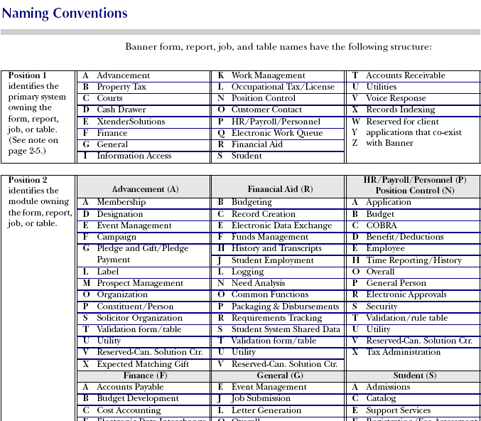

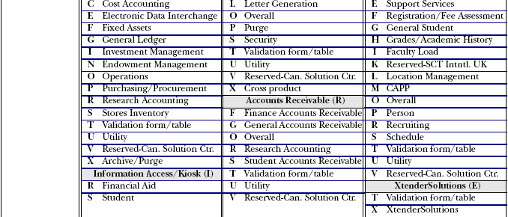

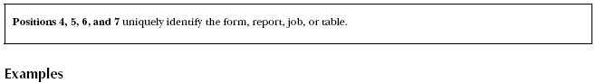
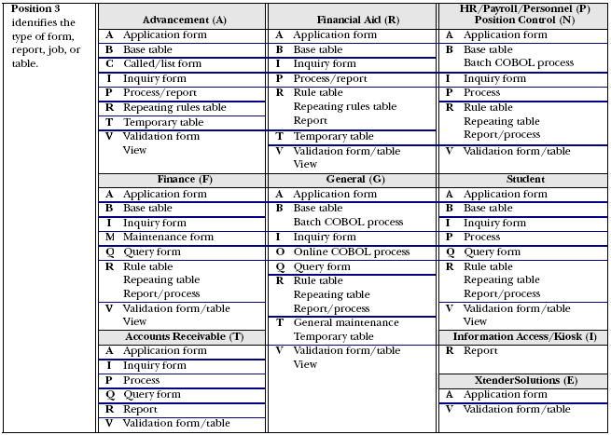

FOIDOCH |  |  |  | FAIVNDH |  |  |  | FAIVHIS
F |  | Finance |  | F |  | Finance |  | F |  | Finance
O |  | Operations |  | A |  | Accounts Payable |  | A |  | Accounts Payable
I |  | Inquiry |  | I |  | Inquiry |  | I |  | Inquiry
DOCH |  | Document History |  | VNDH |  | Vendor Detail History |  | VHIS |  | Vendor History Query
FAIOINF |  |  |  | FGIBDST |  |  |  | FGITRND
F |  | Finance |  | F |  | Finance |  | F |  | Finance
A |  | Accounts Payable |  | G |  | General Ledger |  | G |  | General Ledger
I |  | Inquiry |  | I |  | Inquiry |  | I |  | Inquiry
OINF |  | Open Invoices by FOAPAL |  | BDST |  | Budget Status |  | TRND |  | Detail Transaction Activity

Following are “screen-shots” from several common pages used in Banner® Finance, along with comments to assist in the process.

FGIBAVL – Budget Availability Status 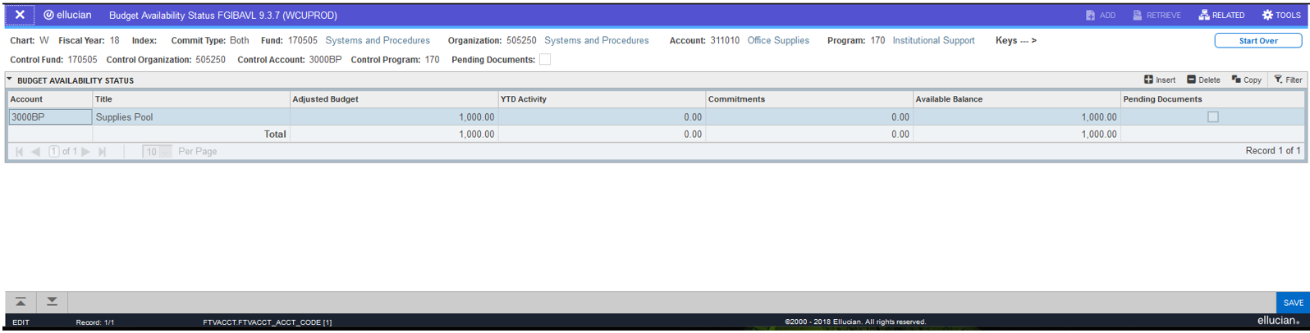

On this page (FGIBAVL) the Chart, Fiscal Year, Fund, and an Account are required, before selecting the “GO” command. This page is used to view the actual available balance of all account codes associated with the fund. This information is very helpful before submitting a requisition.

FGIBDST – Organizational Budget Status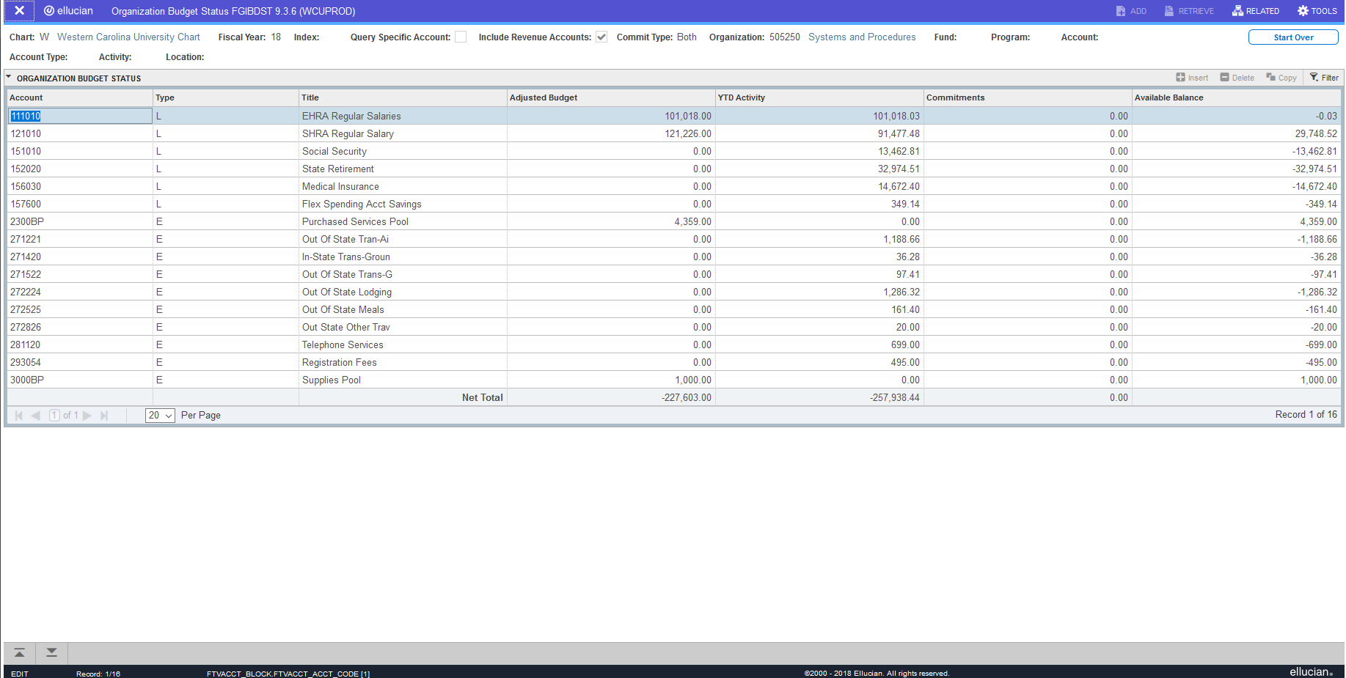

On this page (FGIBDST) only the Chart and Fiscal Year are required. The page (FGIBDST) is very useful for inquiring about budgeted items at the organizational level. When this page is specified, Banner® automatically populates the Chart and the Fiscal Year fields. Tab to the “Organization” field or the “Fund” field, enter the six-digit number and select “GO”. Banner® displays the information as shown in the example above. If a fund number is specified, Banner® will automatically fill in the associated organization and program numbers.

FOIDOCH – Document History

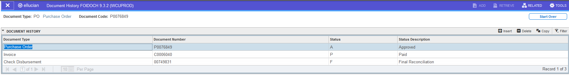

This page requires the document type and number, such as a purchase order, invoice, check, etc. For example, suppose we want to know about purchase order P0076849. Using FOIDOCH, enter PO for the Document Type, P0076849 for the Document Code, then select “GO”. Doing so would cause the FOIDOCH inquiry page to display the above screen shot.

FGIDOCR – Document Retrieval Inquiry

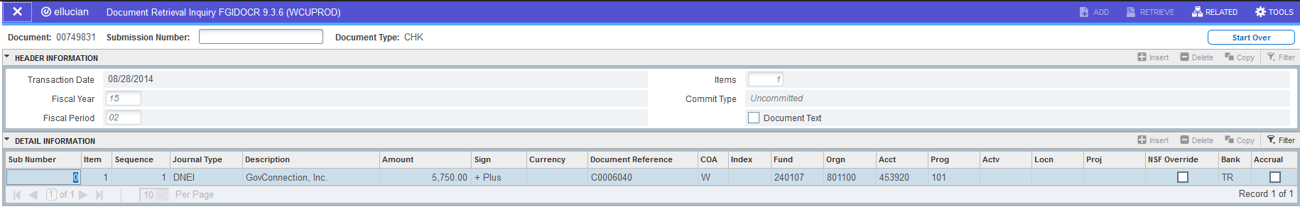

This page requires the document number only. Enter the document number and select “GO”. In this example, we wanted to know about document 00749831, a check.

FGITRND – Detail Transaction Activity

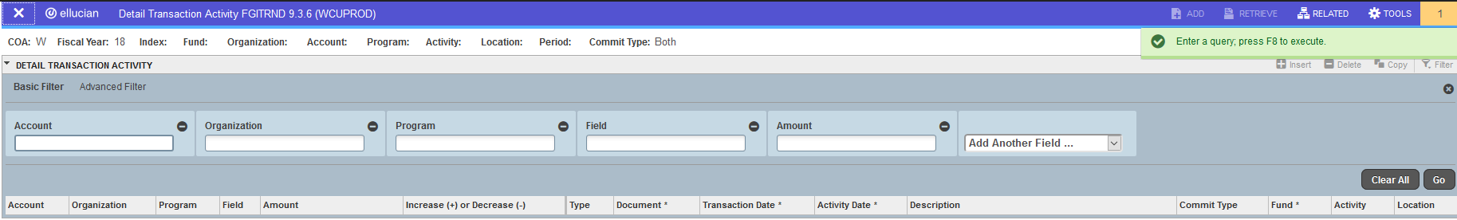 Technically, this page doesn’t require anything to be entered, because Banner® auto populates the Chart designation and the current fiscal year values. For practical purposes, however, it is advisable to enter values for the FOAPAL elements to see any activity on it. A FOAPAL element is any designation of a Fund, Organization, Account, Program, Activity, or Location. Press F8 to execute query.

Logging off Banner®

To log off Banner®, close all pages by clicking the home button located on the left hand of the screen. (See Figure 34).

Home Button
Figure 34: Banner® 9 Tool Bar to get back to Application Navigator

When all pages are closed, the Application Navigator will be displayed.
Click the log out button on the left-hand side of the screen (See Figure 35).
Log Out Button
Figure 35: Banner® 9 Tool Bar to Sign Out

Once logged out successful, the screen will look like Figure 36 below.
Figure 36: Banner® 9 Logout Confirmation

The Log Out button is not required.
Contact information for additional help if needed:

Brian Chamberlin bchamber@wcu.edu 828-227-3479 (Systems)
Ann Green ahgreen@wcu.edu 828-227-3107 (Budgets)
Steve Marr smarr@wcu.edu 828-227-3106 (Accounting, Adjustments)
Jeri Hansen TBD 828-227-XXXX (Contracts & Grants)
Patricia Cabe-Cantrell pscantrell@wcu.edu 828-227-2576 (Contracts & Grants)
TBD TBD 828-227-XXXX (General Accounting)

Notes:

