PROJECT DISCOVERY~TALENT SEARCH

Summer 2015 College Tour Adventure
Rising Juniors & Seniors

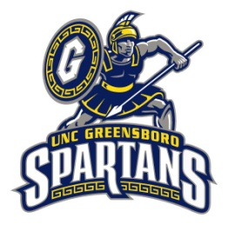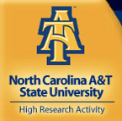

Where? UNCG, ECU, NC State, UNC, NC A&T

When? June 22 – June 24, 2015

June 22: Arrive at WCU 8:00am ~ Travel to UNCG, lunch and tour ~ Travel to ECU, stay inhotel.
June 23: Tour ECU ~ Travel to beach ~Travel to UNC, stay in hotel.
June 24: Tour UNC ~ Travel to NC State, tour ~ Travel to NC A&T, tour
Return to Project Discovery at WCU

How? We will travel by WCU bus and stay in hotels and tour colleges

Cost? Project Discovery will cover the cost of travel, food and sleeping accommodations. You might want to bring spending money for souvenirs, snacks and extras.

Who is eligible to apply? Rising Project Discovery juniors & seniors
Space is limited and preference given to upperclassmen.

Contact the Project Discovery Counselor at your school or call our office at 828-227-7137

