PRM 255-01: Active Recreation & Leisure

Parks & Recreation Management Human Services Department

Spring 2020

Course # & Title: PRM 255-01: Active Recreation & Leisure (3 credit hours)
Class Times: Tuesday & Thursday: 11:00am-12:15pm
Location: Reid 122H (lecture) Reid 112 (activity)
Instructor: Debby Singleton, M.A., PRM Instructor
Preferred Pronouns: she/her/hers
Office: Reid 122-J
Office Hours: Please check my office door for availability or schedule an appointment.
Phone #: 227-3971 (office) E-mail: singleton@wcu.edu
Teaching Assistants: Mary Grace Jarrett & Joey Gonzalez

Course Description: Active Recreation & Leisure will offer an exploration of active leisure pursuits and the connection between parks, recreation, physical activity, wellness, and public health. The course will prepare future professionals to lead, supervise, or program active leisure pursuits in a recreation setting. Learning opportunities will be experiential, engaging, cooperative, participatory, and applicable to the active recreation, leisure, and community health fields.
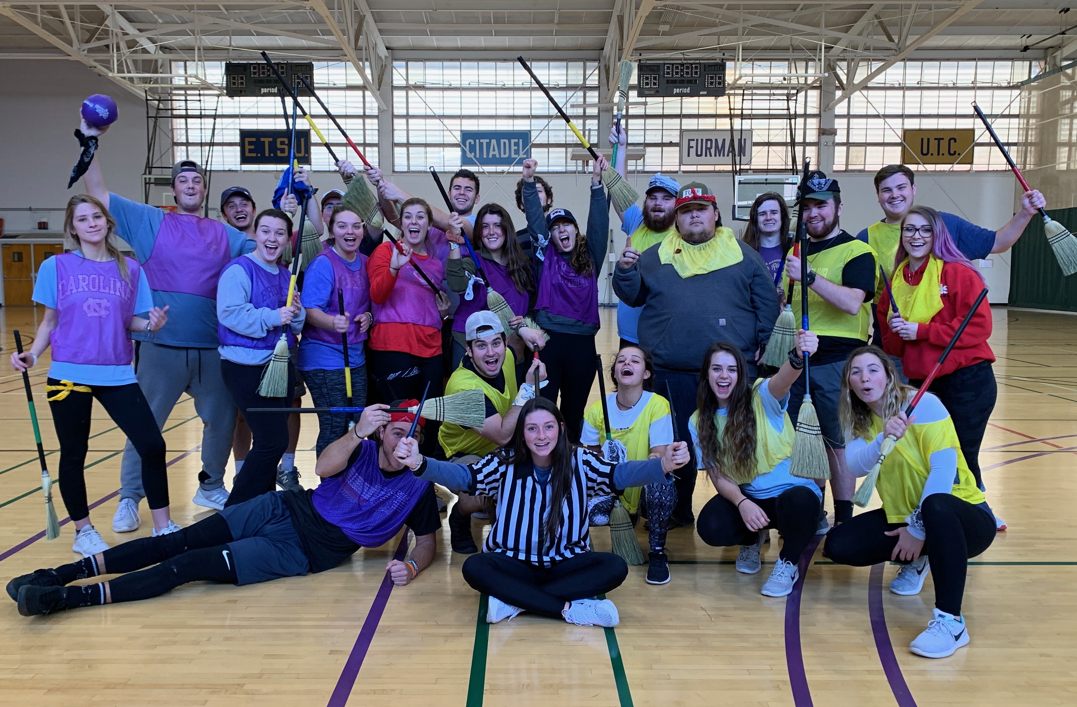PRM 255 Fall 2019, Quidditch

PRM Core Curriculum: PRM 255 is a required course for PRM majors. Students in the PRM major may select to complete PRM 254: Introduction to Outdoor Pursuits OR PRM 255: Active Recreation & Leisure. Majors may also complete both courses, yet only one will count towards the core, the other will be counted as a “guided elective”. Although this course is open to non PRM majors, non PRM students are expected to complete all assignments and requirements for the course.

*This is NOT an ACTIVITY only class. There is substantial course work to be completed in and outside of class time. Activity happens to be part of this course.

COURSE OBJECTIVES:
Students will be able to…

1. Explain the connections between recreation, leisure, physical activity, wellness, and public health (7.01).
2. Practice and facilitate a variety of active recreation and leisure pursuits which they may encounter during their careers. (7.01).
3. Explain instructional techniques, certification requirements, leadership strategies, and coaching skills for diverse populations engaging in a variety of active recreation and leisure pursuits (7.02).
4. Identify facilities, maintenance, staffing considerations, programming, and equipment concerns for a variety of active recreation and leisure pursuits (7.03).
5. Recognize and evaluate risk in a variety of active recreation and leisure activities and indicate strategies to manage for safety (7.03).

Physical Fitness Requirements for this course: This course requires participants to exercise and move at the best of their ability level. Activities may include walking, jogging, dancing, sliding, swimming, climbing, hiking, stretching, cycling, lifting, throwing, catching, bending, jumping, pulling, and pushing. If you are uncertain about your ability to participate, please speak with the instructor. Accommodations and modifications will be accepted, offered, and encouraged.

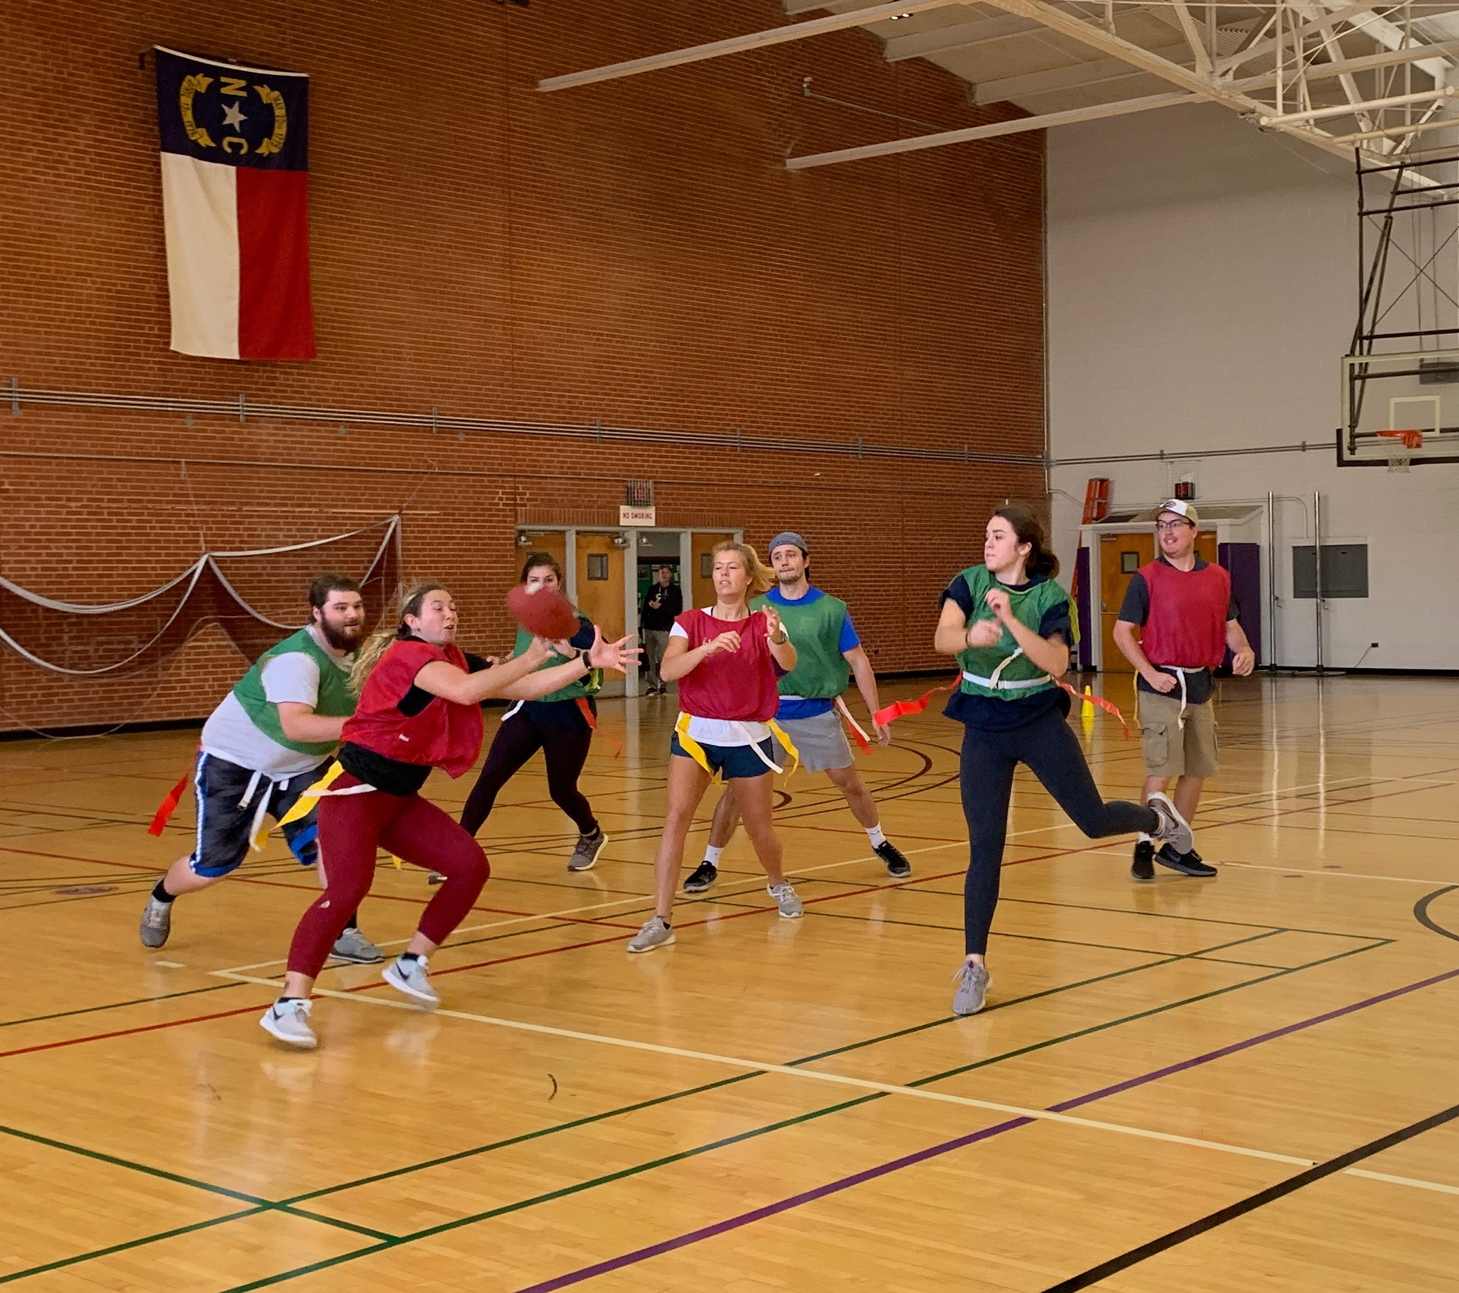Flag Football Fall 2019

Personal Attire Required: All students should dress appropriately for the activities. Please have athletic attire ready for the days we will be participating in activity. This includes: close toed-athletic type shoes (NO flip flops, Chacos, sandals, TEVAs, or open toed shoes), shorts, tights, or athletic style pants (NO jeans), quick dry t-shirt (NO offensive t-shirts), swimsuit for aquafit days (will stay on while moving vigorously in the water), jacket-hats-layers (for outside activities), and WCU logo wear (for off campus events, field trips, and programs).

For student led activity sessions and presentations to the class, students should dress in “recreation professional/business casual” attire. This may include: khaki or dark pants/Bermuda (8-10”) length shorts, polo or button down shirt, casual dress or skirt. For active leadership, nice shorts, appropriate t-shirt or polo shirt, or appropriate attire for the activity is required. These items are NOT considered “professional attire”: jeans, shorts that are 5” or shorter in length, t-shirts, hats, sundresses, clothes that are dirty and/or stinky, greek wear, pajamas, sweat pants, tube tops, etc.

Required Materials: *The instructor will scan chapters and articles for students to read. They will be located in Blackboard Learning Modules. The following texts are used in the class but you do not need to rent or purchase them.
• Barcelona, R. J. (2016). Recreational sport: Program design, delivery, and management (1st ed.). IL: Human Kinetics.
• Dimensions of leisure for life: individuals and society. (2010). Champaign, IL: Human Kinetics.
• Kohl, H. W., & Murray, T. D. (2012). Foundations of physical activity and public health. Champaign, IL: Human Kinetics.
• Payne, L., Ainsworth, B., & Godbey, G. (2010). Leisure, health, wellness: making the connections. State College, PA: Venture Publishing.

• Access to Blackboard to complete the online learning modules for this course. This is a “flipped” class, content is delivered online, active participation is required in class.
• Supplemental Materials: Each learning module will include articles, websites, videos or excerpts from textbooks in addition to the required text for the course.
• Proper athletic attire and footwear. See requirements above.
• Paper and pen. Come to each class ready to take notes even on activity days.

Additional Online Resources:
• National Recreation and Park Association (NRPA): http://www.nrpa.org/
• North Carolina Recreation and Park Association (NCRPA): http://www.ncrpa.net/
• National Intramural-Recreational Sports Association (NIRSA): https://nirsa.net/nirsa/about/
• Active Living Research: http://www.alr-conference.com/
• North Carolina State University: College of Natural Resources, Department of Parks, Recreation, & Tourism Management: Active Recreation Research: https://cnr.ncsu.edu/prtm/research/health-well-being/active-recreation-research/
• Centers for Disease Control (CDC): Parks & Trails Health Assessment Tool Kit: http://www.cdc.gov/healthyplaces/parks_trails/default.htm#.VHPBDETk-bU.facebook

Course Logistics & Schedule:
• Lecture classes will meet in our designated classroom space.
• Activity days will meet in Reid 112 (Main Gym), Reid 129 (the Fitness Lab), Reid 112A (back of main gym), or other designated locations.
• Several classes will require off campus travel to the Jackson County Recreation Department or the Jackson County Greenway.
• Several classes will meet in the Reid Pool, the CRC, the TDC, or at the WCU Climbing Wall.
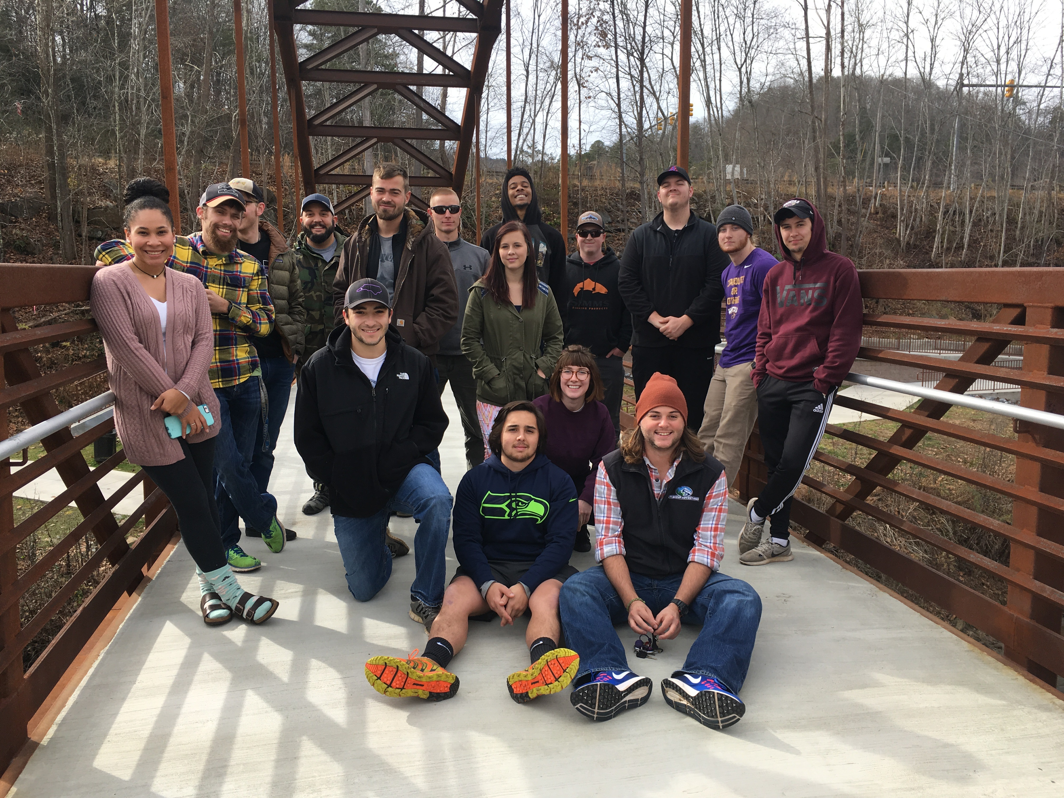Jackson County Greenway field trip, fall 2017

ASSIGNMENTS
This course has been organized around learning modules, active participation, leadership, guest instructors, and field trips. While each assignment overview is given below, the specific requirements of each assignment will be handed out separately and discussed in class well in advance of the due date.

Course Assignments
Assignment | Points
Learning Modules (25 points each) | 135
Recreational Challenge | 100
Student Led Activity Session | 400
Final Exam | 200
Attendance-Participation | 100
Total | 935
*Assignments and/or points may change during the semester. Students will be consulted before changes are made.

1. Learning Modules: (100 points) Students will complete a learning module outside of class for each of the major topics of the course. These topics include:
a. What is Public Health?
b. Kinesiology & Physical Activity
c. Recreation & Leisure
d. Pop Culture & Physical Activity

Each module will include current readings in the subject areas, a discussion forum, and/or an assignment. Assignments will vary but may include quizzes, creation of infographics or videos, class discussions, or reflections. Embedded within several modules are reflections on risk management, programming, supervision issues, equipment and space needs, funding models, and the connection to life long active pursuits.
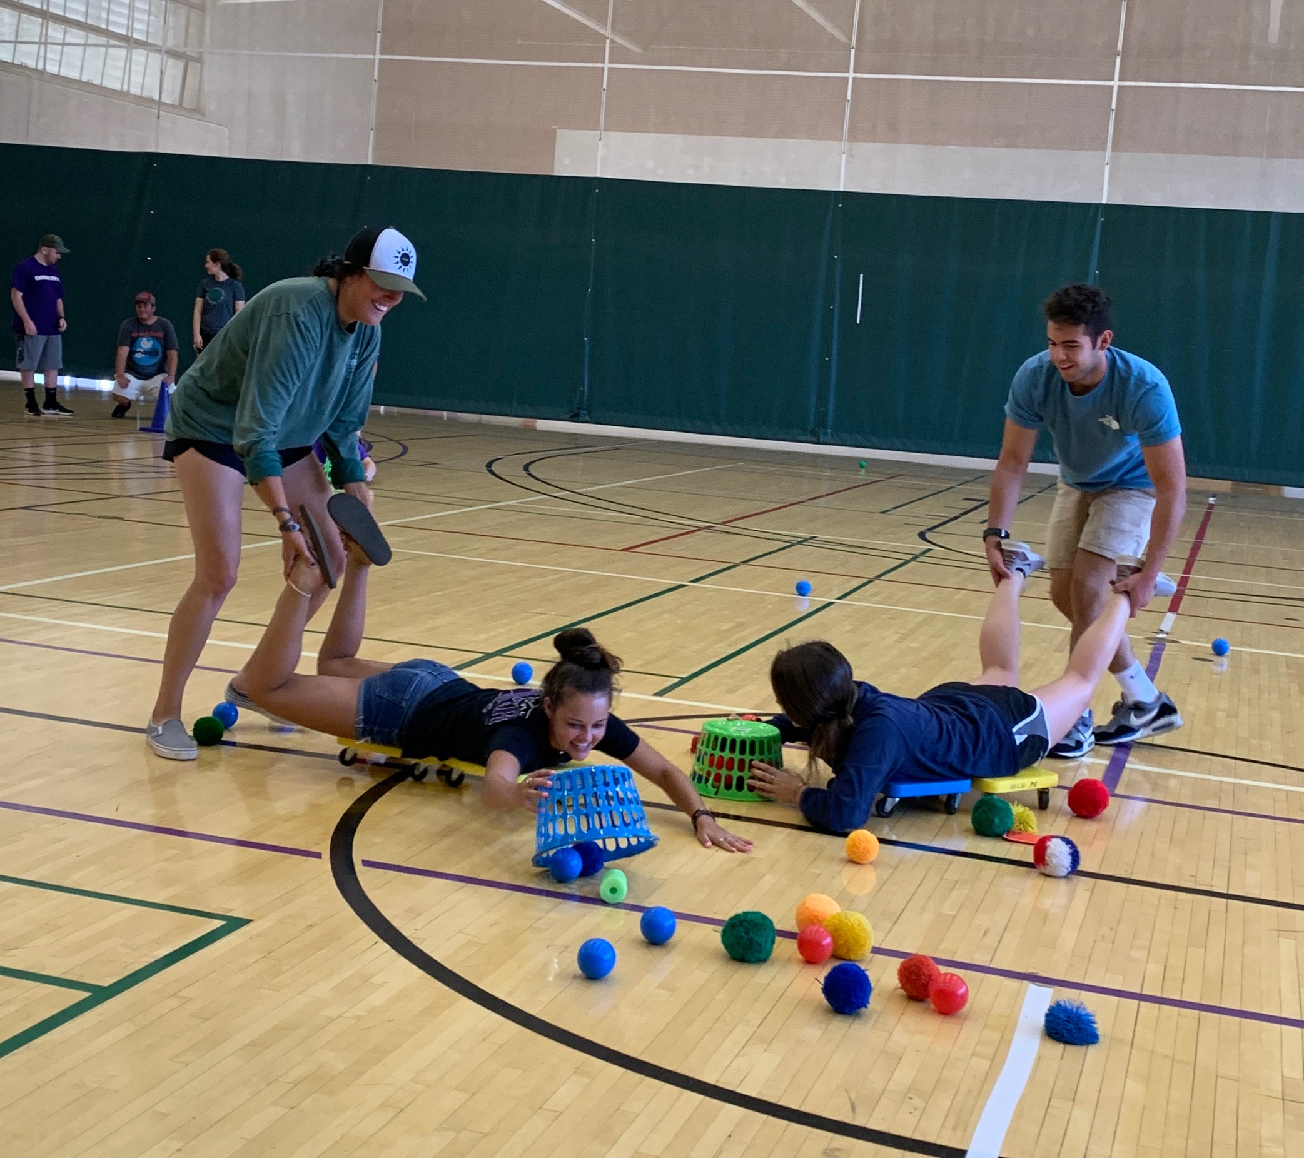 Hungry Hungry Hippos Fall 2019; a pop culture favorite

2. Recreational Challenge: (100 Points) Each student will participate in a fitness-based recreation challenge. Challenges will run for 6 weeks and track activity levels and/or other wellness indicators. At the end of the challenge, students will complete a reflection, submit challenge logs, and discuss how to apply this type of incentive in a recreation setting.

3. Student Led Activity Sessions: (400 points) (COAPRT 7.01 a, b, c; 7.02; 7.03)
Students will be divided into small groups to research, plan, and implement an activity session for an active recreation pursuit for our class. Students will be expected to utilize scholarly and popular literature available through the Hunter Library and associated databases. The grade includes points for the following:
a. activity session outline,
b. creation of a handout for students,
c. a program brief for a recreation based agency,
d. leadership of the activity session, and
e. a reflection on the assignment.
These activity sessions will be scheduled during the 2nd third of the semester. Students will be given a list of possible activities that they can lead. **Complete instructions can be found in Bb.

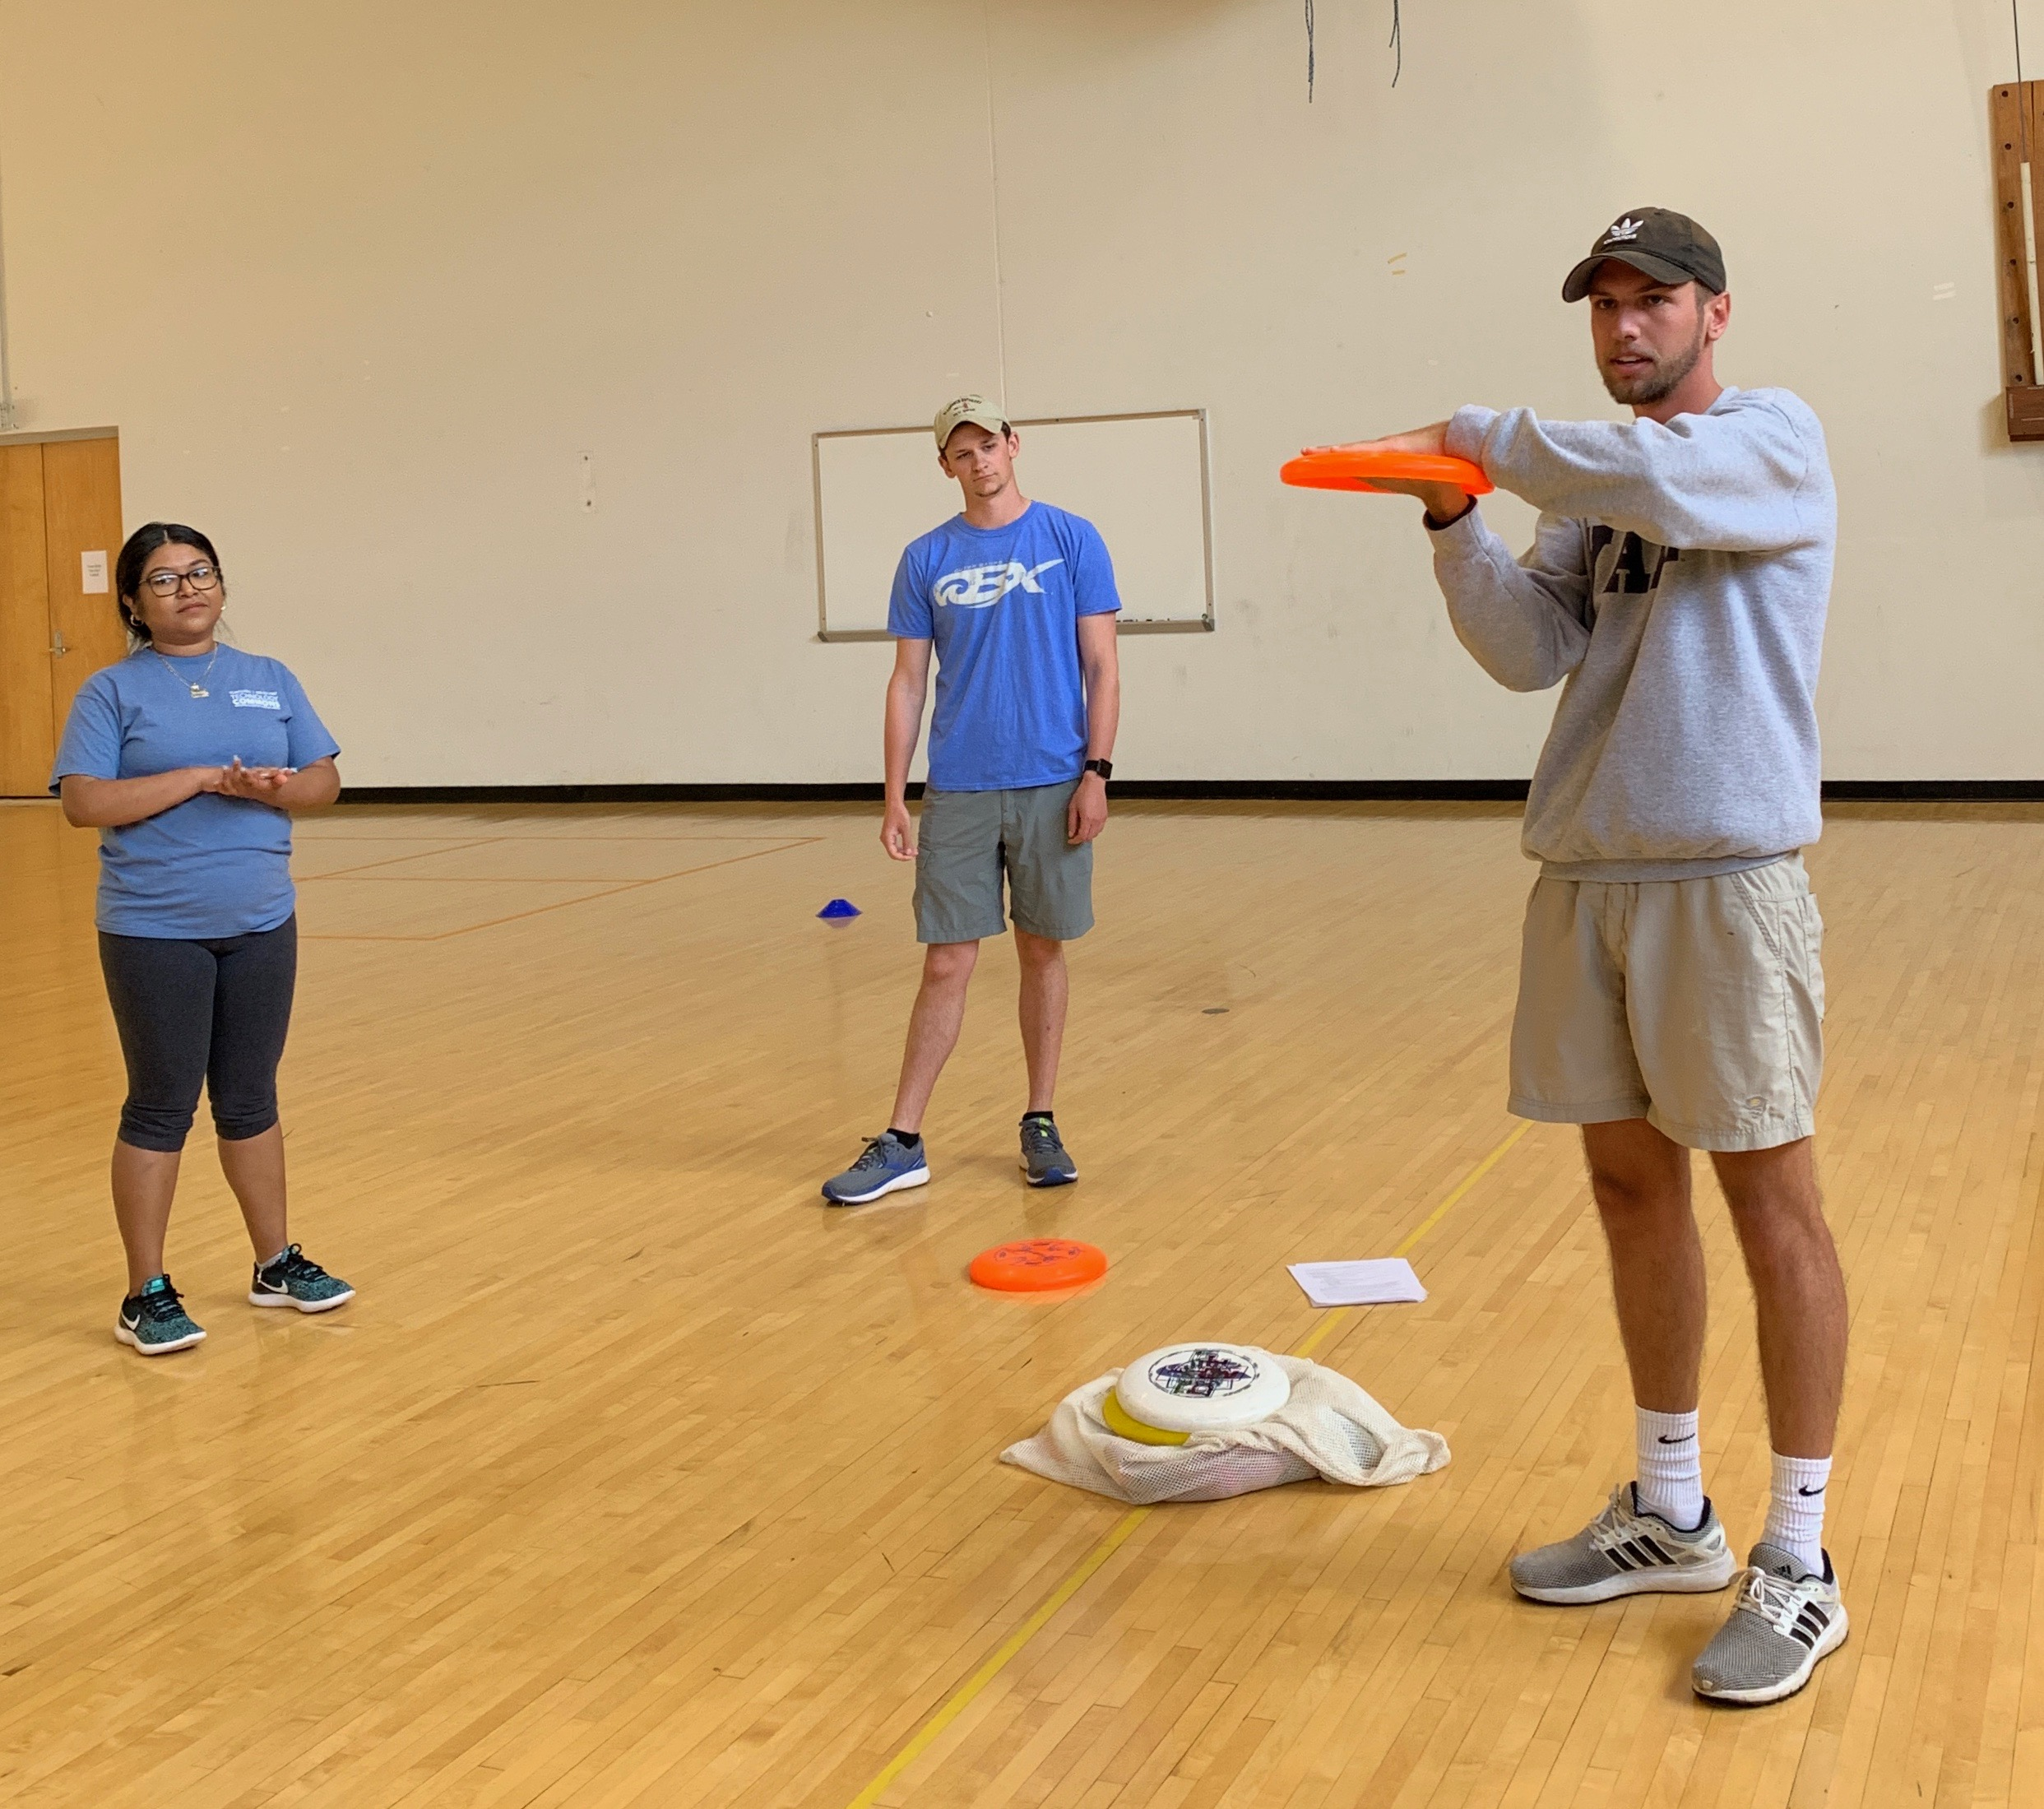 Caleb Adcock leading ultimate frisbee, spring 2019

4. Comprehensive Final Exam (200 points) (COAPRT 7.01a, b, c; 7.02; 7.03) The final exam in the course will encompass information from all learning modules, activity sessions (instructor and student led), guest speakers, and field trips. The format will may be written or online and include a variety of assessment methods.

5. Extra Credit Opportunities: Throughout the semester, I will provide opportunities for extra credit that relate to public health, recreation, leisure, and physical activity. Each extra credit opportunity will be worth 5 to 10 points. To receive the points, students must submit a written, one paragraph (1/2 page) summary which includes the following criteria within one week of the completed activity:
  - Date of activity, time served/participated
  - Name of sponsoring organization and contact person
  - Why did you want to do this, what did you do, what did you take away from the experience?
  - Please include your name and email address (WCU please) as a right-indented header
  - Formatting is 12-point, Times New Roman font with 1” margins.
  - **Maximum amount of extra credit allowed is 30 points total for the semester.

For each assignment, a link in Bb will provide instructions, detailed assignment description, grading rubric, due date and submission requirements. The instructor will go over each assignment in class yet it is your responsible to read the assignment and ask questions if you do not understand something.

Assignment Guidelines:
1. Class assignments are due in Blackboard or in class on the due date listed. Late assignments will be penalized (1 day late = minus 10% of total grade; 2 days late = minus 20%; etc.) If you are having a problem completing an assignment on time, please ask the instructor for assistance. This policy includes weekend days. (Example: assignment worth 25 points is 2 days late; you scored a 22 out of 25; 22 x .20 = 4; 22-4= 18 points.
2. If an assignment is required to be printed out and turned in, please staple multiple page assignments together.
3. Use your spell-check, grammar, and thesaurus tools, which are provided in all word document software. I deduct points for errors, PROOF YOUR WORK!
4. Assignments will be due in Blackboard at the end of each learning module or assignment module. Emailed assignments will NOT be accepted.
5. If you are required to read a chapter in the text or supplemental readings, visit a website, complete homework or a project prior to a class, please do so. Class time is for discussion and activities. Be Prepared!!

Grading Scale
A | 93-100% | C | 73-76.9%
A- | 90-92% | C- | 70-72.9%
B+ | 87-89.9% | D+ | 67-69.9%
B | 83-86.9% | D | 63-66.9%
B- | 80-82.9% | D- | 60-62.9%
C+ | 77-79.9% | F | Below 60%

CLASS CULTURE:
As a classroom of engaged learners, we agree that we will…
- Value and respect different opinions, different experiences, different ability levels, as well as the diversity that exists among us;
- Voice our passions, and not censor ourselves. By this we mean that we want to ensure that we can and should be able to share our thoughts and experiences without interruption especially if our perspectives are different from the class norms, expectations, or experiences of others;
- Encourage questions and clarification;
- Be willing to try new experiences at the best of our ability and with a positive attitude;
- Show support, respect, and attention when our classmates are leading/teaching;
- Be active participants and come to class prepared.

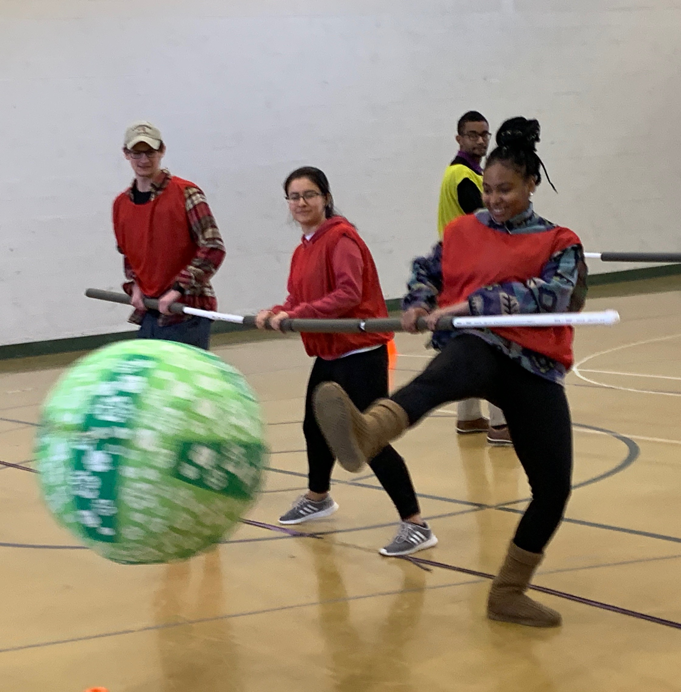Human Foosball, spring 2019

*Instructor’s Comment: I assume that you are here because you want to learn something about this topic and that you will take responsibility to be an active participant in this class. You and I share the same expectations of each other: we will be on time, we will be prepared for that day’s discussion by having done the assigned readings or activities, we will share our ideas and reactions in class discussions and activities, we will be respectful of one another, and we will be engaged in learning about public health, physical activity, recreation and leisure. If you commit yourself to truly doing your best, I will give you the time and assistance you need to get the most out of this class. But the responsibility lies on you to become an engaged learner.

Assumptions and Choices
My assumptions:
- You are an honorable person who stands by her/his word.
- Your enrollment in this class was a willing choice. As such, you are intrinsically motivated to learn.
- You do not equate effort with understanding, and value the latter more highly.
- You are willing to take personal responsibility for your experiences in this class.
- More than likely, you will disagree with me and/or your classmates at some point and will do so respectfully.
- You will come to class prepared and ready to participate.
- You will be respectful to each other, the teaching assistants, and the instructor.
- You will refrain from participating in unhealthy behaviors while class is in session. This includes the use of e-cigarettes, smokeless tobacco, cigarettes, vaping and juul devices.

What about using my computer/phone in class?
In-class technology is a double-edged sword. Studies have shown that using computers in class reduces learning, and a recent study draws a direct correlation between cell phone use (texting) in class and a low GPA.
However, computers provide incredible resources. If you use a computer in class, stay on task. Cell phones should be always be turned off or set to vibrate. If you must use your cell phone to take notes or to refer to when leading your activity, please inform the instructor of your intent.
The majority of this class is activity based, so the use of technology is not needed. Please refrain from using cell phones during activities.
Risk Awareness:
Students should be aware that physical activity is expected as partial fulfillment of the requirements of the class. This includes participation in a variety of active recreation pursuits, practice lessons taught by peers, field trips, and community recreation leisure sports. Students should make the instructor aware of any physical limitations that will limit participation in the class. Students will be required to complete a Risk Awareness form at the beginning of the term.
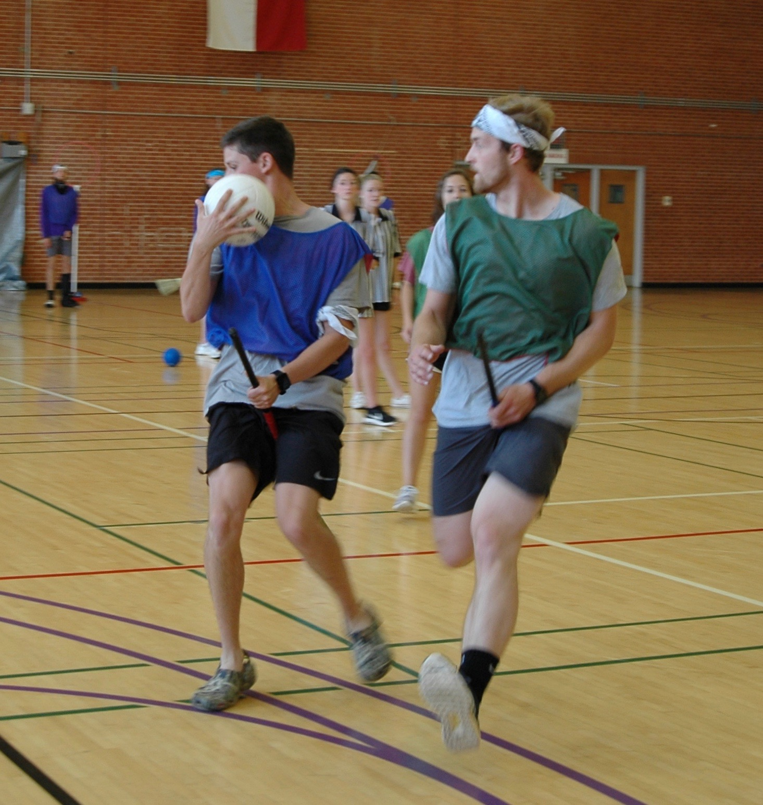 Quidditch is hard core and very active!

Course Policies and Expectations

Participation & Attendance: (100 pts.)

Participation accounts for 50 of these points, and attendance accounts for 50 points. Your participation makes a significant contribution to class discussion. When you are not present, we can’t hear your perspective or learn from the stories you share. Therefore, attendance will be taken each class period. The distinction between “excused” and “unexcused” absences is too arbitrary to enforce; therefore, we will follow the same policy you might encounter at a job—you are allowed THREE personal days/sick days. After that, you will lose 50% of your attendance grade per absence. At 4 absences, your attendance grade will be 25/50 points, at 5 absences, 0 points. That being said, I know that “life happens.” If you are experiencing some kind of personal crisis or other extenuating circumstance, please contact the instructor as soon as possible.

Summary of Attendance Policy
3 absences or less | No Penalty
4 absences | Attendance grade is now 25/50
5 or more absences | Attendance grade is now 0. Email from instructor, meet to discuss options
Summary of Participation Points
Fully engaged, active participation, entire semester= 50 points
Above Average participation, engaged at least 75% of the time= 40 points
Average participation, engaged at least 50% of the time= 30 points
Below Average participation, engaged at least 25% of the time= 20 points
Poor participation, not engaged= 0 points
Does anyone know this guy?

Leaving Class Early:
Unless previously arranged with the instructor for a legitimate reason, students should remain in class the ENTIRE class period. Leaving class early disrupts the flow and students may miss important information. If a student leaves class early 2 times without prior approval, the action will equate to ONE absence.

E-mail Etiquette: Electronic mail to and from your “@catamount.wcu.edu” address is the preferred method of communication. Please follow common e-mail rules:
1. Use your @catamount.wcu.edu email address
2. Use a short and accurate subject header
3. Use a proper salutation (Hello, Good Morning, Greetings, etc.)
4. Introduce yourself in the first paragraph (if needed)
5. The message body should be written in a concise and clear manner. Please do not BS or ramble. Get to the point.
6. Leave-taking (departing farewell) should be appropriate. (Respectfully, Yours sincerely, Take care, etc.)
7. Sign your email with your full (First and Last) name
8. Proofread for content, spelling and grammar.

For the visual learners…

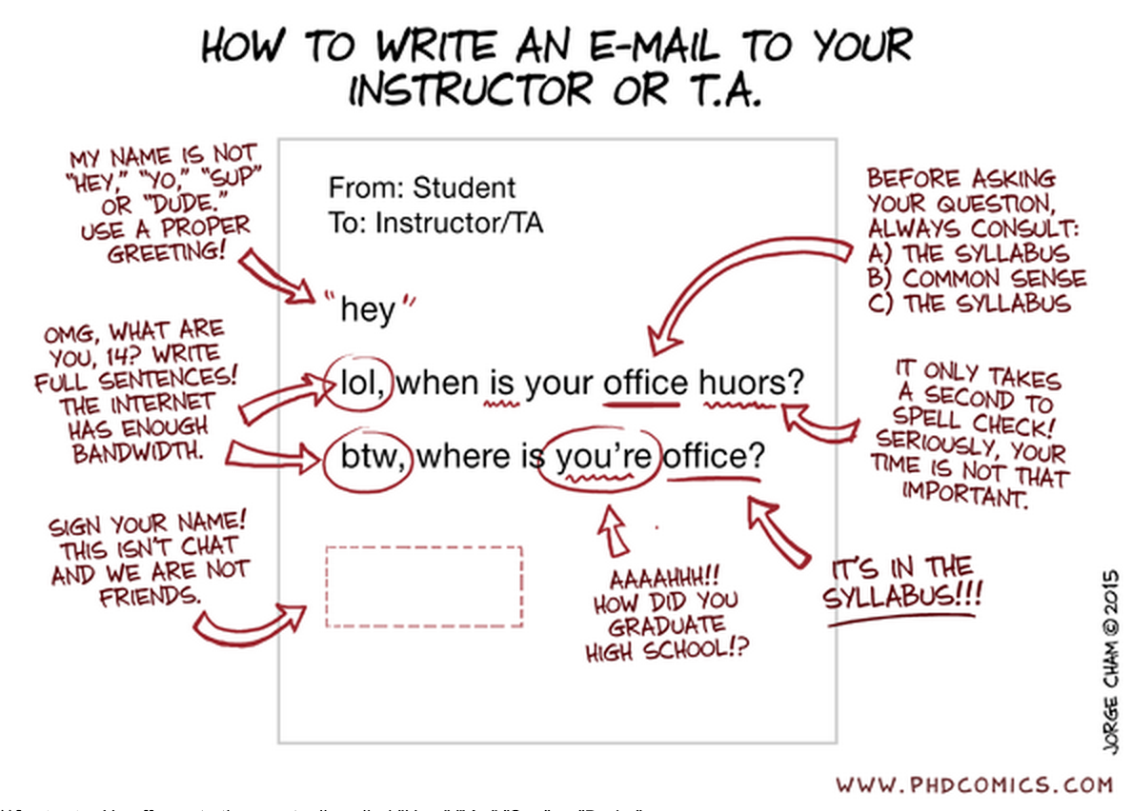

If you need additional information, read this article:
https://www.insidehighered.com/views/2015/04/16/advice-students-so-they-dont-sound-silly-emails-essay

Course Schedule: Please refer to the dynamic course schedule posted in Blackboard for the most current information. *The Schedule is “Fluid”, meaning that the topics for discussion may change depending upon student participation and interest; assignment dates may change due to student input or university scheduling; or unique opportunities may present themselves and be added. Students will be notified in a timely manner of schedule changes.

Course Evaluation Schedule: Students will be asked to participate in an online evaluation of this course. An email will be sent to students reminding them to complete the online course evaluations. The evaluations are scheduled to be available during the last month of each semester.

Appendix A: Boilerplate
“The university requires me to pass along to you a whole litany of contractual information, some of which you may find important, some of which you may not. I have placed this information at the end of this syllabus; I suggest you refer to it as necessary.”

University Expectations and Support Services

Writing and Learning Commons (WaLC)

The Writing and Learning Commons (WaLC) is a free student service, located in BELK 207, providing course tutoring, writing tutoring, academic skills consultations, international student consultations, graduate and professional exam preparation resources, and online writing and learning resources for all students. To schedule tutoring appointments, visit the WaLC homepage (http://walc.wcu.edu) or call 828-227-2274.

Blackboard Support

The learning management system for this class is blackboard and can be found at: http://wcu.blackboard.com Additional help with blackboard can be found at: http://tc.wcu.edu, (828) 227-7487 or by visiting the Technology Commons located on the ground floor of the Hunter Library.

Accommodations for Students with Disabilities

Western Carolina University is committed to providing equal educational opportunities for students with documented disabilities and/or medical conditions. Students who require reasonable accommodations must identify themselves as having a disability and/or medical condition and provide current diagnostic documentation to the Office of Disability Services. All information is confidential. Please contact the Office of Disability Services at (828) 227-3886 or come by Suite 135 Killian Annex for an appointment.

Student Support Services
Student Support Services provides support to students who are either first-generation, low-income or those who have disclosed a disability with: academic advising, mentoring, one-on-one tutorial support, and workshops focused on career, financial aid and graduate school preparation. You may contact SSS at (828) 227-7127 or email sssprogram@wcu.edu for more information. SSS is located in the Killian Annex, room 138.

Civility and Ground Rules
The Western Carolina University Community Creed states: “I will respect the rights and well-being of others.” Each student may possess different ideas, as well as different ways of communicating those ideas. Because of these differences, respect and civility are integral to maintaining the quality of the academic environment and free inquiry.
(http://www.wcu.edu/student-life/policies-affecting-students/statement-of-student-rights-and-responsibilities.asp)

SafeAssign Tool
All written work submitted for this class is eligible for submission to the SafeAssign tool at the instructor’s discretion.
_____________________________________________________________________________________________________________________________________

WCU Policies

Sexual Harassment Policy
The University deems sexual harassment to include conduct constituting sexual harassment under Title VII of the Civil Rights Act of 1964 and Title IX of the Education Amendments of 1972.

Academic Integrity Policy
"I will practice personal and academic integrity" – WCU Community Creed

Academic Integrity Policy and Reporting Process
This policy addresses academic integrity violations of undergraduate and graduate students.
Students, faculty, staff, and administrators of Western Carolina University (WCU) strive to achieve the highest standards of scholarship and integrity. Any violation of the Academic Integrity Policy is a serious offense because it threatens the quality of scholarship and undermines the integrity of the community. While academic in scope, any violation of this policy is by nature, a violation of the Code of Student Conduct and will follow the same conduct process (see ArticleVII.B.1.a.). If the charge occurs close to the end of an academic semester or term or in the event of the reasonable need of either party for additional time to gather information timelines may be extended at the discretion of the Department of Student Community Ethics (DSCE).

General:
This policy addresses academic integrity violations of undergraduate and graduate students. Students, faculty, staff, and administrators of Western Carolina University (WCU) strive to achieve the highest standards of scholarship and integrity. Any violation of this policy is a serious offense because it threatens the quality of scholarship and undermines the integrity of the community.
Instructors have the right to determine the appropriate academic sanctions for violations of the Academic Integrity Policy within their courses, up to an including a final grade of “F” in the course in which the violation occurs.

Definitions:
1. Cheating – Using, or attempting to use, unauthorized materials, information, or study aids in any academic exercise.
2. Fabrication – Creating and/or falsifying information or citation in any academic exercise.
3. Plagiarism – Representing the words or ideas of someone else as one’s own in any academic exercise.
4. Facilitation – Helping or attempting to help someone to commit a violation of the Academic Integrity Policy in any academic exercise (e.g. allowing another person to copy information during an examination).

Undergraduate and Graduate Academic Integrity Process:
Additional information is available on the Student Success website under Student Community Ethics: http://www.wcu.edu/experience/dean-of-students/AcademicIntegrity/academicintegrity.asp

**Students who are caught cheating, fabricating, plagiarizing or facilitating academic dishonesty, will receive a grade of F in this course.
__________________________________________________________________________________________________________________________________

General Academic Info:
Academic Calendar includes dates for all breaks, university closures, final exams, etc. The academic calendar can be found at: http://www.wcu.edu/learn/academic-calendar.aspx
Final Exam
The university final exam schedule can be found here: https://www.wcu.edu/registrar/calendars/fall_final_exam.pdf

Important Dates
Students must be familiar with the class attendance, withdrawal, and drop-add policies and procedures. Please double check these dates online, as they sometimes change. Here is the link to these dates on WCU’s website: https://www.wcu.edu/WebFiles/registrar/REG_2018-2019_Academic_Calendar_FINAL.pdf
_______________________________________________________________________________________________________________________________________

Syllabus Updates:

This syllabus, with its course schedule, is based on the most recent information about the course content and schedule planned for this course. Its content is subject to revision as needed to adapt to new knowledge or unanticipated events. Updates will remain focused on achieving the course objectives and students will receive notification of such changes. Students will be notified of changes and are responsible for attending to such changes or modifications as distributed by the instructor or posted to Blackboard

