PRM 370: Capstone Internship Orientation

Parks & Recreation Management Department of Human Services
Spring 2020

Course # & Title: PRM 370-01: Capstone Internship Orientation (1 credit hour)
Location: Belk 305; Wednesdays 8:00am-8:50am (Face to Face, Online/Hybrid)
Instructor: Debby Singleton, M.A., Instructor
Preferred Pronouns: She/her/hers
Office: Reid 122-J
Office Hours: Check office door for availability or schedule an appointment.
Phone #: 227-3971 (office) E-mail: singleton@wcu.edu

Course Description: This course is designed to prepare the student for the major internship prior to undertaking an experiential learning opportunity. (1 credit hour)

Course Objectives:
Students will be able to….
1. Revise and update their professional documents and digital portfolios to assist them in the search and application process for their capstone internship (7.04).
2. Develop a comprehensive plan to guide them during the research and application process for their capstone internship (7.04).
3. Develop professional best practice competencies (7.04).
4. Complete pre-internship requirements (7.04).

A Note From Me to You: This is your PRM launching pad! This is a very exciting time in your PRM career, but it can also be very stressful. This is the time to get your ducks in a row and ask for clarification, ask for help. This class is organized to help you be successful as you take the next step into your internship course.

Involvement in Parks & Recreation Management & WCU Activities:
• I strongly encourage you to become involved in the PRM Majors Club this year. Please become an Active Member and support club events.
• In addition, I strongly encourage each of you to join a professional organization within your career path such as NRPA, NCRPA, AEE, WEA, PSIA/AASI, ACA (paddling), ACA (camps), AORE. As a member, you will receive updates from their career center and have access to the career connection online.
• Join a listserv for TALS, AEE, Conservation Job Board, USAJobs, AORE, NCRPA, NRPA and more.
• Make and strengthen your connections with PRM faculty, adjuncts and mentors. These connections will be extremely important as you search for internships and future employment.
• Visit the CCPD in Reid 150 for advice concerning your resume, cover letter, and attend their events. Attend the Career & Networking Fair. The CCPD even has technology rooms where you can conduct Skype interviews for internships or possible jobs. Each semester, employers visit campus and conduct on-site interviews in the CCPD, check their schedule to see if there are any you are interested in pursuing. It is also a good idea to check JobCat on a regular basis for internship and job opportunities.

Note on Drug Testing & Criminal Background Checks:
Because students may work with minors during their coursework, all students are required to complete two background checks during their time in the PRM program. The first occurs at the beginning of the program, either during PRM 260 or before they declare the PRM major (whichever comes first). The second occurs during PRM 370 or before the capstone internship, whichever comes first.

The second required background check from the PRM program is required during this course (PRM 370). You MUST complete your background check before Friday of the second week of class. Please use the following link to complete this check: _______________________________.

As you search for internships, be aware that many organizations and agencies may require you to complete drug testing or criminal background checks as part of your interview process.

Course Format:
This is a hybrid style course for Spring 2020 meaning that coursework will be completed in Bb learning modules outside of class and class time will be for discussion and activities. We may not meet every week. All students will complete exercises in the Internship Workbook and various other assignments PRIOR to coming to class. A final face to face, small group “exit interview” will be scheduled towards the end of the semester.

Required Resources:
• Seagle, E., et al. Internship in Recreation and Leisure Services. 6th edition, PA State College: Sagamore-Venture Publishing Inc. *May be purchased through Amazon or Sagamore/Venture Publishing. Make sure it is the 6th edition!
https://www.amazon.com/Internships-Recreation-Leisure-Services-Practical/dp/1571678719
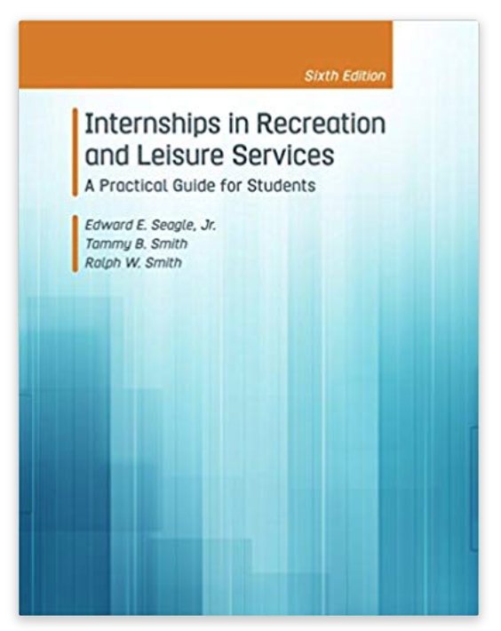
• Professional Handbook produced by WCU’s Center for Career & Professional Development: http://www.wcu.edu/learn/academic-enrichment/ccpd/
• Linked In website: https://www.linkedin.com/
• Internship and Job Opportunity Websites located in Bb.
• The Internship-Job Board located in the Green Room.

COURSE ASSIGNMENTS:
Assignment | Points
Assignments (workbook exercises and others) | 200
Resume (COAPRT 7.04) | 100
Cover Letter/Email (COAPRT 7.04) | 100
Digital Portfolio (Linked In) & Comprehensive Portfolio  (COAPRT 7.04) | 250
Attendance & Reflection Paper  Catamount Career & Networking Day | 100
Exit Interview (COAPRT 7.04) | 100
Final Exam (COAPRT 7.04) | 100
CCPD JobCat Orientation (COAPRT 7.04) | 100
Attendance/Participation | 100
Total Points | 1050
*Class assignments and points may be updated, deleted, or changed during the semester. Students will be consulted.

Brief Description of COURSE REQUIREMENTS/ASSIGNMENTS:
• For all assignments, a link in Bb will provide instructions, detailed assignment description, grading rubric, due date and submission requirements. The instructor will be available via email or office hours to answer questions regarding assignments.

• Workbook and Other Assignments: (200 points) (COAPRT 7.04) Students are expected to read each chapter in the Internship Workbook and complete the assigned exercises by the due dates provided. Other assignments and exercises will also be required throughout the semester.

• Resume: (100 points) (COAPRT 7.04) Students will create-update their professional resume. Students will submit a 1st draft for instructor critique the first week of class. The second submission is for the final resume grade. This is done EARLY in the semester. *Please visit the CCPD and meet with a Career Mentor to have them critique your resume prior to turning it in for a grade. **Outdoor Leadership/Instruction and Recreation Resource Management career path students are STRONGLY ENCOURAGED to have an updated Outdoor Activity Log.

• Cover Letter/Email: (100 points) (COAPRT 7.04) Students will create a professional cover letter template and a professional email template to be used in securing your capstone internship or for future employment. This is done EARLY and LATER in the semester. The first draft will be submitted to the instructor to critique. The second submission is for the final cover letter grade. *Please visit the CCPD and meet with a Career Mentor to have them critique your cover letter prior to turning it in for a grade.

• Digital Portfolio (Linked In) & Capstone Portfolio: (250 points) (COAPRT 7.04) You will be required to create/update your digital portfolio (Linked In profile). For your Capstone Portfolio you are required to include your resume, certificates, outdoor activity log (if applicable), any projects completed so far, etc. Each of these assignments are worth 125 points.

• Attendance & Reflection of the CCPD Career & Networking Day: (100 points) (COAPRT 7.04) Each student is required to attend the Career & Networking Day. A reflection on the experience will be submitted after attendance. (*If a student can not attend due to conflict with classes or a university sponsored event, they must attend an alternative CCPD networking event. Prior approval from the instructor is needed for this option.)

• Exit Interview: (100 points) (COAPRT 7.04) Each student will attend a face to face, small group, exit interview with the instructor to review their capstone internship requirements, resume, cover letter/email, and digital portfolios.

• Final Exam: (100 points) (COAPRT 7.04) The final exam is open book and notes. The test questions will be taken from the Internship Workbook, class discussions, exercises, and the capstone internship syllabus. The final exam may be online or in the classroom.

• CCPD Job Cat Orientation/Internship Application: (100 points) (COAPRT 7.04) Students are required to attend a JobCat Orientation session before the last week of class if they have not already done so for a mini-internship. Students are also required to complete the JobCat internship application which includes their supervisor’s contact information, job description, and other information regarding the capstone internship. Students may not register for PRM 483 or PRM 484 until this application is completed.

• Participation and Attendance: (100 points) This is a quantitative and a subjective grade. Since this is a face to face, hybrid style course, students are expected to keep up with weekly assignments, schedule, and online requirements. **Attendance is taken during face to face classes, but will not be recorded during hybrid classes.

Participation accounts for 50 of these points, and attendance accounts for 50 points. Your participation makes a significant contribution to class discussion. When you are not present, we can’t hear your perspective or learn from the stories you share. Therefore, attendance will be taken each class period. The distinction between “excused” and “unexcused” absences is too arbitrary to enforce; therefore, we will follow the same policy you might encounter at a job—you are allowed ONE personal day/sick day during the course of the semester. After that, you will lose 50% of your attendance grade per absence. At 1 absence, your attendance grade will be 25/50 points, at 2 absences, 0 points. That being said, I know that “life happens.” If you are experiencing some kind of personal crisis or other extenuating circumstance, please contact the instructor as soon as possible.

Attendance | Participation Points
50 points= zero to one absence | Fully engaged, active participation, entire semester= 50 points
25 points= 2 absences | Above Average participation, engaged at least 75% of the time= 40 points
0 points= 3+ absences | Average participation, engaged at least 50% of the time= 30 points
 | Below Average participation, engaged at least 25% of the time= 20 points
 | Poor participation, not engaged= 0 points

• Extra Credit Opportunities: Throughout the semester, I will provide opportunities for extra credit that relate to professionalism in PRM. Each extra credit opportunity will be worth 5-10 points. To receive the points, students must submit in class or delivered to the instructor a written, one paragraph (1/2 page) summary which includes the following criteria within one week of the completed activity:
  - Date of activity, time served/participated
  - Name of sponsoring organization and contact person
  - Why did you want to do this, what did you do, what did you take away from the experience?
  - Please include your name and email address (WCU please) as a right-indented header
  - Formatting is 12-point, Times New Roman font with 1” margins.
  - **Maximum amount of extra credit allowed is 30 points total for the semester.

Extra Credit may also be obtained through attending WCU’s Career and Professional Development Center variety of workshops and events throughout the semester. The PRM Program offers a wide array of programs and events to help you expand your network and community. The instructor will provide information on these events, the number you are required to attend for this class, and the requirements for assessment points. PRM will also offer panel discussions and industry leader discussions to help you find internships and summer jobs.

Don’t be this kid.

Assignment Guidelines:
1. Class assignments are due in Blackboard or in class on the due date listed. Late assignments will be penalized (1 day late = minus 10% of grade; 2 days late = minus 20%; etc.) If you are having a problem completing an assignment on time, please ask the instructor for assistance. This policy includes weekend days. (Example: assignment worth 25 points is 2 days late; you scored a 22 out of 25; 22 x .20 = 4; 22-4= 18 points. This policy includes weekend days.
2. If an assignment is required to be printed out and turned in, please staple multiple page assignments together and make sure your name is on the assignment.
3. Internship Workbook exercises may be handwritten on the copied exercise pages and then scanned to submit. Or you can type up the exercise and answers and then submit a word document in the assignment module or a printed copy.
4. Assignments should be typed using MS Word, an easy to read 12 point font, 1’ margins, and saved using your last name and the title of the document. Example: “singleton-resume.docx”
5. Assignments completed using applications such as Pages, Notes, or something other than MS Word, will NOT be graded.
6. Use your spell-check, grammar, and thesaurus tools, which are provided in all word document software. I deduct points for errors, PROOF YOUR WORK!
7. Emailed assignments will NOT be accepted.
8. If you are required to read a chapter in the workbook or supplemental readings, visit a website, complete homework or a workbook exercise prior to a class, please do so. Class time is for discussion and activities. Be Prepared!!

GRADING SCALE:
A+ | >101%
A | 93-100% | C | 73-76.9%
A- | 90-92% | C- | 70-72.9%
B+ | 87-89.9% | D+ | 67-69.9%
B | 83-86.9% | D | 63-66.9%
B- | 80-82.9% | D- | 60-62.9%
C+ | 77-79.9% | F | Below 60%

Course Schedule: Please refer to the course schedule posted in Blackboard for the most current information. *The Schedule is “Fluid”, meaning that the topics for discussion may change depending upon student participation and interest; assignment dates may change due to student input or university scheduling; or unique opportunities may present themselves and be added. Students will be notified in a timely manner of schedule changes.

Course Evaluation Schedule: Students will be asked to participate in an online evaluation of this course. An email will be sent to students reminding them to complete the online course evaluations. The evaluations are scheduled to be available during the last month of the semester.

Netiquette Guide:
A hybrid/online class format is still a class and certain behaviors are expected when you communicate with both your peers and your instructor. The purpose of this guide is to help you be a more effective and successful student when communicating in chat rooms, discussion boards and part of your online learning activities in this course.
1. Treat your instructor with respect.
2. Always use your professor’s proper title: mine is “Ms.” or “Professor”.
3. Use clear and concise language. Be respective of the reader’s time and attention.
4. Avoid using slang terms such as “wasup?” and texting abbreviations such as “u” instead of “your”.
5. Use standard fonts that are optimized for online reading along with consistent and readable size (12-14 point).
6. Avoid using the caps lock feature AS IT CAN BE INTERPRETED AS YELLING.
7. Limit and possibly avoid the use of emoticons. Not everyone knows how to interpret them.
8. Be causing when using humor or sarcasm as tone is sometimes lost in an email or discussion post and your message might be taken literally or offensively.
9. Be careful sharing personal information online (both yours and other’s).

Discussion Board “Netiquette” and Guidelines:
When posting on the Discussion Board, you should:
1. Make posts that are on topic and within the scope of the course material. If necessary, re-read the instructions from your instructor.
2. Take your posts seriously and review and edit your posts before sending.
3. Be as brief as possible while still making a thorough comment.
4. Always give proper credit when referencing or quoting another source.
5. Be sure to read all messages in a thread before replying.
6. Don’t repeat someone else’s post without adding something of your own to it.
7. Avoid short, generic replies such as, “I agree”. You should include why your agree or add to the previous point. The point of a discussion in an online course is to help you and your other students learn through in-depth consideration of important topics.
8. Always be respectful of others’ opinions even when they differ from your own. When you disagree with someone, you should express your differing opinion in a respectful, non-critical way.
9. Be open-minded as that is one of the major points of participating in an open classroom discussion.

E-mail Etiquette: Electronic mail to and from your “@catamount.wcu.edu” address is the preferred method of communication. Please follow common e-mail rules:
1. Use your @catamount.wcu.edu email address
2. Use a short and accurate subject header
3. Use a proper salutation (Hello, Good Morning, Greetings, etc.)
4. Introduce yourself in the first paragraph (if needed)
5. The message body should be written in a concise and clear manner. Please do not BS or ramble. Get to the point.
6. Leave-taking (departing farewell) should be appropriate. (Respectfully, Yours sincerely, Take care, etc.)
7. Sign your email with your full (First and Last) name
8. Proofread for content, spelling and grammar.

For the visual learners…
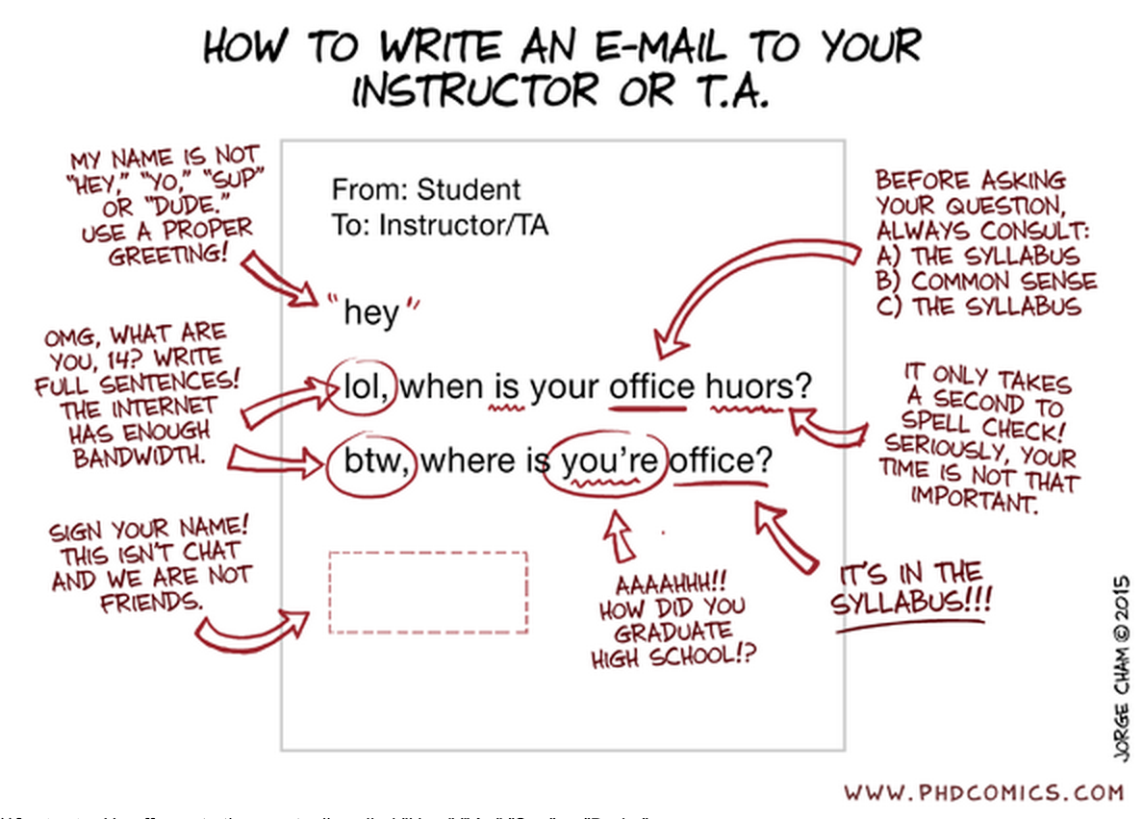

If you need additional information, read this article:
https://www.insidehighered.com/views/2015/04/16/advice-students-so-they-dont-sound-silly-emails-essay

Appendix A:
Everything the university requires instructors to place on their syllabi. It is a good idea to be familiar with these items.

CAMPUS RESOURCES:
Center for Career & Professional Development: Located in Reid 150, the center provides assistance with resumes, cover letters, job searches, interview techniques, and career planning. Visit their website at http://careers.wcu.edu for additional information.
Writing and Learning Commons (WaLC):
The Writing and Learning Commons (WaLC), located in BELK 207, provides free course tutoring,
writing tutoring, academic skills consultations, international student consultations, and online writing and learning resources for all students. To view schedules and make appointments for any of these services, visit tutoring.wcu.edu or call 828-227-2274.

Technology Resources: There are various technology resources available to you to help you complete assignments in this course. You can check out video cameras, voice recorders, and tripods from the Instructional Technology office in Killian 102B. The Technology Commons on the bottom floor of the library also has equipment for checkout. Both units also provide consultation on the use of technology and software training. If you have questions or need assistance, see Misty Colton in Killian 102B, call 828.227.2747, or email mcolton@wcu.edu

Math Tutoring Center:
The Mathematics Tutoring Center (MTC) in Stillwell 455 provides drop-in tutoring for math courses and math-related content across the curriculum, workshops on study skills specific to math courses, and graduate and professional exam preparation resources. Tutoring is available on a drop-in basis, MTWR 9:00am-9:00pm and Friday 9:00am-5:00pm. For more information, please visit http://mtc.wcu.edu/ or contact us at 828–227–3830.

Hunter Library:
Hunter Library provides students with access to group and individual study spaces and to thousands of information resources: print and electronic books, newspapers, and scholarly journal articles. These resources can be searched online and often accessed there (http://www.wcu.edu/hunter-library) or library staff and subject specialists skilled in their specific disciplines can be contacted via the library’s research guides (http://researchguides.wcu.edu/) or from PRM’s designated research librarian, Elizabeth Marcus emarcus@email.wcu.edu, or from the research guide: http://researchguides.wcu.edu/prm

Blackboard Support:
The learning management system for this class is Blackboard and can be found at http://wcu.blackboard.com NOTE: Blackboard will be unavailable for one day in May and one day in December each year for required system upgrade. Check the Academic Calendar for specific date as well the Blackboard login and Home pages.
Additional help with Blackboard can be found at tc.wcu.edu, (828) 227-7487 or by visiting the Technology Commons located on the ground floor of the Hunter Library.

Academic Toolbox:
The Academic Toolbox is available in all WCU courses via the course Blackboard site. It can be found in the left-hand side column. The Academic Toolbox contains information and contact information for nearly all of the resources needed by WCU students, including but not limited to: technology assistance, academic services, student support, co-curricular programs and university policies.

Mentoring and Persistence to Success (MAPS)
Mentoring and Persistence to Success (MAPS) provides support to students who are first-generation (neither parent has a four-year degree), low-income, financially independent (emancipated youth, homeless or without consistent residence, or aged out of foster care), or those who have participated in the Academic Success Program (ASP) or Catamount Gap. For those who enroll, MAPS provides a variety of services, including academic advising, mentoring, and personal and social coaching. You may contact MAPS at (828) 227-7127 or email maps@wcu.edu for more information. MAPS is located in 205 Killian Annex.
Intercultural Affairs: The ICA office offers a variety of workshops, trainings, and conferences throughout the year. Visit the ICA office (227 AK Hinds University Center) or our website (http://ica.wcu.edu) for details.
Academic Calendar:
This includes dates for all breaks, university closures, final exams, etc. The academic calendar can be found at http://www.wcu.edu/learn/academic-calendar.asp

Final Exam
The university final exam schedule can be found at
http://www.wcu.edu/learn/academic-services/registrars-office/

Civil Discourse at Western Carolina:
Consistent with WCU’s core values and our campus creed, the WCU community accepts the freedoms and responsibilities of our shared community. WCU encourages all to clearly express their own views while at the same time seeking to understand the varieties of style, identity, and opinion that are held in any diverse community. In order for us to sustain a learning environment that promotes and values freedom of expression, we have a shared charge to accept personal responsibility for our actions, reactions, and speech, while seeking to learn from the actions, reactions, and speech of others.
Classroom Expectations:
The shared learning space of the college classroom is built on respect for each other and each other’s learning. Learning together means our actions can intentionally and unintentionally distract others from their learning goals. As responsible learners who respect the rights of others and vow to minimize avoidable distractions such as: non-academic technology use, coming in late, sleeping, off-topic discussions, doing other homework, eating, etc.
Accommodations for Students with Disabilities:
Western Carolina University is committed to providing equal educational opportunities for students with documented disabilities and/or medical conditions. Students who require accommodations must identify themselves as having a disability and/or medical condition and provide current diagnostic documentation to the Office of Accessibility Resources. Please contact the Office of Accessibility Resources, 135 Killian Annex (next to the One Stop), (828) 227-3886 or by email at accessibility@wcu.edu. Website: http://accessibility.wcu.edu/

Student Support Services:
Student Support Services provides support to students who are either first-generation, low-income or those who have disclosed a disability with: academic advising, mentoring, one-on-one tutorial support, and workshops focused on career, financial aid and graduate school preparation. You may contact SSS at (828) 227-7127 or email sssprogram@wcu.edu for more information. SSS is located in the Killian Annex, room 138.
**If you do require accommodations for this class, it is YOUR RESPONSIBILITY to schedule them with Student Support Services.

SafeAssign Tool:

All written work submitted for this class is eligible for submission to the SafeAssign tool at the instructor’s discretion.

Grading and Quality Point System
Grade Interpretation Quality Points per Grade Interpretation Quality Points per
Semester Hour Semester Hour
A+ Excellent 4.0 I Incomplete --
A Excellent 4.0 IP In Progress --
A- 3.67 S Satisfactory --
B+ 3.33 U Unsatisfactory --
B Good 3.0 W Withdrawal --
B- 2.67 AU Audit --
C+ 2.33 NC No Credit --
C Satisfactory 2.0
C- 1.67
D+ 1.33
D Poor 1.0
D- .67
F Failure 0

The grades of A+, A, A-, B+, B, B-, C+, C, C-, D+, D, D- and F indicate gradations in quality from Excellent to Failure. Please note that a C- grade is less than satisfactory and may not meet particular program and/or course requirements.

Institutional Policies

Course Recording and Broadcasting:
Students may make visual or audio recordings (Recording) of any class related content, using any approved recording device (e.g., smart phone, computer, digital recorder, etc.) upon the prior permission of the instructor and subject to the following restriction(s). The Recording, along with the video capture of visible course materials (e.g., visible PowerPoint slides and/or visible lecture notes), shall be limited to the student’s personal, course related, educational use and shall be subject to all applicable copyright laws and institutional policies. The student may not transfer, transmit, or otherwise disseminate the Recording to any third party, including classmates, without the permission of the instructor. Any violation of these restrictions, or any other restriction verbally communicated by the instructor, may subject the student to the provisions of the WCU Academic Integrity Policy, the WCU Code of Student Conduct or both.

Meetings of this course may be broadcast and/or recorded. Broadcasting and recording are intended to complement the classroom experience. Instructors may broadcast and/or record courses for pedagogical use, student reference, to meet the accommodation needs of students with a documented disability, or any other reason deemed appropriate by WCU and/or the instructor. Course recordings will be available to students registered for the course pursuant to applicable university policy. All broadcasts and recordings are limited to personal, course related, educational use and may not be transmitted, transferred, distributed, sold, or posted on social media outlets without the written permission of the instructor. Unauthorized transmission, transfer, distribution, sale or posting of the broadcast and/or recording for any purpose other than the student's personal, course related, educational use is not permitted. Students are expected to follow appropriate university policies and maintain the security of passwords used to access recorded materials.

In the event that broadcasting and/or recording is not a course requirement (such as recording a class meeting for research purposes), prior to any appearance on a recording, the instructor shall receive formal, written permission of any and all identifiable students who may appear in the recording, pursuant to applicable university policy. If requested the instructor shall provide a classroom area where students who do not wish to be recorded may be located.

Academic Integrity Policy and Reporting Process:
This policy addresses academic integrity violations of undergraduate and graduate students. Graduate students should read inside the parenthesis below to identify the appropriate entities in charge of that step of the process.

Students, faculty, staff, and administrators of Western Carolina University (WCU) strive to achieve the highest standards of scholarship and integrity. Any violation of the Academic Integrity Policy is a serious offense because it threatens the quality of scholarship and undermines the integrity of the community. While academic in scope, any violation of this policy is by nature, a violation of the Code of Student Conduct and will follow the same conduct process (see ArticleVII.B.1.a.). If the charge occurs close to the end of an academic semester or term or in the event of the reasonable need of either party for additional time to gather information timelines may be extended at the discretion of the Department of Student Community Ethics (DSCE).

General:
This policy addresses academic integrity violations of undergraduate and graduate students. Students, faculty, staff, and administrators of Western Carolina University (WCU) strive to achieve the highest standards of scholarship and integrity. Any violation of this policy is a serious offense because it threatens the quality of scholarship and undermines the integrity of the community.
Instructors have the right to determine the appropriate academic sanctions for violations of the Academic Integrity Policy within their courses, up to and including a final grade of “F” in the course in which the violation occurs.

Definitions:
Cheating – Using, or attempting to use, unauthorized materials, information, or study aids in any academic exercise.
Fabrication – Creating and/or falsifying information or citation in any academic exercise.
Plagiarism – Representing the words or ideas of someone else as one’s own in any academic exercise.
Facilitation – Helping or attempting to help someone to commit a violation of the Academic Integrity Policy in any academic exercise (e.g. allowing another person to copy information during an examination).

Undergraduate and Graduate Academic Integrity Process:
Additional information is available on the Student Success website under Student Community Ethics: http://www.wcu.edu/experience/dean-of-students/academic-integrity.aspx

**Students who are caught cheating, fabricating, plagiarizing or facilitating academic dishonesty, will receive a grade of F in this course.

Syllabus Updates
This syllabus, with its course schedule, is based on the most recent information about the course content and schedule planned for this course. Its content is subject to revision as needed to adapt to new knowledge or unanticipated events. Updates will remain focused on achieving the course objectives and students will receive notification of such changes. Students will be notified of changes and are responsible for attending to such changes or modifications as distributed by the instructor or posted to Blackboard.

Students must be familiar with the class attendance, withdrawal, and drop-add policies and procedures.

