BAHAMAS 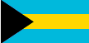

BASIC INFORMATION
- Capital City: Nassau
- Population: 377,400
- Location: Caribbean, chain of islands in the North Atlantic Ocean, southeast of Florida, northeast of Cuba

HIGHER EDUCATION HIGHLIGHTS:
- The College of the Bahamas is the leading higher education institution
- Several two year universities
- Some United States universities offer degree programs in Bahamas

FIND MORE INFORMATION:
http://www.nationsonline.org/oneworld/bahamas.htm
http://thecommonwealth.org/our-member-countries/bahamas/society
http://thebahamasguide.com/facts/education/

BRAZIL 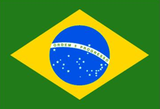

BASIC INFORMATION:
- Capital City: Brasilia
- Population: 195,976,000
- Location: Atlantic coast of South America

HIGHER EDUCATION HIGHLIGHTS:
- Approximately 1.5 million students in higher education institutions
- 83 universities, 720 independent schools and 67 federations
- Regulated through the Ministry of Education

FIND MORE INFORMATION:
http://www.britannica.com/EBchecked/topic/78101/Brazil
http://iberoamerican-universities.universia.net/en/brazil/educational-system/index.html
http://www.schwartzman.org.br/simon/pdf/future_english.pdf
http://www.nafsa.org/uploadedFiles/Chez_NAFSA/Resource_Library_Assets/Networks/ACE/EDU%20Systems%20Brazil.pdf

CAMBODIA
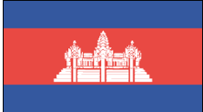BASIC INFORMATION:
- Capital City: Phnom Penh
- Population: 14.5 million
- Location: The Indochinese Peninsula, bordered by Thailand and Laos to the north and Vietnam on the east and south

HIGHER EDUCATION HIGHLIGHTS:
- Higher Education system consists of universities, institutes, or technical institutes and a Royal academy
- Approximately 38 Public and 59 Private Higher Education Institutions
- Can award bachelors, masters, or Doctor of Philosophy

FIND MORE INFORMATION:
http://www.cambodia.org
http://www.bbc.com/news/world-asia-pacific-13006541
http://www.academia.edu/2300622/Cambodia_s_Higher_Education_Structure_and_the_Implications_of_the_2015_ASEAN_Economic_Community
http://siteresources.worldbank.org/INTEASTASIAPACIFIC/Resources/Cambodia-HEandSkillsforLaborMarket.pdf

CANADA 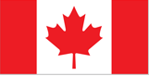

BASIC INFORMATION:
- Capital City: Ottawa
- Population: 32,225, 000
- The second largest country in area
- Location: North America, north of the United States

HIGHER EDUCATION HIGHLIGHTS:
- Educate more than 1.5 million students annually
- Perform one-third of Canada’s research and development
- No federal ministry of education, provinces and territories are responsible for all levels of education

FIND MORE INFORMATION:
http://travel.nationalgeographic.com/travel/countries/canada-facts/
http://www.canada.ca/en/
http://www.lonelyplanet.com/canada
http://www.canadian-universities.net
http://www.aucc.ca/canadian-universities/

CHINA 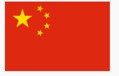

BASIC INFORMATION:
- Officially the People’s Republic of China
- The world’s most populous country with over 1.35 billion people
- Capital City: Beijing
- Location: middle and east Asia, bounded on the east by the Pacific Ocean
- Climate: continental monsoon

HIGHER EDUCATION HIGHLIGHTS:
- Over 2,000 universities and colleges
- More than five million enrolled in degree courses; more than two million enrolled in higher education
- Bachelor, Masters, and Doctoral degrees as well as non-degree programs
- More than 60% of high school graduates in China attend a university

FIND MORE INFORMATION:
https://www.cia.gov/library/publications/the-world-factbook/geos/ch.html
http://www.china-mike.com/facts-about-china/facts-chinese-education/
http://www.chinatoday.com/general/a.htm
http://www.travelchinaguide.com/intro/china.htm
http://www.sicas.cn/Students/Info/Content_110621144852564.shtml

EL SALVADOR 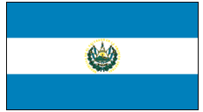

BASIC INFORMATION:
- Capital City: San Salvador
- Population: 6,052,064
- Location: Pacific Coast of Central America

HIGHER EDUCATION HIGHLIGHTS:
- Three public and twelve private universities
- Enrollment age is typically between 19 and 23.

FIND MORE INFORMATION:
http://www.infoplease.com/country/el-salvador.html
http://www.encyclopedia.com/topic/El_Salvador.aspx
http://education.stateuniversity.com/pages/425/El-Salvador-HIGHER-EDUCATION.html

ENGLAND 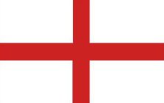

BASIC INFORMATION:
- Part of the United Kingdom
- Capital City: London
- Population: 53,012,456

HIGHER EDUCATION HIGHLIGHTS:
- Higher Education consistent throughout the United Kingdom
- Undergraduate and Postgraduate degrees
- Undergraduate focuses heavily on developing writing and analytical skills
- More than 2 million students

FIND MORE INFORMATION:
http://www.worldatlas.com/webimage/countrys/europe/england/ukefacts.htm
http://www.visitengland.com
http://www.britannica.com/EBchecked/topic/700965/England
http://www.kic.org.uk/pathways/study-uk/education-uk/uk-education-system/
http://www.educationuk.org/usa/sub/higher-education/

FINLAND 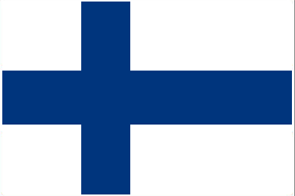

BASIC INFORMATION:
- Capital City: Helsinki
- Population: 5.4 million
- Northernmost country in the EU
- Location: Bordered by Sweden, Norway and Russia

HIGHER EDUCATION HIGHLIGHTS:
- Focus on learning rather than testing
- Offers all citizens equal opportunities to receive education
- Universities and polytechnics are entirely autonomous
- Most education and training is publically funded

FIND MORE INFORMATION:
http://finland.fi/public/default.aspx?culture=en-US&contentlan=2
http://europa.eu/about-eu/countries/member-countries/finland/index_en.htm
http://www.oph.fi/english/education_system
http://www.euroeducation.net/prof/finco.htm

FRANCE 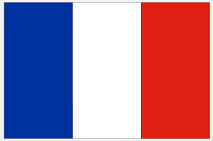

BASIC INFORMATION:
- Capital City: Paris
- Population: 65,821,000
- Location: Europe’s west side, bordered by the North Sea along the Channel to the Atlantic Ocean and the Mediterranean Sea to the south
- Most expansive country in the European Union

HIGHER EDUCATION HIGHLIGHTS:
- Over 3,500 higher education institutions
- Higher education institutions include: grandes ecoles, specialized schools, university institutes for technology, and preparatory classes for grandes ecoles
- Follows the Bologna process (3 cycles)
FIND MORE INFORMATION:
http://www.france.fr/en.html
http://www.niad.ac.jp/english/overview_fr_e.pdf
http://www.studialisedu.net/french-education-system
http://highereducation.frenchculture.org

GERMANY 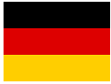

BASIC INFORMATION:
- Capital City: Berlin
- Population: 82,490,000
- Europe’s most populous country
- Location: Central Europe, bordering the Baltic Sea and the North Sea, between the Netherlands and Poland, south of Denmark

HIGHER EDUCATION HIGHLIGHTS:
- Approximately 1.98 million students
- Approximately 376 higher education institutions
- No tuition fees

FIND MORE INFORMATION:
http://travel.nationalgeographic.com/travel/countries/germany-facts/
http://www.eupedia.com/germany/trivia.shtml
http://www.entdecke-deutschland.diplo.de/__Zentrale_20Komponenten/Ganze-Seiten/en/Bildung/Studienlandschaft.html?site=367613

INDIA 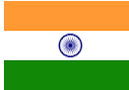

BASIC INFORMATION:
- Capital City: New Delhi
- Population: 1,103,596,000
- 2nd most populous country in the world
- Location: Peninsula in Indian Ocean

HIGHER EDUCATION HIGHLIGHTS:
- Under the Ministry of Human Resource Development (MHRD)
- Approximately 677 universities
- The third largest higher education system in the world behind China and the U.S.

FIND MORE INFORMATION:
http://travel.nationalgeographic.com/travel/countries/india-facts/
http://www.bbc.com/news/world-asia-25881705
http://mhrd.gov.in/university-and-higher-education

INDONESIA 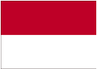

BASIC INFORMATION:
- Capital City: Jakarta
- Population: 253, 609, 643
- Consists of 17,000 islands
- Straddles the equator
- Largest number of active volcanoes in the world

HIGHER EDUCATION HIGHLIGHTS:
- 53 state universities and 400 private universities
- Enrollment in higher education lags behind the rest of the region

FIND MORE INFORMATION:
http://www.infoplease.com/country/indonesia.html
http://www.lonelyplanet.com/indonesia
http://wenr.wes.org/2014/04/education-in-indonesia/
http://www.timeshighereducation.co.uk/news/indonesia-struggles-to-bridge-its-skills-gap/2/2008876.article

IRAN 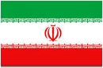

BASIC INFORMATION:
- Capital City: Tehran
- Population: 80,840,713
- Republic in Central Asia, south of the Caspian Sea and north of the Persian Gulf

HIGHER EDUCATION HIGHLIGHTS:
- Approximately 3,791,000 students
- Systems supervised by the Ministry of Science, Research and Technology and Ministry of Health & Medical education

FIND MORE INFORMATION:
http://www.cnn.com/2013/06/03/world/meast/iran-fast-facts/
http://www.infoplease.com/country/iran.html
http://wenr.wes.org/2013/04/wenr-april-2013-an-overview-of-education-in-iran/

IRELAND

BASIC INFORMATION:
- Capital City: Dublin
- Population: 4,832,765
- Location: An island in the eastern part of the North Atlantic directly west of the United Kingdom

HIGHER EDUCATION HIGHLIGHTS:
- 7 Universities, 14 Institutes of Technology and 7 Colleges of Education
- Planning and development of higher education and research led by the Higher Education Authority (HEA)
- One of the highest participation rates in the world

FIND MORE INFORMATION:
http://www.lonelyplanet.com/ireland
http://www.encyclopedia.com/topic/Ireland.aspx
http://www.education.ie/en/The-Education-System/Higher-Education/

JAMAICA 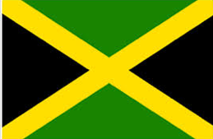

BASIC INFORMATION:
- Capital City: Kingston
- Population: 2.715 million
- Location: An island country situated in the Caribbean Sea; the third largest island in the Greater Antilles

HIGHER EDUCATION HIGHLIGHTS:
- The University Council of Jamaica (UCJ) is the national quality assurance body
- Ministry of Education has overall responsibility of education system

FIND MORE INFORMATION:
http://www.lonelyplanet.com/jamaica
http://www.factmonster.com/country/jamaica.html
http://www.unesco.org/new/en/education/resources/unesco-portal-to-recognized-higher-education-institutions/dynamic-single-view/news/jamaica/
http://www.ucj.org.jm

JAPAN 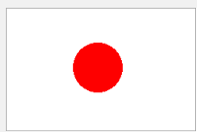

BASIC INFORMATION:
- Capital: Tokyo
- Population: 127,368,088
- Location: North Pacific off of the coast of Russia and the Korean peninsula
- Consists of four main islands and over 4,000 smaller islands in the Pacific Ring of Fire
- Over 70% of Japan is mountainous terrain

HIGHER EDUCATION HIGHLIGHTS:
- Consists of universities, junior colleges, colleges of technology, and specialized training colleges
- Typically four year programs, excepting medicine, dentistry, and veterinary medicine
- 87 universities managed by government; 86 public universities; and 553 private universities

FIND MORE INFORMATION:
https://www.cia.gov/library/publications/the-world-factbook/geos/ja.html
http://www.japantravelinfo.com/top/index.php
https://www.eda.admin.ch/countries/japan/en/home/living-in/information-about/education/higher-education-in-japan.html
http://www.unesco.org/education/wef/countryreports/japan/rapport_1.html

KOREA 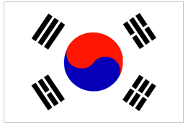

BASIC INFORMATION:
- Capital City: Seoul
- Divided between North and South
- Population of both North and South Korea: 51,202,130
- Location: Peninsula in North-East Asia; bordered by Amnok River to northwest and Duman River to northeast; situated between the Yellow Sea and East Sea

HIGHER EDUCATION HIGHLIGHTS:
- Ranks number one for total education enrollment among OECD countries
- 85% of higher education institutions are private
- 7 different types of institutions: colleges and universities; industrial universities; universities of education; junior colleges; broadcast and correspondence universities; technical colleges; other miscellaneous institutions

FIND MORE INFORMATION:
http://english.visitkorea.or.kr/enu/AK/AK_EN_1_4_4.jsp
http://travel.nationalgeographic.com/travel/countries/south-korea-facts/
http://wenr.wes.org/2013/06/wenr-june-2013-an-overview-of-education-in-south-korea/

NEPAL 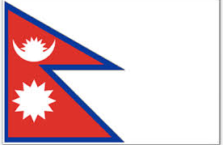

BASIC INFORMATION:
- Capital City: Kathmandu
- Population: 25,371,000
- Location: Between China and India in South Asia
- Home of Mount Everest

HIGHER EDUCATION HIGHLIGHTS:
- Ministry of Education and Sport (MOES) is responsible for the education sector
- Enrollment over 253,886
- Over 575 Universities, Institutes or Colleges

FIND MORE INFORMATION:
http://welcomenepal.com/promotional/#
http://www.lonelyplanet.com/nepal
http://travel.nationalgeographic.com/travel/countries/nepal-facts/
http://siteresources.worldbank.org/EDUCATION/Resources/278200-1121703274255/1439264-1193249163062/Nepal_CountrySummary.pdf
http://wenr.wes.org/2013/03/wenr-march-2013-academic-mobility-and-the-education-system-of-nepal/

NETHERLANDS 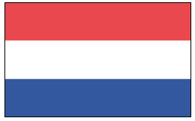

BASIC INFORMATION:
- Also known as Holland
- Capital City: Amsterdam
- Population: 16,877,351
- Location: On the coast of the North Sea

HIGHER EDUCATION HIGHLIGHTS:
- Binary system so choose between two types of education: research-oriented or higher professional
- A third smaller branch is the institute for international education

FIND MORE INFORMATION:
http://www.infoplease.com/country/netherlands.html
http://www.eupedia.com/netherlands/trivia.shtml
http://www.studyinholland.nl/education-system
http://www.government.nl/issues/education/higher-education

PAKISTAN 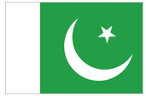

BASIC INFORMATION:
- Capital City: Islamabad
- Largest City: Karachi
- Population: 179 million
- Location: Northwest part of South Asia
- World’s second tallest mountain Karakoram (K2)

HIGHER EDUCATION HIGHLIGHTS:
- Divided into two main sectors: University/Degree Awarding Institutions and affiliated Colleges sector
- Predominantly public

FIND MORE INFORMATION:
http://www.bbc.com/news/world-south-asia-12965781
http://www.pakistan.gov.pk
http://www.hec.gov.pk/Pages/HECMain.aspx
http://siteresources.worldbank.org/EDUCATION/Resources/278200-1121703274255/1439264-1193249163062/Pakistan_countrySummary.pdf

POLAND

BASIC INFORMATION:
- Capital City: Warsaw
- Population: 38,538,447
- Location: Bordered by Germany, the Czech Republic, Slovakia, Ukraine, Belarus, Lithuania, and Russia as well as the Baltic Sea
HIGHER EDUCATION HIGHLIGHTS:
- Fourth highest enrollment number in Europe (over 2 million students)
- Over 450 higher education institutions
- Follows the Bologna process

FIND MORE INFORMATION:
http://europa.eu/about-eu/countries/member-countries/poland/index_en.htm
http://www.nauka.gov.pl/en/higher-education/
http://www.studyinpoland.pl/konsorcjum/index.php?option=com_content&view=article&id=16:how-media-reflects-and-affects-issues-on-internationalization-of-higher-education-in-poland&catid=17&Itemid=81
http://www.mastersportal.eu/articles/288/higher-education-in-poland.html

SAUDI ARABIA 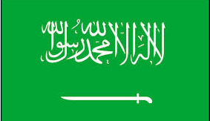

BASIC INFORMATION:
Capital: Riyadh
Population: 27.6 million
Location: Most of the Arabian Peninsula with coastlines on the Indian Ocean, Persian Gulf, and Red Sea.

HIGHER EDUCATION HIGHLIGHTS:
- Approximately 1 million students enrolled in Saudi universities and colleges
- 25 public universities; 9 private universities
- Under the jurisdiction of the Ministry of Education

FIND MORE INFORMATION:
http://www.washingtonpost.com/wp-srv/world/countries/saudiarabia.html
http://www.saudiembassy.net
http://wenr.wes.org/2014/11/higher-education-in-saudi-arabia/

SCOTLAND 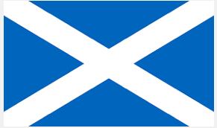

BASIC INFORMATION:
- Capital City: Edinburgh
- Population: Approximately 5.2 million
- Location: Occupies the northern third of Great Britain; bordered by England
- Home to about 800 small islands

HIGHER EDUCATION HIGHLIGHTS:
- Post-secondary education administered by the Scottish Qualifications Authority
- Political responsibility for education is vested in the Scottish Parliament and the Scottish Government’s Education and Lifelong Learning Department
- 19 higher education institutions
- Universities are funded by the Scottish Government via the Scottish Funding Council (SFC)

FIND MORE INFORMATION:
http://www.scotland.org/about-scotland/
http://www.lonelyplanet.com/scotland
http://www.gtcs.org.uk/education-in-scotland/scotlands-education-system.aspx
http://www.gov.scot/Topics/Education/UniversitiesColleges/16640

THAILAND 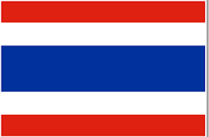

BASIC INFORMATION:
- Capital City: Bangkok
- Population: 67,741,401
- Location: Western half od the Indochinese peninsula and northern two-thirds of the Malay peninsula in southeast Asia

HIGHER EDUCATION HIGHLIGHTS:
- Educational policy is guided by the National Education Act
- Administered by Ministry of Education
- Approximately 1,706,516 students enrolled in universities
- Approximately 79 public universities, 71 private universities, and 20 community colleges

FIND MORE INFORMATION:
http://www.lonelyplanet.com/thailand
http://www.infoplease.com/country/thailand.html
http://www.unesco.org/new/en/education/resources/unesco-portal-to-recognized-higher-education-institutions/dynamic-single-view/news/thailand/
http://wenr.wes.org/2014/03/education-in-thailand/

